Table of Contents

**ANIMAL NUTRACEUTICALS** 1

**The Wellness Market at an Inflection Point** 1

**Master White Paper: The Animal Nutraceutical Landscape (2024-2030)** 1

**Executive Summary** 1

**I. Definition, Scope and Structural Dynamics** 1

**I.1. Terminology** 1

**I.2. Regulatory Landscape by Region** 1

**I.2. Regulatory Strategic Matrix (Summary)** 1

**Table I.1: Global Regulatory Access Strategy** 1

**I.3. Scope of Analysis** 1

**Conclusion of Part I** 1

**II.1. Mobility and Joint Health (Species: Pet)** 1

**Table II.1: Mobility and Joint Health Targets** 1

**II.2. Gut Health and Microbiome Modulation (Species: Multi-Species)** 1

**Table II.2: Gut Health and Microbiome Modulation Targets** 1

**II.3. Immunity and Resilience (Species: Multi-Species)** 1

**Table II.3: Immunity and Resilience Targets** 1

**II.4. Cognitive Support and Aging (Species: Pet)** 1

**Table II.4: Cognitive Support and Aging Targets** 1

**II.5. Calming and Behavioral Wellness (Species: Pet)** 1

**Table II.5: Calming and Behavioral Wellness Targets** 1

**II.6. Performance, FCR, and Growth (Species: Livestock)** 1

**Table II.6: Performance and Efficiency Targets** 1

**II.7. Special Niches (Species: Multi-Species)** 1

**Table II.7: Special Niches Targets** 1

**II.8. Natural Ectoparasite Defense (Species: Multi-Species)** 1

**Table II.8: Natural Ectoparasite Defense Targets** 1

**II.9. Nutrigenomics and Systemic Prevention (Species: Multi-Species)** 1

**Table II.9: Nutrigenomics Targets** 1

**II.10. Advanced Formulations and Delivery Systems (Species: Multi-Species)** 1

**Table II.10: Advanced Delivery Systems** 1

**II.11. Sustainability and the “Green Claim” Economy (Species: Livestock)** 1

**Table II.11: Sustainability and Green Claim Targets** 1

**II.12. Comparative Market Impact** 1

**II.13. Ingredient Market Share** 1

**Conclusion of Part II: The Shift to Precision** 1

**III. Market Structure and Value Capture** 1

**III.1. Global Animal Demographics and Trends: Sizing the Opportunity** 1

**III.2. Urbanization, Administration, and Decision Pathways** 1

**III.4. Premiumization and Emerging High-Value Niches** 1

**III.5. The Value Chain: From Molecule to Market** 1

**III.6. Strategic Value Creation & Competitive Landscape** 1

**III.7. Future Outlook: The Asian AGP Dividend** 1

**Conclusion of Part III** 1

**Part IV. Competitive Landscape & Strategic Investment Analysis** 1

**IV.1. Mapping the Competitive Landscape** 1

**IV.2 Key Players and Portfolio Architecture** 1

**IV.2.1 Pharma-linked Animal Health Groups** 1

**IV.2.2 Feed and Specialty Nutrition Majors** 1

**IV.2.3 Consumer-Facing Pet Nutrition Brands** 1

**IV.3. Notable Transactions and Investment Landscape (2015-2025)** 1

**Table IV.1: Major Transactions >$100M (2015-2025)** 1

**IV.3.1. Companion Animals: The “Pet Premium” (Brands & Platforms)** 1

**IV.3.2. Livestock & Aquaculture: Precision & Scale** 1

**IV.3.3. Upstream & Ingredient Platforms** 1

**IV.3.4. Valuation Benchmarks & Deal Psychology** 1

**IV.3.5. Key Investor Profiles** 1

**Table IV.2: Key Investor Profiles & Portfolios** 1

**IV.3.6. Competitive Analysis Summary** 1

**IV.4 Valuation Dynamics and Margin Analysis** 1

**IV.4.1 Pet-focused consumer brands: “The Wellness Premium”** 1

**IV.4.2 Livestock and specialty-ingredient platforms: “Efficiency at Scale”** 1

**IV.4.3 Key Valuation Drivers: The 4 Accelerators (2024–2025)** 1

**IV.5 Market Structure Summary: The “Margin Ladder”** 1

**IV.6. Strategic Implications for Investors** 1

**IV.7. Strategic Capital Allocation Matrix** 1

**IV.7.1 Quadrant Analysis** 1

**IV.7.2 Watchlist: The Top Picks** 1

**Conclusion of Part IV: The Consolidation Landscape** 1

**V. Emerging Strategic Frontiers (2026-2030)** 1

**V.1. The Institutionalization of Green Labels** 1

**V.2. The Nutrigenomics Frontier: Biology as Software** 1

**V.3. The Regulatory Grey Zones (Future-Proofing)** 1

**V.4. The Longevity Economy: Pet Humanization 2.0** 1

**V.5. Bio-Manufacturing: The New Supply Chain** 1

**V.6. The Livestock Strategic Pivot: The “Great Divergence” (2026-2030)** 1

**V.7. Outlook: How AGP Limitations in India and China Could Reshape the Market Size** 1

**VI. Conclusion: The Investment Roadmap for 2030** 1

**Appendix: Author & Disclaimer** 1

**Appendix B: Comprehensive Industry Players List** 1

**References** 1

**1. Market Intelligence & Industry Data** 1

**2. Regulatory Frameworks (Official Sources)** 1

**3. Scientific Literature & Clinical Trials** 1

**4. Corporate Reporting & Strategy** 1

**5. Corporate & Commercial Citations (Alphabetical)** 1

**6. Trade & Financial News (Transaction Announcements & Retail Analysis)** 1

**7. Valuation Multiples & Business Benchmarks** 1

**JANUARY 2026 | STRATEGIC INTELLIGENCE**

**ANIMAL NUTRACEUTICALS**

The Wellness Market at an Inflection Point

*Mapping value creation across a $6 billion global industry  
driven by pet humanization and the post-antibiotic transition*

# **ANIMAL NUTRACEUTICALS**

## **The Wellness Market at an Inflection Point**

**JANUARY 2026 | STRATEGIC INTELLIGENCE**

*Mapping value creation across a $6 billion global industry driven by pet humanization and the post-antibiotic transition*

# **Master White Paper: The Animal Nutraceutical Landscape (2024-2030)**

## **Executive Summary**

**The Bifurcation of Value: A Financial & Strategic Appraisal** The global animal nutraceutical market is navigating a fundamental industrial shift. Transforming from a monolithic commodity sector, it has crystallized into a **$13+ billion investable asset class** (Combined Scope) projected to reach **$18–24 billion by 2035** (CAGR ~5–7%). This white paper analyzes a market defined by the separation between two distinct operational requirements: the therapeutic management of companion animals (**High Margin/Growth Play**) and the biochemical optimization of livestock production (**High Volume/Resilience Play**).

**1. The Core Problematic: Divergent Economic Mechanics** Capital allocation must distinguish between two mutually exclusive market mechanics.

**Segment 1: The Pet Economy ~ $6B:** Driven by the “**Silver Economy**” of aging pets and inelastic “humanization” demand, this B2C sector offers high gross margins (60%+) and recurring revenue. * **Valuation:** Assets with demonstrated clinical efficacy command **15–20x EBITDA**, outperforming general CPG. * **Trajectory:** Projected **CAGR of ~6–9%**. * **Risk: Channel Erosion.** Digital platforms are compressing veterinary margins by **100–200 basis points**, forcing a strategic pivot to Direct-to-Consumer (DTC) models to preserve unit economics.

**Segment 2: The Livestock Economy ~ $7B:** Governed by Feed Conversion Ratios (FCR), this B2B sector operates as critical sanitary infrastructure. * **Valuation:** High-volume industrial model trading at **8–12x EBITDA** with thinner margins (**3–10% EBITDA**). * **Driver: Regulatory Alpha.** The global phase-out of antibiotic growth promoters is triggering a CAPEX supercycle, converting functional biologicals (enzymes, probiotics) from elective inputs into mandatory “license to operate” costs.

**2. Strategic Market Findings: Moats & Arbitrage** * **Industrial Concentration:** The **Top 5 Global Manufacturers** control **~55%** of the feed additive market, forcing challengers to compete on proprietary IP rather than scale. * **Arbitrage & Consolidation:** The pet segment remains fragmented, offering a classic “**Roll-Up**” opportunity for sponsors to arbitrage the valuation gap between private players and strategic platforms. * **Asian Regulatory Harmonization:** As China and India implement strict antimicrobial guidelines, a **$4–6 billion incremental opportunity** is emerging, shifting volume demand eastward.

**3. Emerging Frontiers: Bio-Industrial Innovation (2026–2035)** Future value creation will be defined by **Precision & Proof**, moving from anecdotal supplementation to medicalization: * **The Silver Economy:** The focus in companion animals is shifting from palliative “senior care” to active **life extension**. Innovation is targeting the biological hallmarks of aging to fundamentally slow the biological clock and extend the high-value “healthspan” of the pet. * **Nutrigenomics:** Transitioning from phenotypic approximation to **genotypic precision**, enabling interventions based on specific genetic risk profiles. * **Scope 3 Efficiency:** Sustainability is now a procurement specification. Enzymatic solutions targeting **methane reduction** and **nitrogen retention** are essential for supply chain decarbonization. * **Precision Fermentation:** Adopting **bioreactor-based production** (algal/insect proteins) to decouple nutrition from arable land constraints and solve the “Fish-In/Fish-Out” ratio.

**4. Scope of Report** This White Paper serves as a Strategic Guide for capital allocation. It deconstructs the **Regulatory Grey Zone**, analyzes the shift from commodities to functional solutions, maps the exit landscape for investors, and identifies the technologies defining the next decade of value creation.

## **I. Definition, Scope and Structural Dynamics**

***Section Scope:*** *Defining the regulatory “grey area” and divergent compliance pathways (US FDA/AAFCO vs. EU EFSA) to establish market entry rules.*

### **I.1. Terminology**

“Nutraceutical” (1989) describes food derivatives with health benefits beyond basic nutrition. Lacking a harmonized legal definition, products often fall into a regulatory Grey Zone. In intensive farming, functional ingredients are regulated as feed additives—substances improving feed quality or animal performance.

The **EU** provides a strict framework (Reg 1831/2003) with specific categories like “zootechnical additives” for performance benefits. The **US** forces a binary choice: “Food” (GRAS) or “New Animal Drug.” Recent legislation (Innovative FEED Act) aims to create a “zootechnical” pathway in the US, aligning with global standards.

### **I.2. Regulatory Landscape by Region**

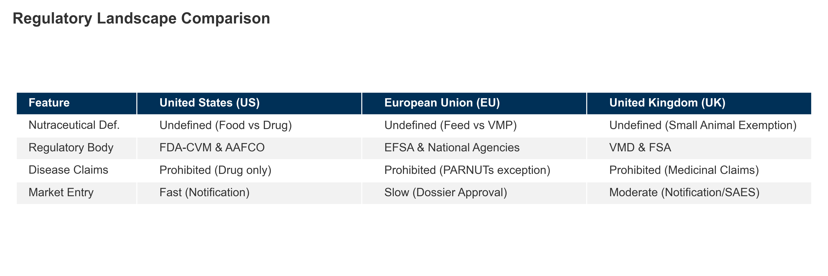 *Figure I.1: Key regulatory differences between US and EU animal nutraceutical frameworks.* ***[Source: FDA GFI #293, EU Reg 1831/2003]***

### **I.2. Regulatory Strategic Matrix (Summary)**

The global landscape diverges: US focuses on **Safety** (GRAS), EU on **Efficacy** (Zootechnical), UK on **Innovation**.

### **Table I.1: Global Regulatory Access Strategy**

| **Region** | **“Nutraceutical” Status** | **Key Regulation** | **The Grey Zone Strategy** | **Market Access Key** |
| --- | --- | --- | --- | --- |
| **USA** | Binary: Food vs. Drug. | **FDA GFI #293** | Market as **“Food”** or **“Supplement”**. Avoid “Cure” claims. | **NASC Seal**: Industry standard. |
| **EU** | Feed vs. VMP. | **Reg (EC) 1831/2003** | Use **“Zootechnical”** category (Efficacy dossier required). | **EFSA Dossier**: High barrier. |
| **UK** | Feed vs. VMP. | **VMR 2024** & FSA | **SAES** for minor species. | **FSA Register**: Faster approvals. |
| **China** | **Strictly Regulated.** | **MoA Decree 20** | **“Pet Feed”** classification. | **MARA License**: Mandatory. |

*(Note: The Proposed US* ***Innovative FEED Act*** *would align the US with the EU/UK).*

##### **I.2.4. Only Alternatives: AGP Bans and Zinc Oxide Restrictions**

Two milestones reshaped the landscape: 1. **End of Antibiotic Growth Promoters (AGPs):** Banned in EU (2006), US (2017), China (2020), creating a vacuum for probiotics and phytogenics. 2. **Ban on Medicinal Zinc Oxide (ZnO):** EU ban (2022) forced adoption of nutraceutical strategies for piglet gut health.

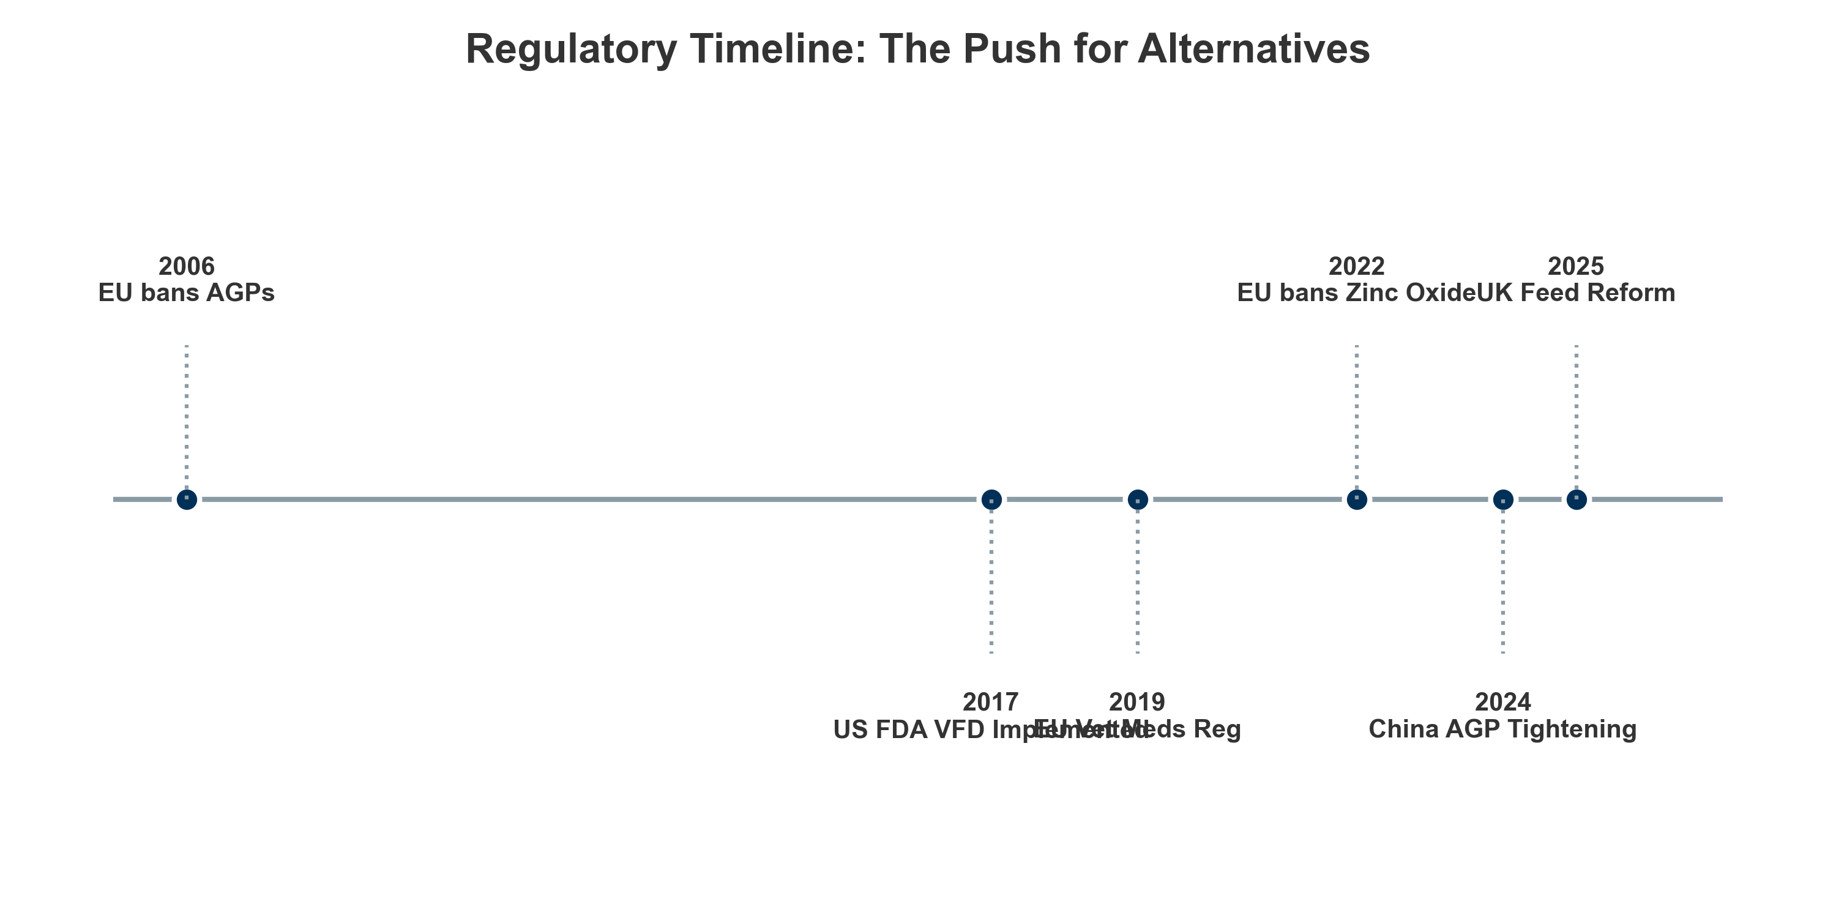 *Figure I.2: Timeline of major regulatory developments in animal nutraceuticals (2020-2026).* ***[Source: Internal Analysis based on Regulatory Decrees]***

## **I.3. Scope of Analysis**

This report focuses on functional bioactive compounds, excluding VMPs and bulk commodities.

**Market Scope: Harmonized Definition (~$13B)** * **Combined Scope:** **Pet Supplements** (~$6B) + **Livestock Functional Additives** (~$7B). * **Inclusions:** Functional treats, performance additives. * **Exclusions:** Prescription drugs, bulk grains, human supplements.

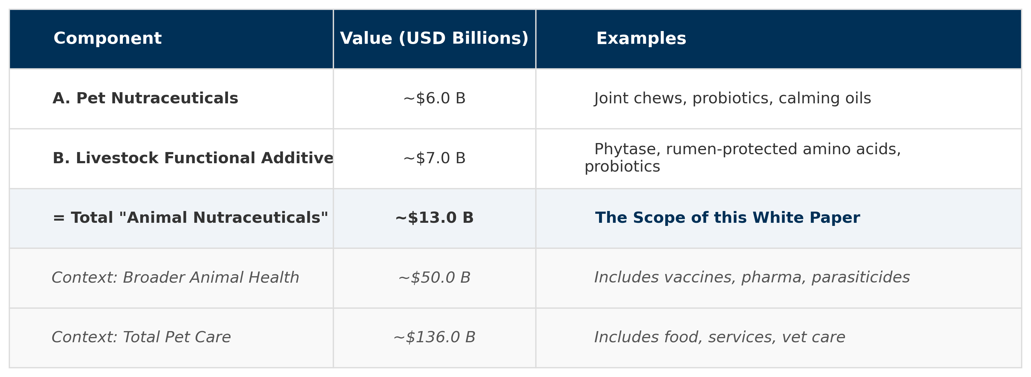 *Figure I.3: TAM Reconciliation and Market Scope (2024 Estimates).* ***[Source: Grand View Research (2024), Euromonitor (2024)]***

#### **I.3.1. What Is Included**

Focus on ingredients modulating physiology (joint, gut, immune, cognition).

##### **I.3.1.1. Delivery Systems**

* **Companions:** Palatability driven. Soft chews (~59%) preferred over tablets.
* **Horses:** Routine driven. Top-dressed powders and pellets dominate.
* **Livestock:** Efficiency driven. Premixes, microencapsulation, water-solubles.

#### **I.3.2. What Is Excluded**

* Prescription VMPs (NSAIDs, antibiotics).
* Agricultural commodities.
* General multivitamins without specific health indications.
* Human supplements (toxicity risks).

### **Conclusion of Part I**

We have defined the regulatory divergence and scoped a **$13 billion addressable market**. **Part II** will examine the **functional architecture** driving clinical value.

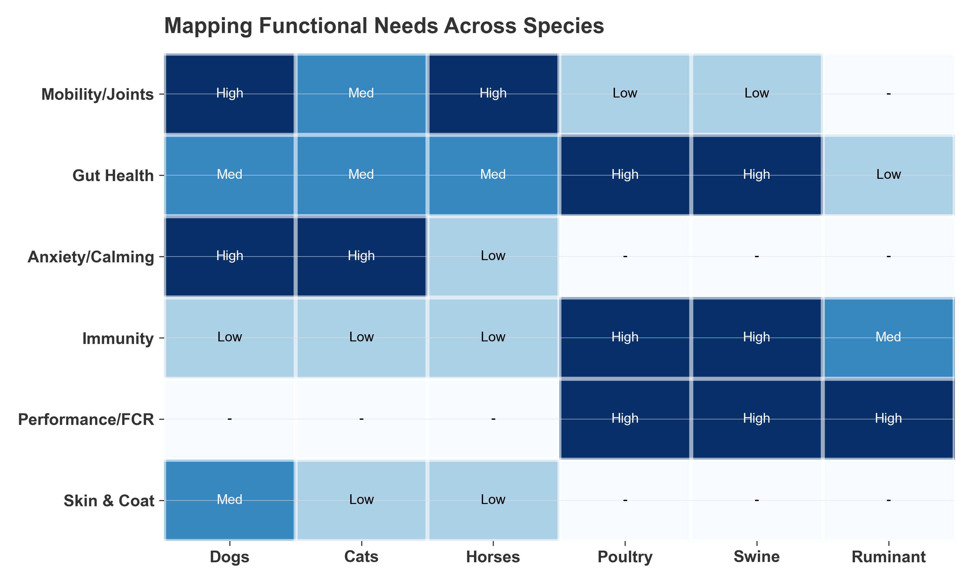 *Figure II.1: Mapping functional needs across companion and production animal species.* ***[Source: Internal Functional Analysis]***

1. Functional Segmentation, Use Cases, Drug-Sparing Logic, and Clinical Validation

***In this section:*** *We analyze the Industry’s “Biological Core” (Performance, Mobility, Gut Health) and “Strategic Enablers” (Delivery, Bio-Defense), highlighting the shift to outcome-driven solutions.*

**Taxonomy Key:** * **Pet/Companion:** Focus on longevity, humanization, palatability. * **Livestock/Production:** Focus on efficiency, FCR, sustainability. * **Multi-Species:** Cross-domain ingredients.

The market has shifted from basic feeding to precise physiological outcomes. We examine the **Biological Core (II.1–II.7)**—including **Performance** ($7.1B), **Gut Health** ($5.6B), **Mobility** ($2.9B), and **Behavior** ($1.4B)—followed by **Strategic Enablers (II.8–II.11)** like **Bio-Defense** ($3.5B) and **Delivery Systems** ($7.7B).

### **II.1. Mobility and Joint Health (Species: Pet)**

Joint health dominates the companion sector (~34% share), valued at **$1.42B (2024)** and projected to reach **$2.64B by 2033**. Including the high-value equine sector, the category exceeds **$2.1B**. Growth is shifting from volume-based **Glucosamine** (low clinical evidence) to high-value, NSAID-sparing actives like **UC-II Collagen** and **Omega-3s**.

* **The Glucosamine Paradox:** Commands 52% volume share but relies on legacy habit rather than strong efficacy (Level B/C).
* **Equine Niche:** High-revenue “Sports Medicine” focus ($700-800M), utilizing high dosages for performance maintenance.
* **Innovators:** **UC-II** (Oral Tolerance, low dose) and **Omega-3s** (Level A evidence) are replacing generic powders.

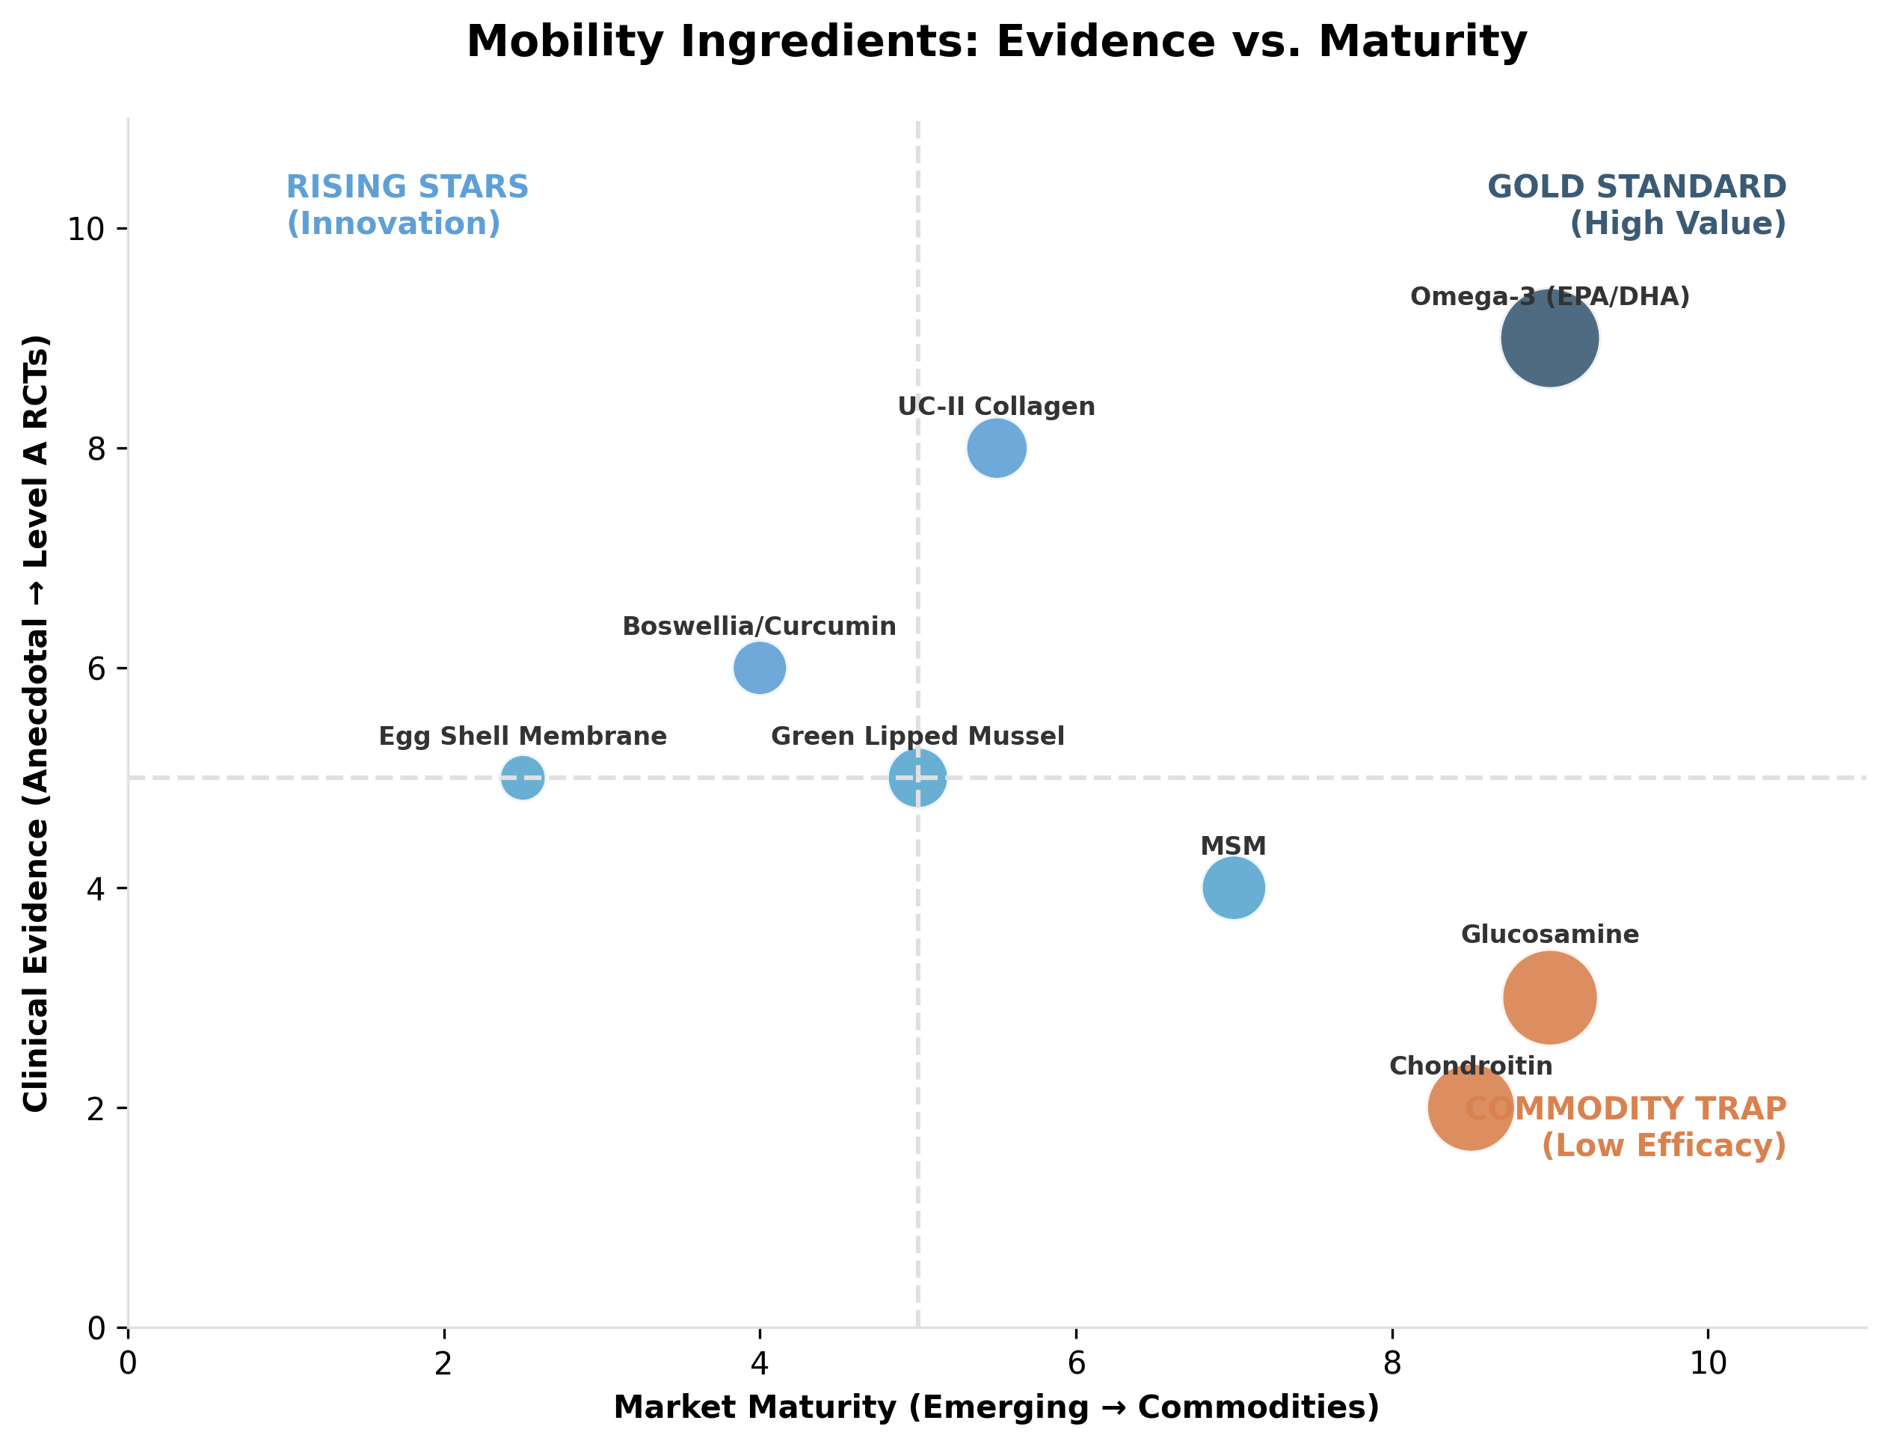 *Figure II.1: Evidence levels and market positioning of key nutraceutical ingredients (Mobility).* ***[Source: Internal efficacy analysis based on JAVMA/JVIM studies]***

### **Table II.1: Mobility and Joint Health Targets**

| **Component** | **Primary Target** | **Sector** | **Strategy** | **Clinical Validation (Level & Outcome)** | **Est. Value ($M)** |
| --- | --- | --- | --- | --- | --- |
| **Omega-3 (EPA/DHA)** | Dogs, Cats (OA Pain) | Pet | Adjunct to NSAIDs | **Level A**: Proven analgesic/anti-inflammatory benefit. (Roush et al., 2010) | $315M |
| **Collagen (e.g. UC-II)** | Dogs (Mobility) | Pet | Adjunct (**Gelita**, Lonza) | **Level A/B**: Oral tolerance reduces pain/stiffness. (Gupta et al., 2009) | $51M |
| **Eggshell Membrane** | Dogs (Stiffness) | Pet | Adjunct to NSAIDs | **Level B**: Improved mobility scores. (Ragetly et al., 2025) | $16M |
| **Green Lipped Mussel** | Dogs (Joint Function) | Pet | Adjunct to NSAIDs | **Level B**: Supportive, dose/quality dependent. (Vandeweerd et al., 2012) | $45M |
| **Glucosamine/Chondroitin** | Dogs, Horses | Pet | Legacy / Baseline | **Level B/C**: Mixed efficacy; largely a legacy volume driver. (Kampa et al., 2023) | $291M |
| **MSM** | Horses, Dogs | Pet | Adjunct | **Level C**: Some support for recovery/soreness. (Zhang et al., 2022) | $58M |
| **Oral Hyaluronic Acid** | Horses, Dogs | Pet | Lubrication (e.g. **Bioiberica**) | **Level C**: Variable oral bioavailability vs injectable. (Aguado et al., 2021) | $6M |
| **Boswellia/Curcumin** | Dogs, Horses | Pet | Anti-inflammatory | **Level C**: Plausible mechanics, limited verified veterinary trials. | $30M |

## **II.2. Gut Health and Microbiome Modulation (Species: Multi-Species)**

**Gut Health ($5.6B)** is the fastest-growing sector, driven by the antibiotic-free transition. The focus has shifted from digestion to **‘Eubiosis’**—a stable, pathogen-resistant microbiome. The broader gut health market is projected to reach **$120.4B by 2033** (CAGR 8.1%).

* **Probiotics:** Dominate pets (38% share) and livestock ($6.9B). Trends favor spore-formers (*B. subtilis*) for stability.
* **Synbiotics:** The “Survival Kit” strategy pairing bacteria with specific prebiotics (e.g., MOS/FOS) for resilience.
* **Enzymes:** **Phytase** ($600M+) is an inelastic commodity for phosphorus release; pet enzymes target EPI and senior digestion.
* **Postbiotics ($229M):** Rapidly growing due to stability in extruded feeds. They trigger immune responses via molecular patterns (MAMPs) without the viability risks of live cultures.

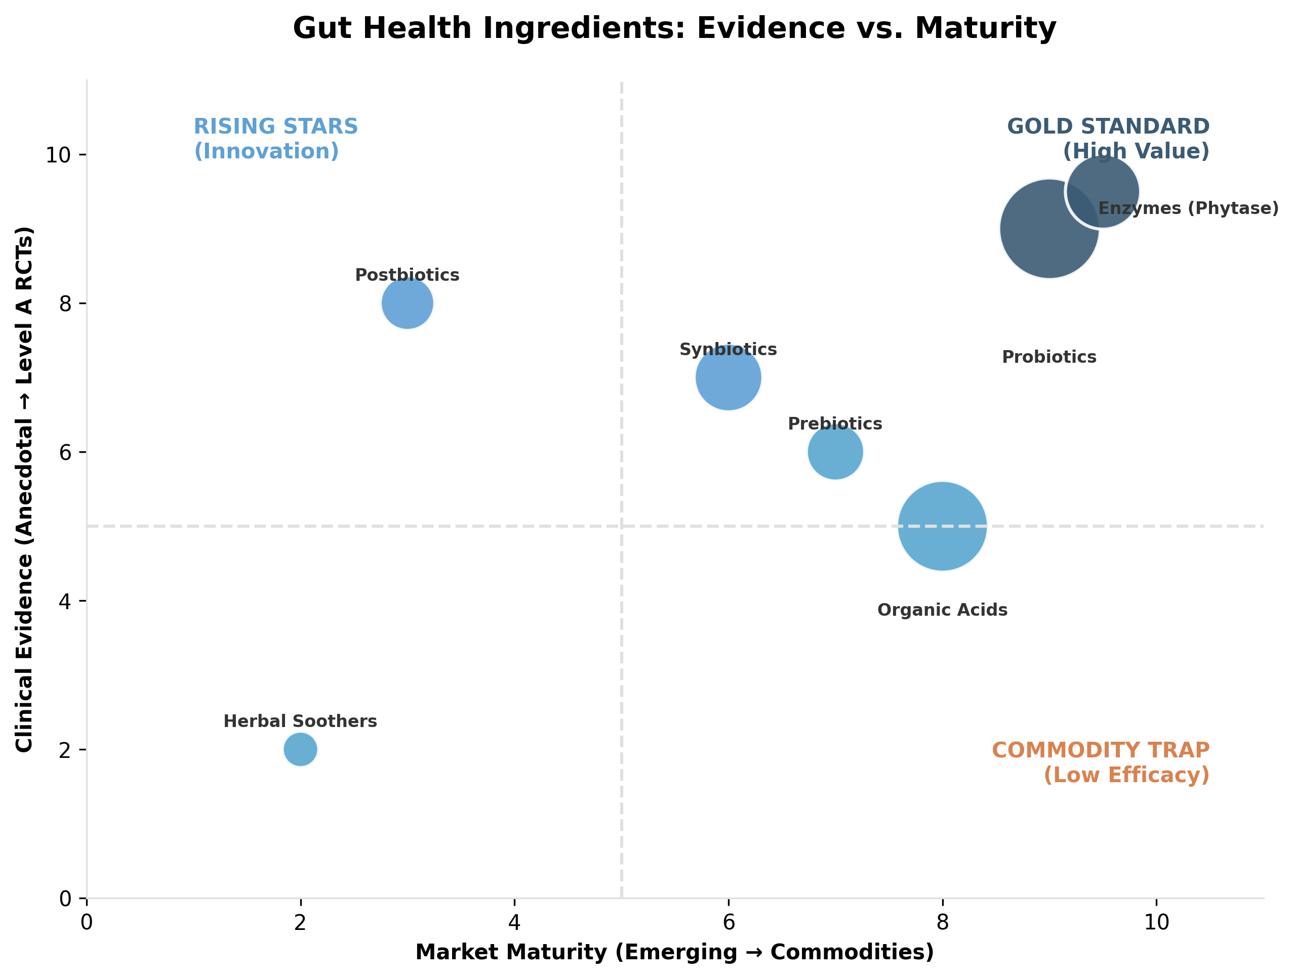 *Figure II.2: Evidence levels and market positioning of key nutraceutical ingredients (Gut Health).* ***[Source: Internal Efficacy Analysis]***

### **Table II.2: Gut Health and Microbiome Modulation Targets**

| **Component** | **Primary Target** | **Sector** | **Strategy** | **Clinical Validation (Level & Outcome)** | **Est. Value ($M)** |
| --- | --- | --- | --- | --- | --- |
| **Probiotics (Specific)** | Dogs (Diarrhea), Livestock (FCR) | Multi | Antibiotic reduction | **Level A**: Shortens acute diarrhea (Pets); improves ADG/FCR (Swine). (Kelley et al., 2009) | $1,590M |
| **Prebiotics (MOS/FOS)** | Poultry, Swine | Livestock | Pathogen binding | **Level B**: Reduces pathogen shedding and improves lesion scores. (Kiarie et al., 2012) | $157M |
| **Synbiotics** | Dogs (Shelters) | Pet | Resilience (**Protexin**) | **Level B**: Synergistic reduction in diarrhea incidence. (Rose et al., 2017) | $303M |
| **Postbiotics/Butyrate** | Piglets (Weaning) | Livestock | Enteric stability | **Level B**: Supports gut morphology and villus height. (Chen et al., 2023) | $173M |
| **Organic Acids** | Swine, Poultry | Livestock | pH Modulation | **Level B**: Effective pathogen control tool. (Khan et al., 2022) | $266M |
| **Enzymes (Phytase)** | Poultry, Swine | Livestock | Digestibility | **Level A**: Mature evidence for performance/digestibility gain. (Cowieson et al., 2020) | $424M |
| **Toxin Binders** | Livestock | Livestock | Risk Management | **Level B**: Efficacy varies by toxin spectrum. (EFSA, 2011) | $266M |
| **Herbal Soothers** | Pets | Pet | GI Comfort | **Level C**: Limited trials; supportive care only. | $12M |

## **II.3. Immunity and Resilience (Species: Multi-Species)**

The **$2.67B Immunity sector** acts as a biological shield for antibiotic-free production. Anchors include **Seaweed Polysaccharides** ($1.08B) for oxidative stress and **Plasma/Colostrum** ($533M) for weaning resilience.

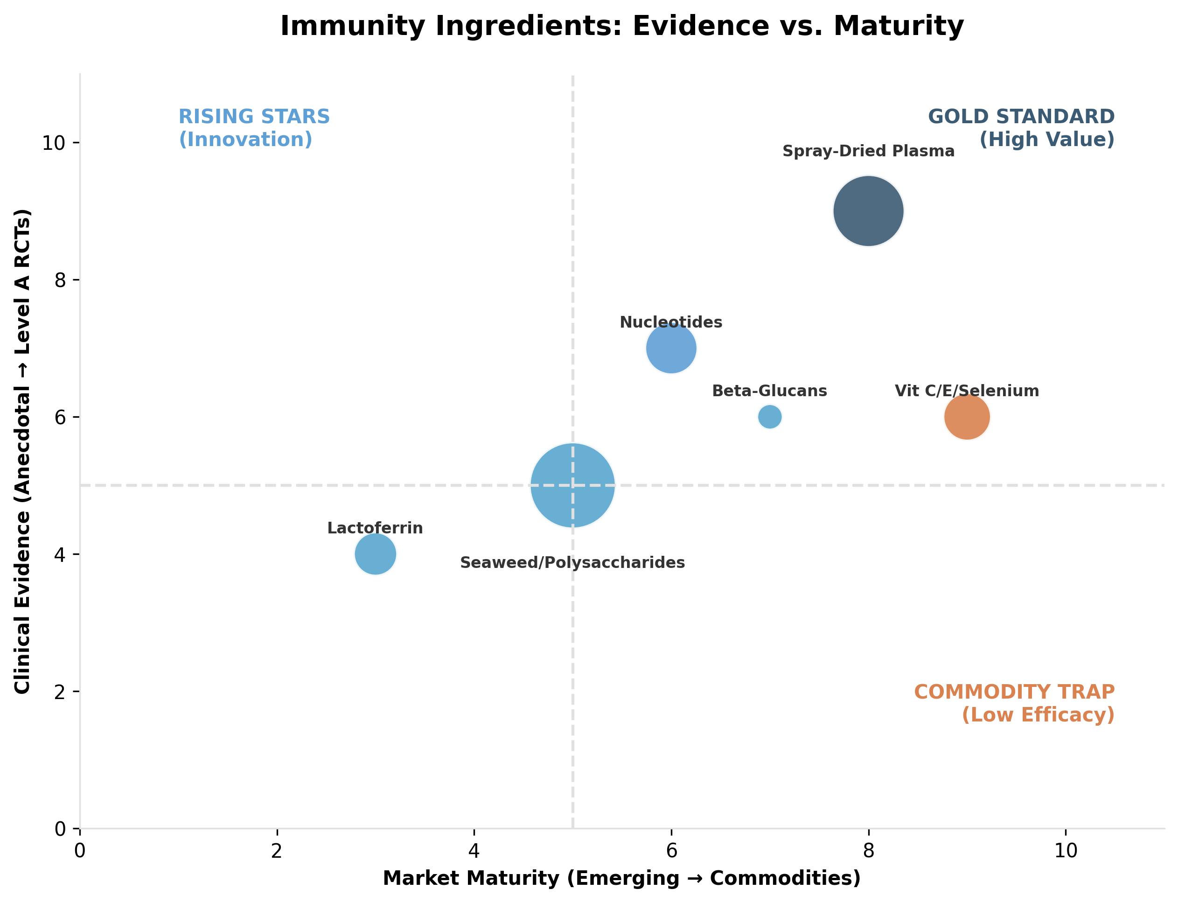 *Figure II.3: Evidence levels and market positioning of key nutraceutical ingredients (Immunity).* ***[Source: Internal Efficacy Analysis]***

### **Table II.3: Immunity and Resilience Targets**

| **Component** | **Primary Target** | **Sector** | **Strategy** | **Clinical Validation (Level & Outcome)** | **Est. Value ($M)** |
| --- | --- | --- | --- | --- | --- |
| **Beta-glucans (Yeast)** | Aqua (Shrimp), Poultry | Livestock | Immunostimulant | **Level B**: Improves survival marks in aquaculture. (Hauton, 2021) | $9M |
| **Plasma/Colostrum** | Piglets (Weaning) | Livestock | Passive Immunity | **Level A/B**: Strong data for post-weaning growth/health. (Torrallardona, 2010) | $533M |
| **Nucleotides** | Poultry, Aqua | Livestock | Cell proliferation | **Level B**: Supports growth/repair under stress. (Jang et al., 2019) | $151M |
| **Seaweed/Polysaccharides** | Ruminants, Monogastrics | Livestock | Oxidative Stress (**Olmix**) | **Level B/C**: Variable; effects species-dependent. (Sweeney et al., 2022) | $1,080M |
| **Selenium/Vit E** | Multi-species | Multi | Antioxidant | **Level B**: Proven essential; value in deficiency/stress. | $68M |
| **Vitamin C** | Aqua | Aqua | Stress Mitigation | **Level B**: Critical for resilience in aquatic systems. | $36M |
| **Lactoferrin** | Calves, Pets | Multi | Immune Support | **Level C**: Promising but data is less standardized. | $72M |

### **II.4. Cognitive Support and Aging (Species: Pet)**

The **$1.35B Cognitive sector** targets aging pets (Canine Cognitive Dysfunction). **MCTs** ($109M) provide alternative brain fuel (Level A evidence), while **DHA** ($85M) supports neuro-preservation.

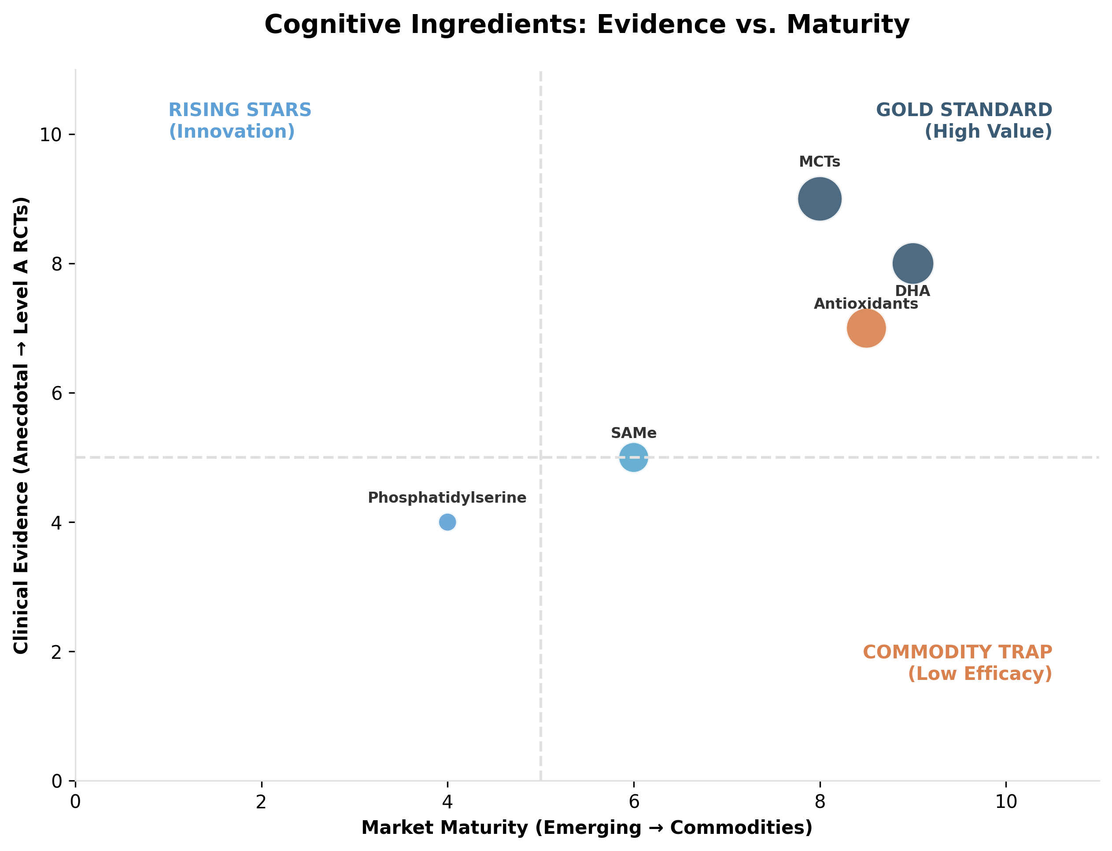 *Figure II.4: Evidence levels and market positioning of key nutraceutical ingredients (Cognition).* ***[Source: Internal Efficacy Analysis]***

### **Table II.4: Cognitive Support and Aging Targets**

| **Component** | **Primary Target** | **Sector** | **Strategy** | **Clinical Validation (Level & Outcome)** | **Est. Value ($M)** |
| --- | --- | --- | --- | --- | --- |
| **MCTs** | Senior Dogs (CCD) | Pet | Alternative Fuel | **Level A**: Proven cognitive benefit (DISHAA). (Pan et al., 2010) | $109M |
| **DHA (Omega-3)** | Dogs, Cats | Pet | Neuro-support | **Level B**: Biologically strong; outcomes depend on dose. | $85M |
| **Antioxidants** | Senior Dogs | Pet | Oxidative Stress | **Level B/A**: Support for learning/memory in aged dogs. (Cotman et al., 2002) | $73M |
| **Phosphatidylserine** | Senior Pets | Pet | Membrane Support | **Level C**: Limited veterinary-specific trials. | $4M |
| **SAMe** | Aging Animals | Multi | Liver/Brain | **Level C**: Stronger evidence for liver than cognition. | $24M |
| **Ginkgo Biloba** | Senior Pets | Multi | Circulation | **Level C**: Limited veterinary evidence. | $1M |
| **B Vitamins** | Senior Pets | Multi | Vitality | **Level C**: Preventative for deficiency. | $17M |

### **II.5. Calming and Behavioral Wellness (Species: Pet)**

Behavioral Wellness (**$1.4B**) reduces reliance on sedatives. **Multi-Complexes** ($121M) dominate, with **CBD/Hemp** ($80M) and **L-Theanine** driving growth in non-drowsy anxiolysis.

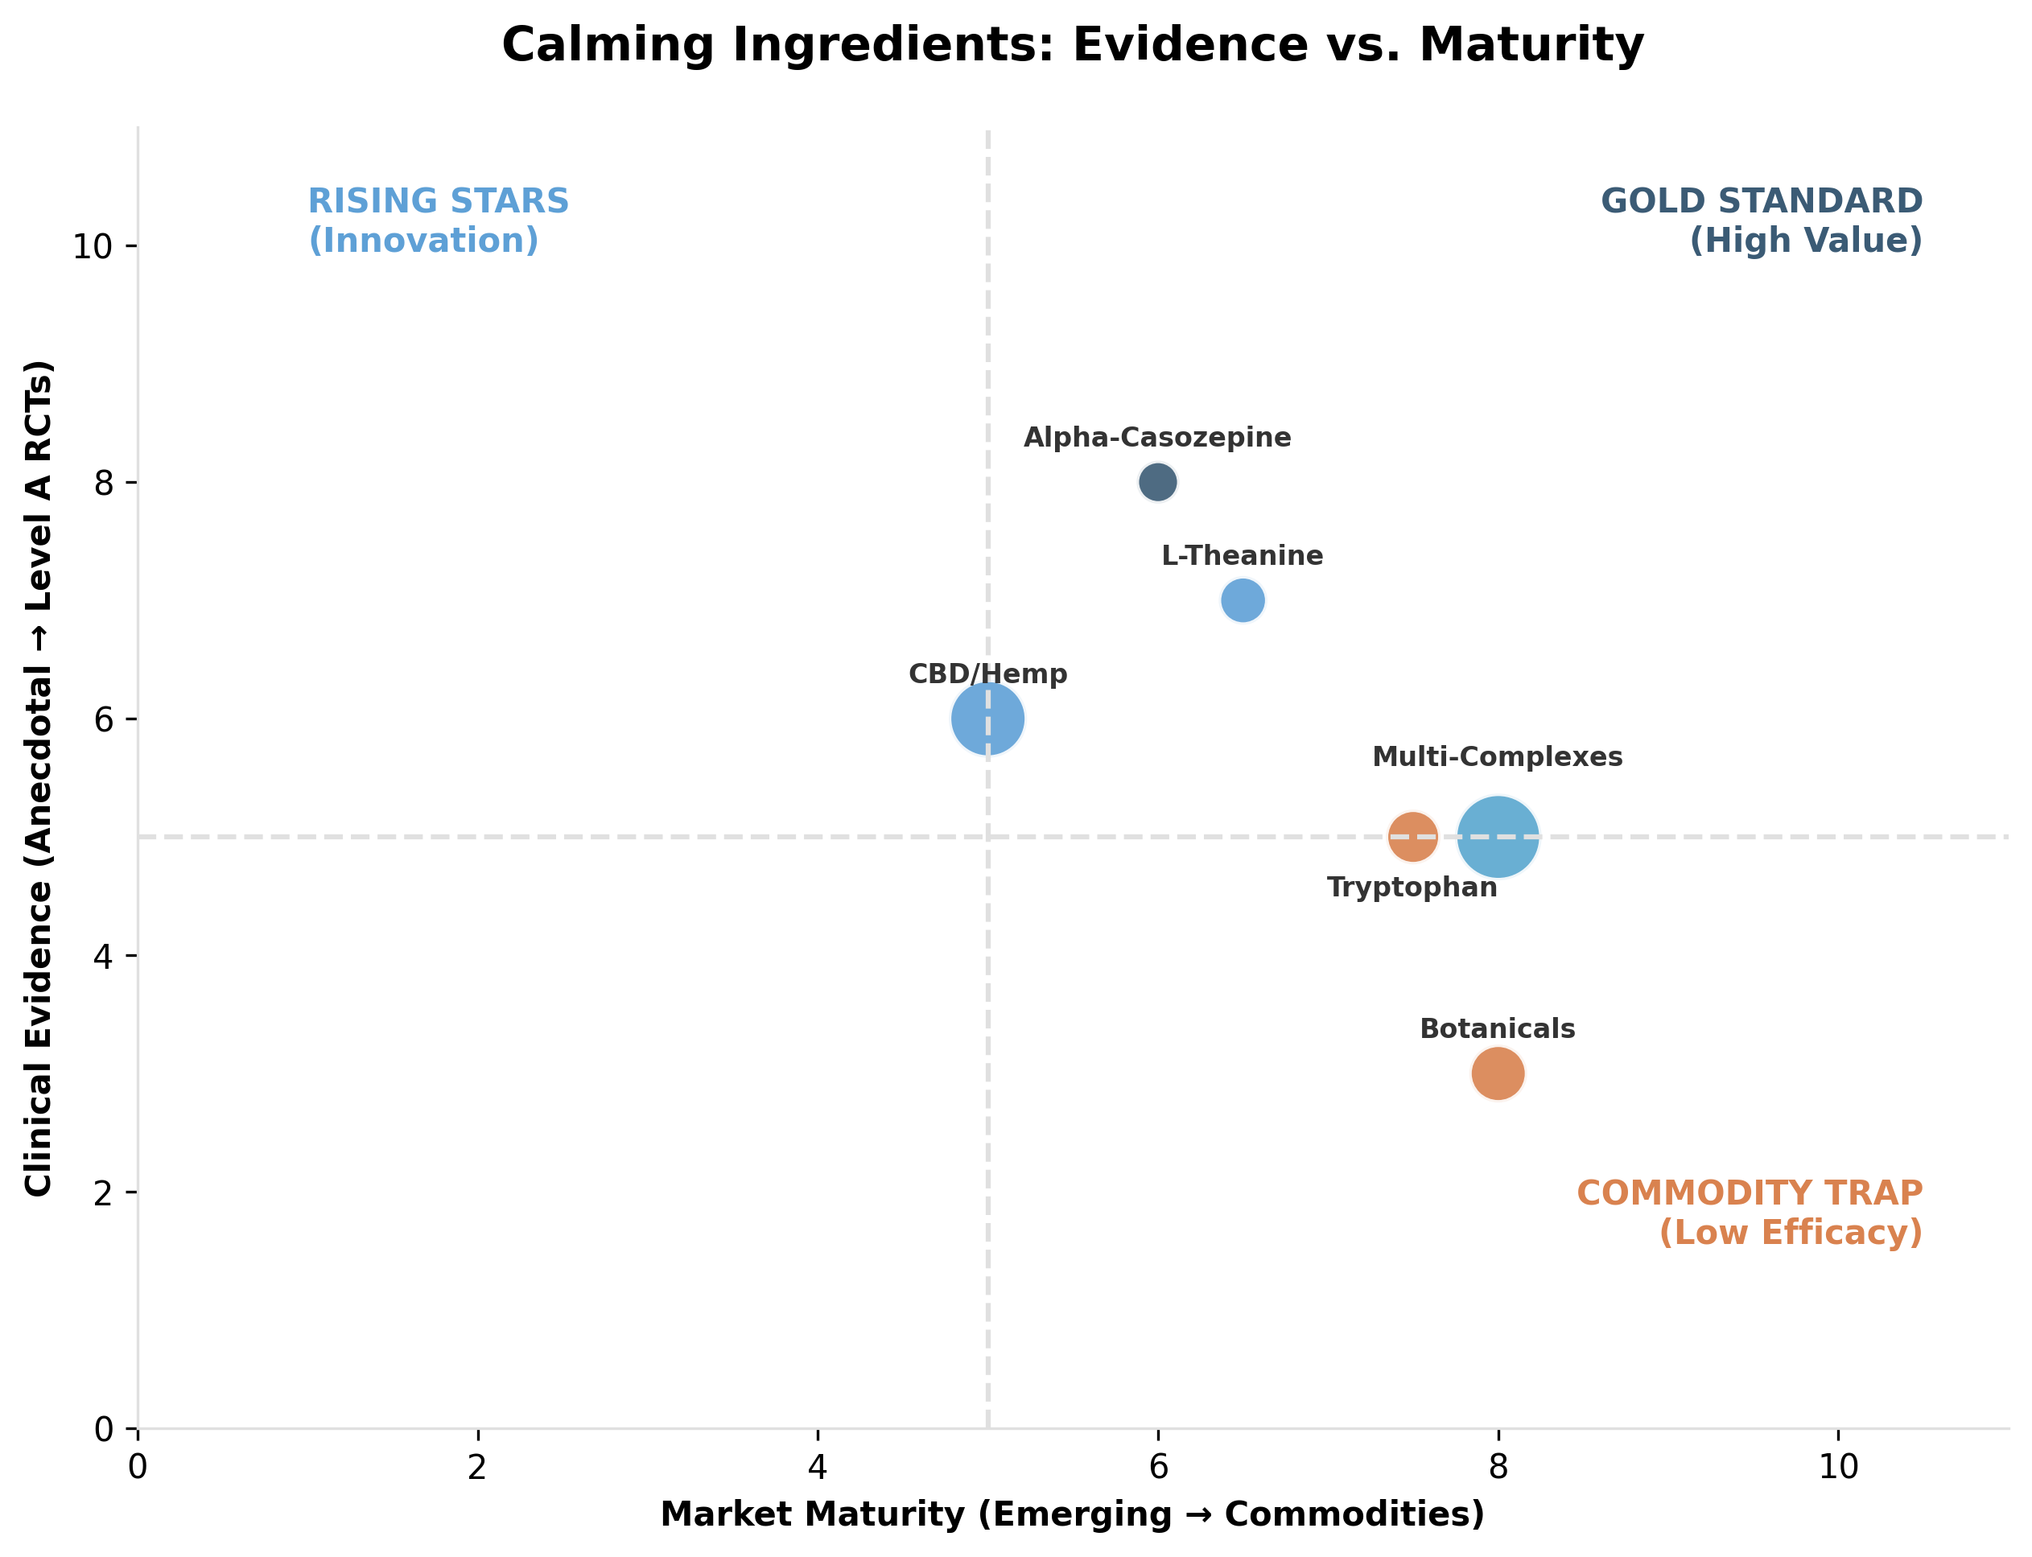 *Figure II.5: Evidence levels and market positioning of key nutraceutical ingredients (Calming).* ***[Source: Internal Efficacy Analysis]***

### **Table II.5: Calming and Behavioral Wellness Targets**

| **Component** | **Primary Target** | **Sector** | **Strategy** | **Clinical Validation (Level & Outcome)** | **Est. Value ($M)** |
| --- | --- | --- | --- | --- | --- |
| **L-Theanine** | Dogs, Cats | Pet | Anxiolysis | **Level B**: Supportive evidence for situational anxiety. (Pike et al., 2015) | $12M |
| **Alpha-Casozepine** | Dogs, Cats | Pet | Stress Mod. | **Level B**: Controlled evidence supports calming. (Beata et al., 2007) | $7M |
| **Tryptophan** | Dogs | Pet | Aggression/Stress | **Level B/C**: Evidence exists but context-dependent. | $19M |
| **Magnesium/B-Vits** | Dogs, Horses | Pet | Stress Stack | **Level C**: Plausible but limited RCTs. | $2M |
| **Botanicals** | Pets | Pet | Adjunct | **Level C**: Variable; safety review required. | $24M |
| **CBD/Hemp** | Dogs | Pet | Pain/Anxiety | **Level C/B**: Growing base; regulatory issues persist. (Mejia et al., 2023) | $80M |
| **Multi-Complexes** | Pets | Pet | Convenience (**VetriScience**) | **Level C**: Efficacy depends on lead active. | $121M |

### **II.6. Performance, FCR, and Growth (Species: Livestock)**

Valued at **$7.1B**, this sector replaces Antibiotic Growth Promoters with “Precision Efficiency” tools. **Yeast Cultures** ($484M) and **Enzymes** (Phytase $145M, Xylanase $242M) optimize Feed Conversion Ratios (FCR) and minimize metabolic waste.

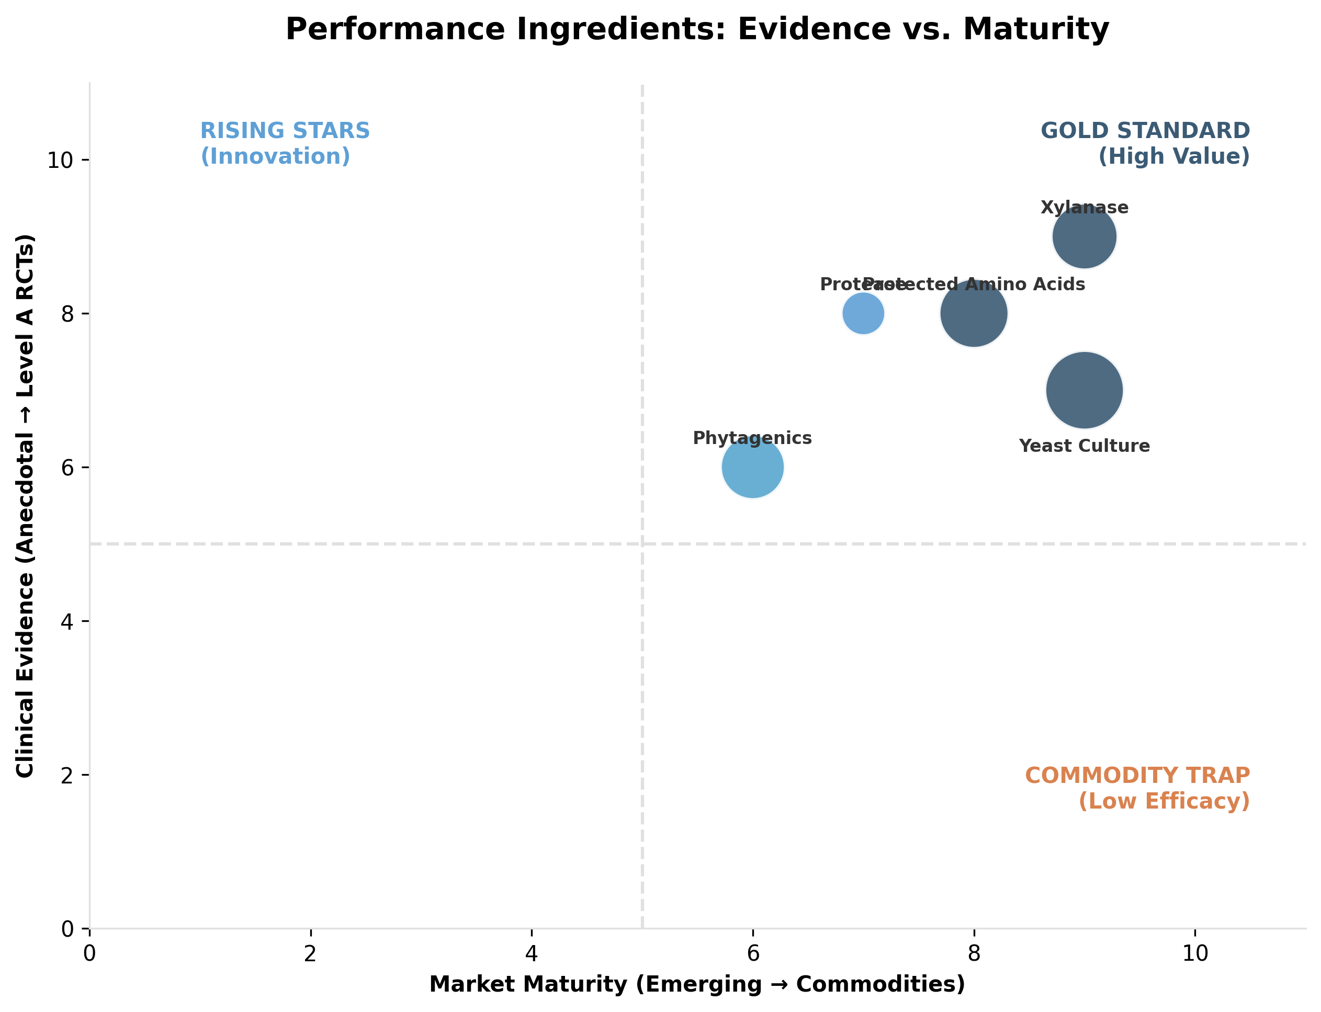 *Figure II.6: Evidence levels and market positioning of key nutraceutical ingredients (Performance).* ***[Source: Internal Efficacy Analysis]***

### **Table II.6: Performance and Efficiency Targets**

| **Component** | **Primary Target** | **Sector** | **Strategy** | **Clinical Validation (Level & Outcome)** | **Est. Value ($M)** |
| --- | --- | --- | --- | --- | --- |
| **Phytase** | Poultry, Swine | Livestock | P Digestibility | **Level A**: Established tool for FCR & P waste reduction. | $145M |
| **Xylanase** | Poultry, Swine | Livestock | Carbohydrate Dig. | **Level A**: Mature evidence base; strong ROI. | $242M |
| **Protease** | Poultry | Livestock | Protein Util. | **Level A/B**: Reduces nitrogen waste. | $48M |
| **Phytogenics** | Poultry, Swine | Livestock | Gut Stability (**Anpario**) | **Level B**: Broad but heterogeneous; delivery matters. | $216M |
| **Yeast Culture** | Ruminants | Livestock | Rumen Efficiency (**Leiber**) | **Level B**: Meta-analysis support; context sensitive. | $484M |
| **Organic Minerals** | Multi | Livestock | Tissue Integrity (**Zinpro**) | **Level B**: Supportive; economics depend on baseline. | $0M (Adjunct) |
| **Electrolytes** | Poultry, Horses | Multi | Rehydration | **Level B**: Strong rationale for heat stress/performance. | $203M |
| **Amino Acids** | Ruminants, Swine | Livestock | N Efficiency | **Level B**: Mature for protected AA; improves yield. | $291M |
| **Carnitine/CLA** | Pets, Horses | Pet | Metabolism | **Level C**: Niche; limited veterinary-specific RCTs. | $13M |

### **II.7. Special Niches (Species: Multi-Species)**

The **$1.75B Niche sector** targets “functional aesthetics.” **Astaxanthin** ($327M) drives aquaculture pigmentation, while **Zinc Methionine** ($42M) and **Omega-6** ($29M) support companion animal dermatology.

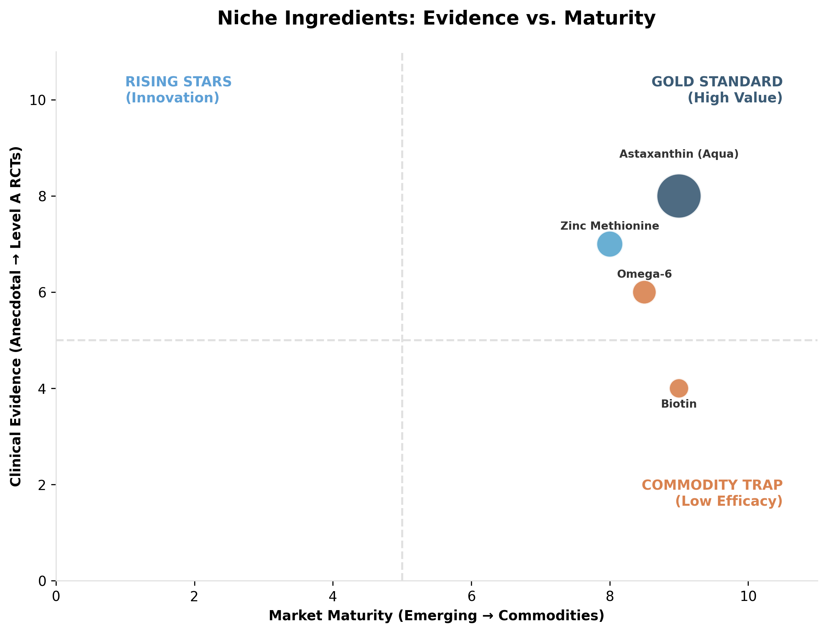 *Figure II.7: Evidence levels and market positioning of key nutraceutical ingredients (Niches).* ***[Source: Internal Efficacy Analysis]***

### **Table II.7: Special Niches Targets**

| **Component** | **Primary Target** | **Sector** | **Strategy** | **Clinical Validation (Level & Outcome)** | **Est. Value ($M)** |
| --- | --- | --- | --- | --- | --- |
| **Omega-6/Linoleic** | Dogs, Cats | Pet | Skin Barrier | **Level B**: Strongest for barrier repair/deficiency. | $29M |
| **Biotin** | Horses, Dogs | Pet | Hoof/Coat | **Level C**: Commonly used; mixed evidence strength. | $14M |
| **Zinc Methionine** | Dogs | Pet | Skin Integrity | **Level B/C**: Supportive; baseline status matters. | $42M |
| **Cranberry** | Dogs, Cats | Pet | Urinary Tract | **Level C**: Mixed evidence; careful positioning needed. | $12M |
| **Astaxanthin** | Aqua, Poultry | Livestock | Pigmentation | **Level B**: Established for flesh coloration economics. | $327M |

### **II.8. Natural Ectoparasite Defense (Species: Multi-Species)**

The **$1.0B Natural Defense** sector targets consumer “Chemophobia.” **Natural Repellents** ($133M) use essential oils to compete with pharmaceuticals, trading efficacy for safety appeal.

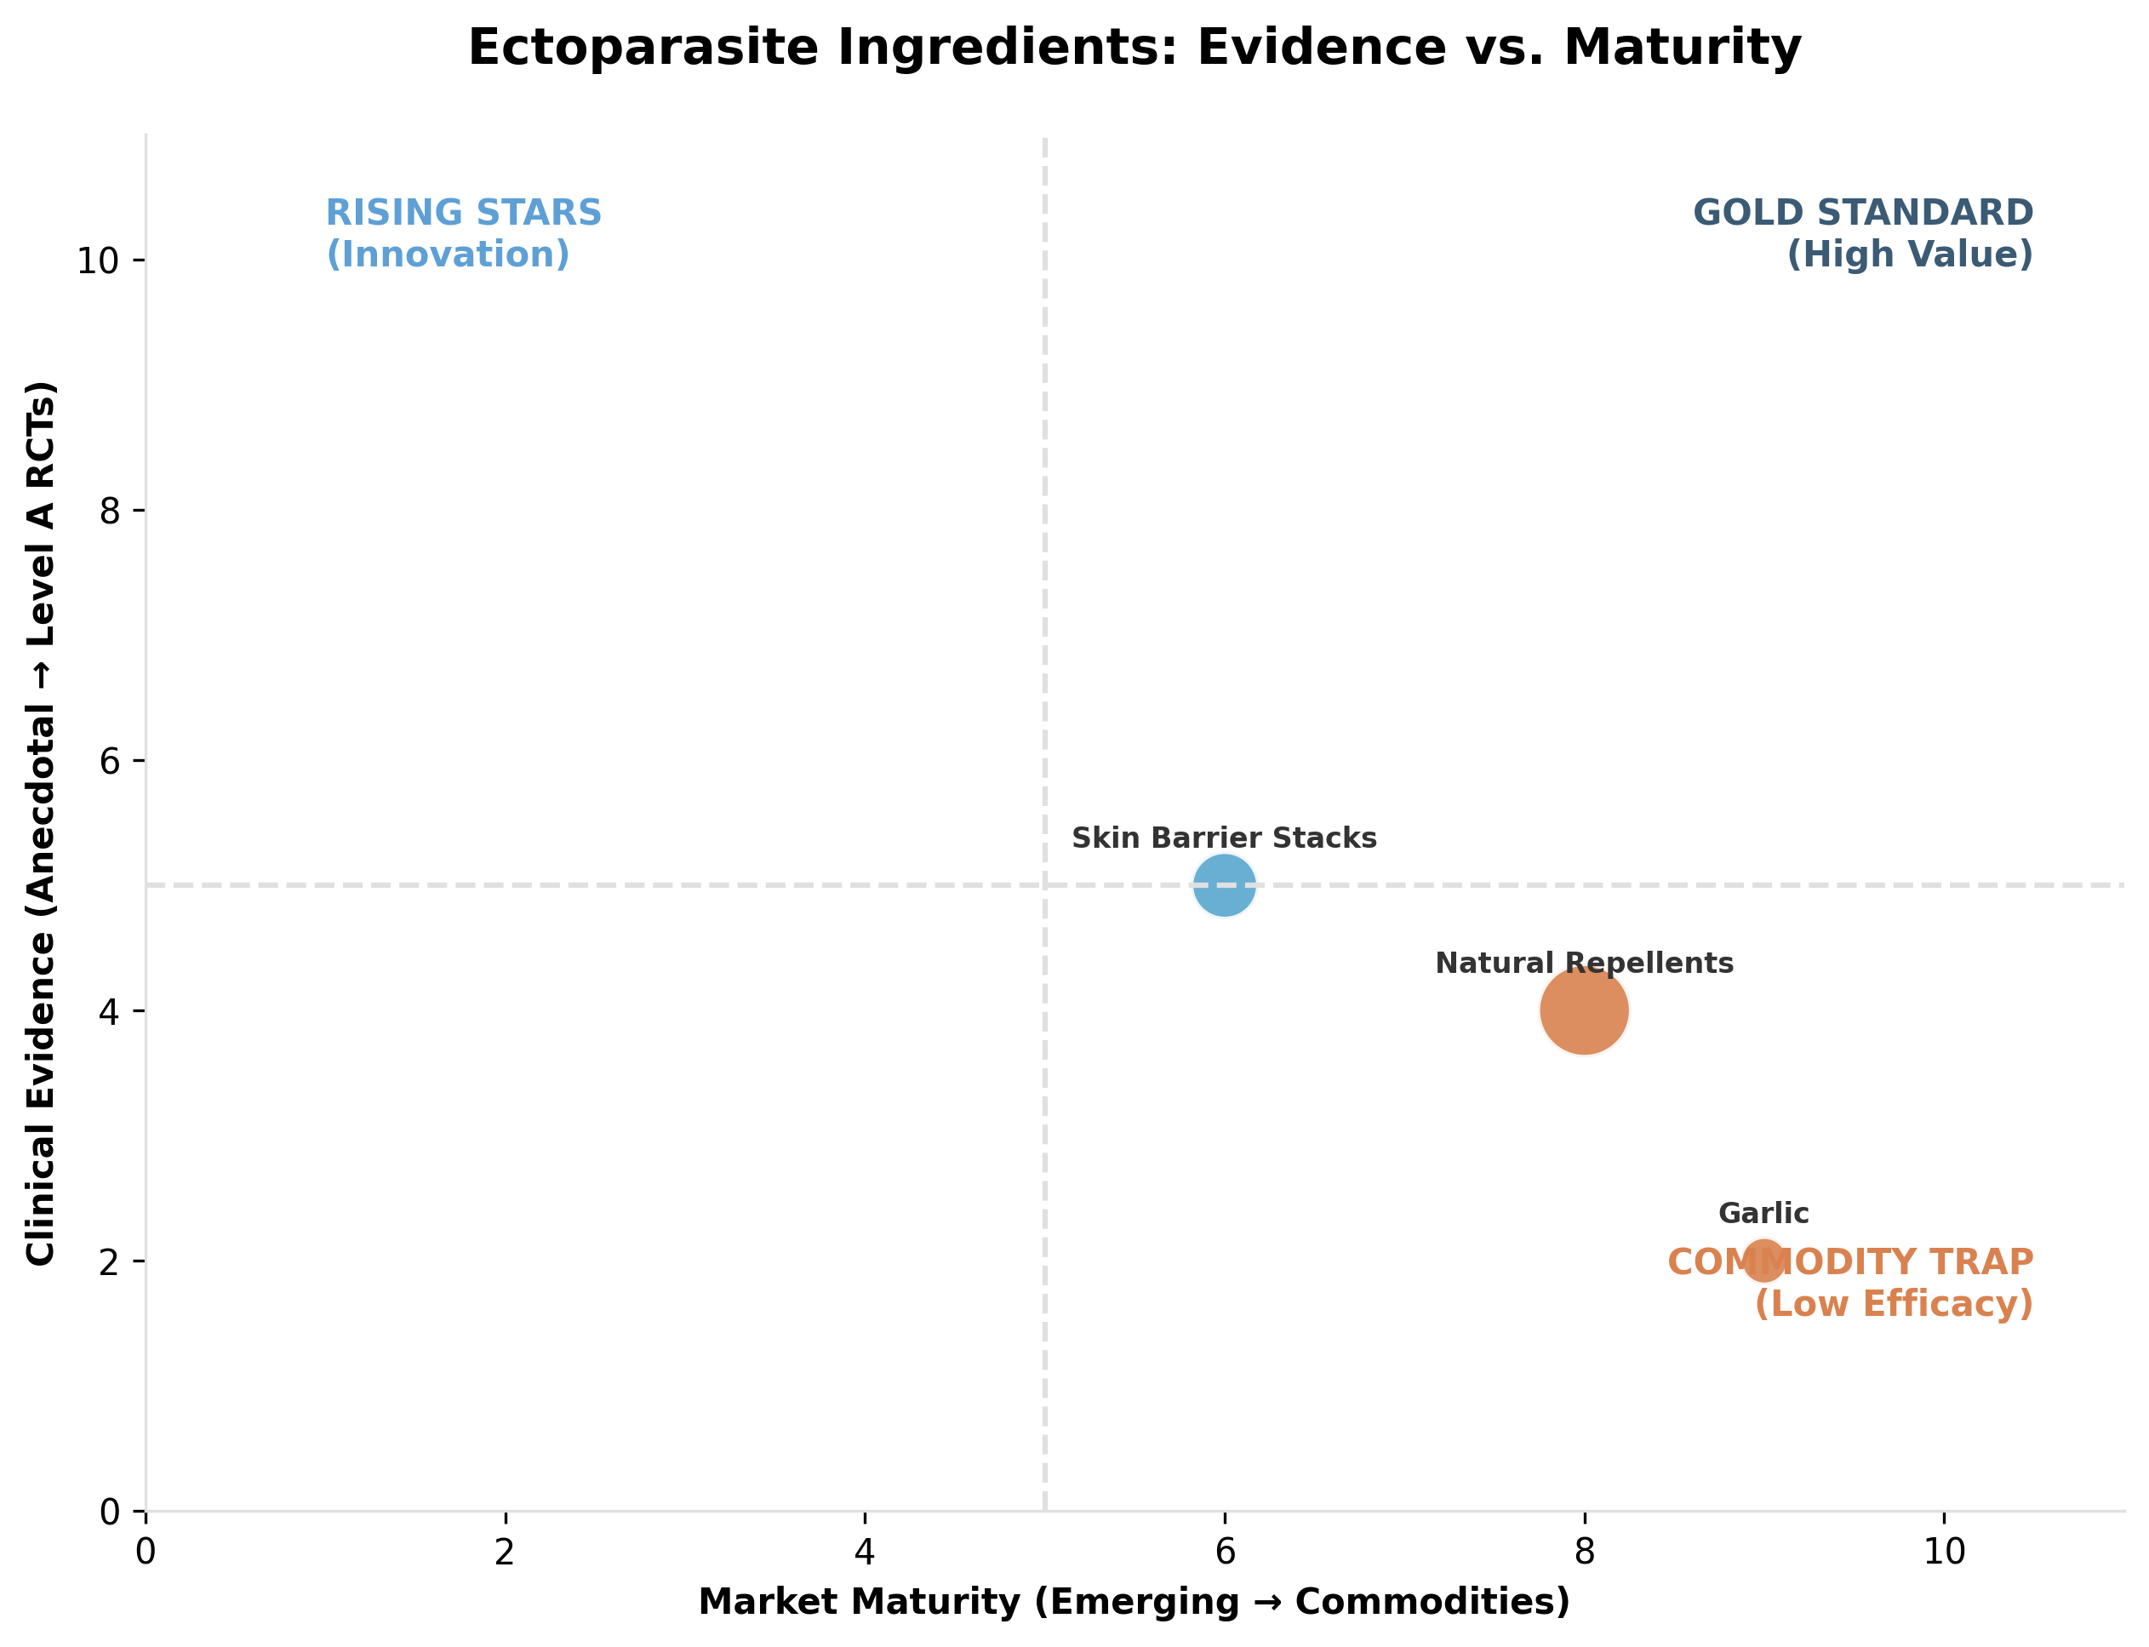 *Figure II.8: Evidence levels and market positioning of key nutraceutical ingredients (Ectoparasite).* ***[Source: Internal Efficacy Analysis]***

### **Table II.8: Natural Ectoparasite Defense Targets**

| **Component** | **Primary Target** | **Sector** | **Strategy** | **Clinical Validation (Level & Outcome)** | **Est. Value ($M)** |
| --- | --- | --- | --- | --- | --- |
| **Natural Repellents** | Dogs | Pet | Isoxazoline Alt (**Farnam**) | **Level C**: Efficacy variable; high safety appeal. (Robinson, 2025) | $133M |
| **Garlic/Botanicals** | Pets | Pet | Natural Claims | **Level C**: Weak efficacy; safety concerns at high dose. | $10M |
| **Skin Barrier Stacks** | Dogs (Flea Allergy) | Pet | Adjunct Support | **Level C**: Defensible for dermatitis; weak for control. | $36M |

### **II.9. Nutrigenomics and Systemic Prevention (Species: Multi-Species)**

**Nutrigenomics ($3.5B)** differentiates ingredients via gene-expression data. **Gut Infrastructure** ($526M) and **Biomarker Substantiation** ($148M) create defensible validation for non-patentable IP.

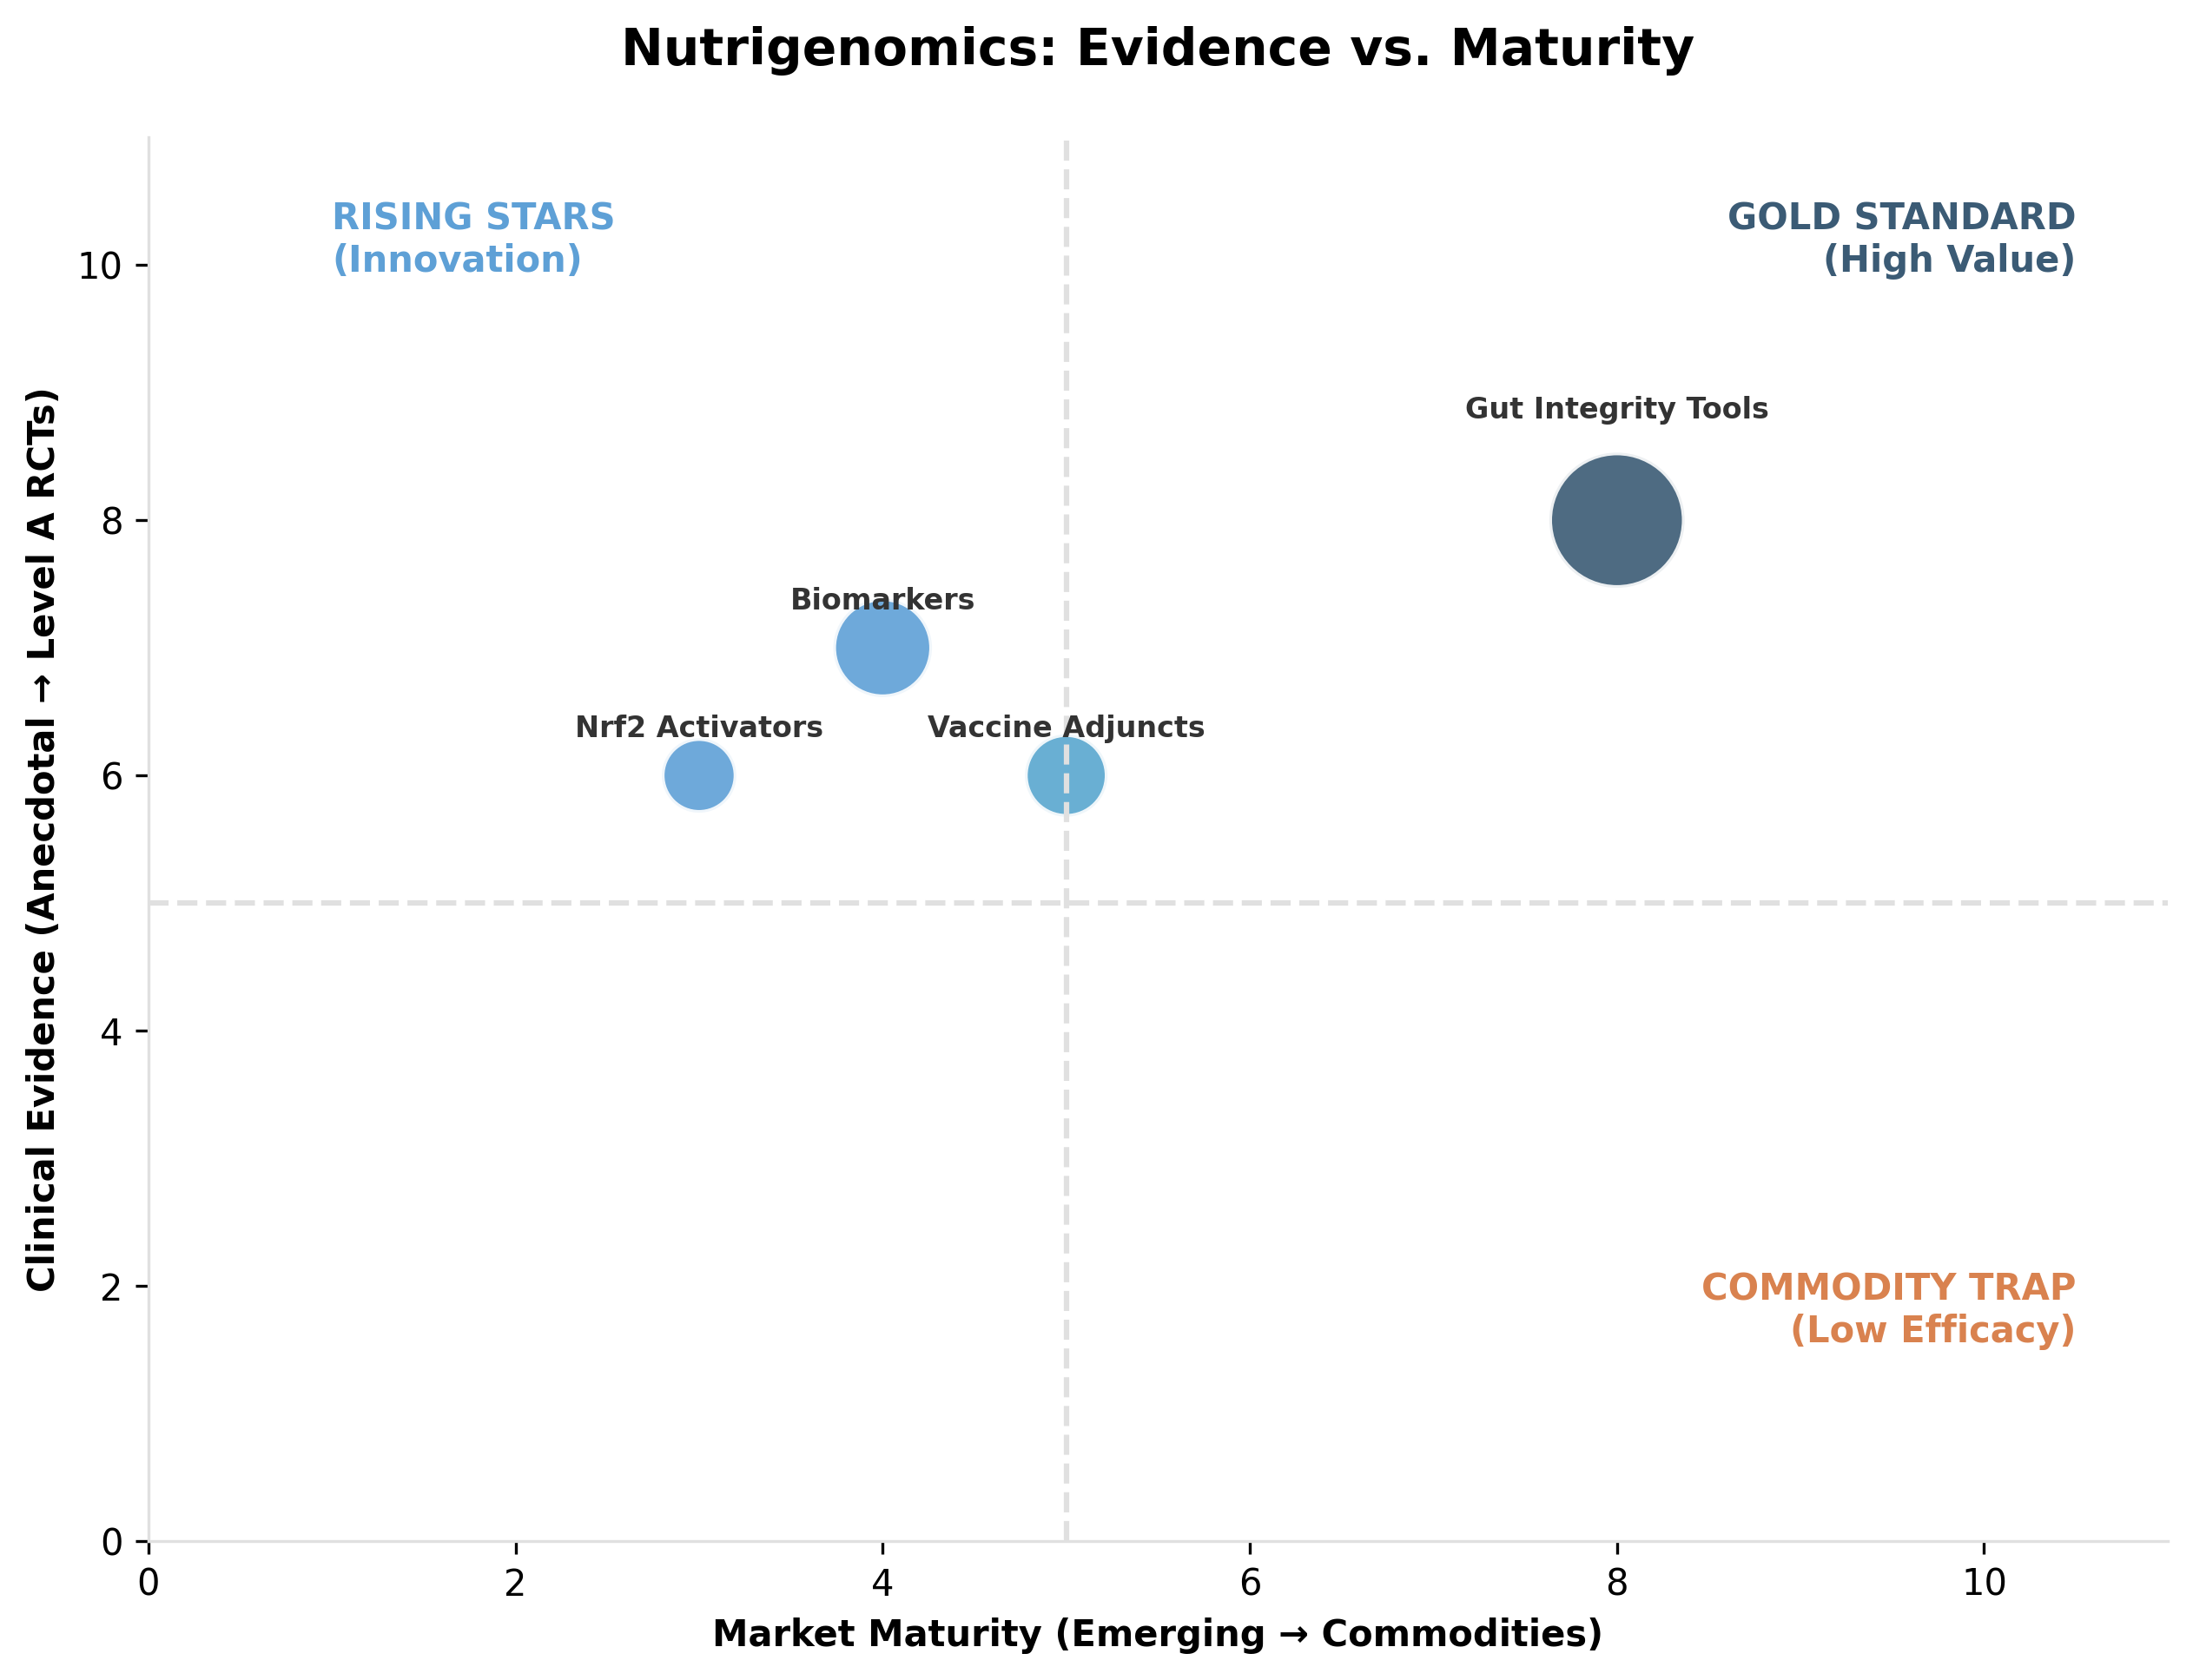 *Figure II.9: Evidence levels and market positioning of key nutraceutical ingredients (Nutrigenomics).* ***[Source: Internal Efficacy Analysis]***

### **Table II.9: Nutrigenomics Targets**

| **Strategy** | **Sector** | **Role** | **Validation** | **Est. Value ($M)** |
| --- | --- | --- | --- | --- |
| **Biomarker Substantiation** | Multi | Substantiation | **Level B**: Creates defensibility for non-patentable IP. | $148M |
| **Nrf2 Activators** | Multi | Mechanism | **Level B/C**: Mechanistically strong; species data needed. | $48M |
| **Gut Infrastructure** | Livestock | Antibiotic Alt. | **Level A/B**: Strongest where linked to ROI/Health outcomes. | $526M |
| **Vaccine Interaction** | Livestock | Adjunct | **Level B/C**: Context-dependent enhancement. | $73M |

This scientific rigor allows companies to sell **biological consistency**, positioning products as a “Blueprint” for predictable production.

### **II.10. Advanced Formulations and Delivery Systems (Species: Multi-Species)**

The **$7.7B Delivery Systems** layer ensures efficacy. **Rumen Protection** ($920M) brings amino acids to livestock, while **Soft Chews** ($593M) drive pet compliance via palatability.

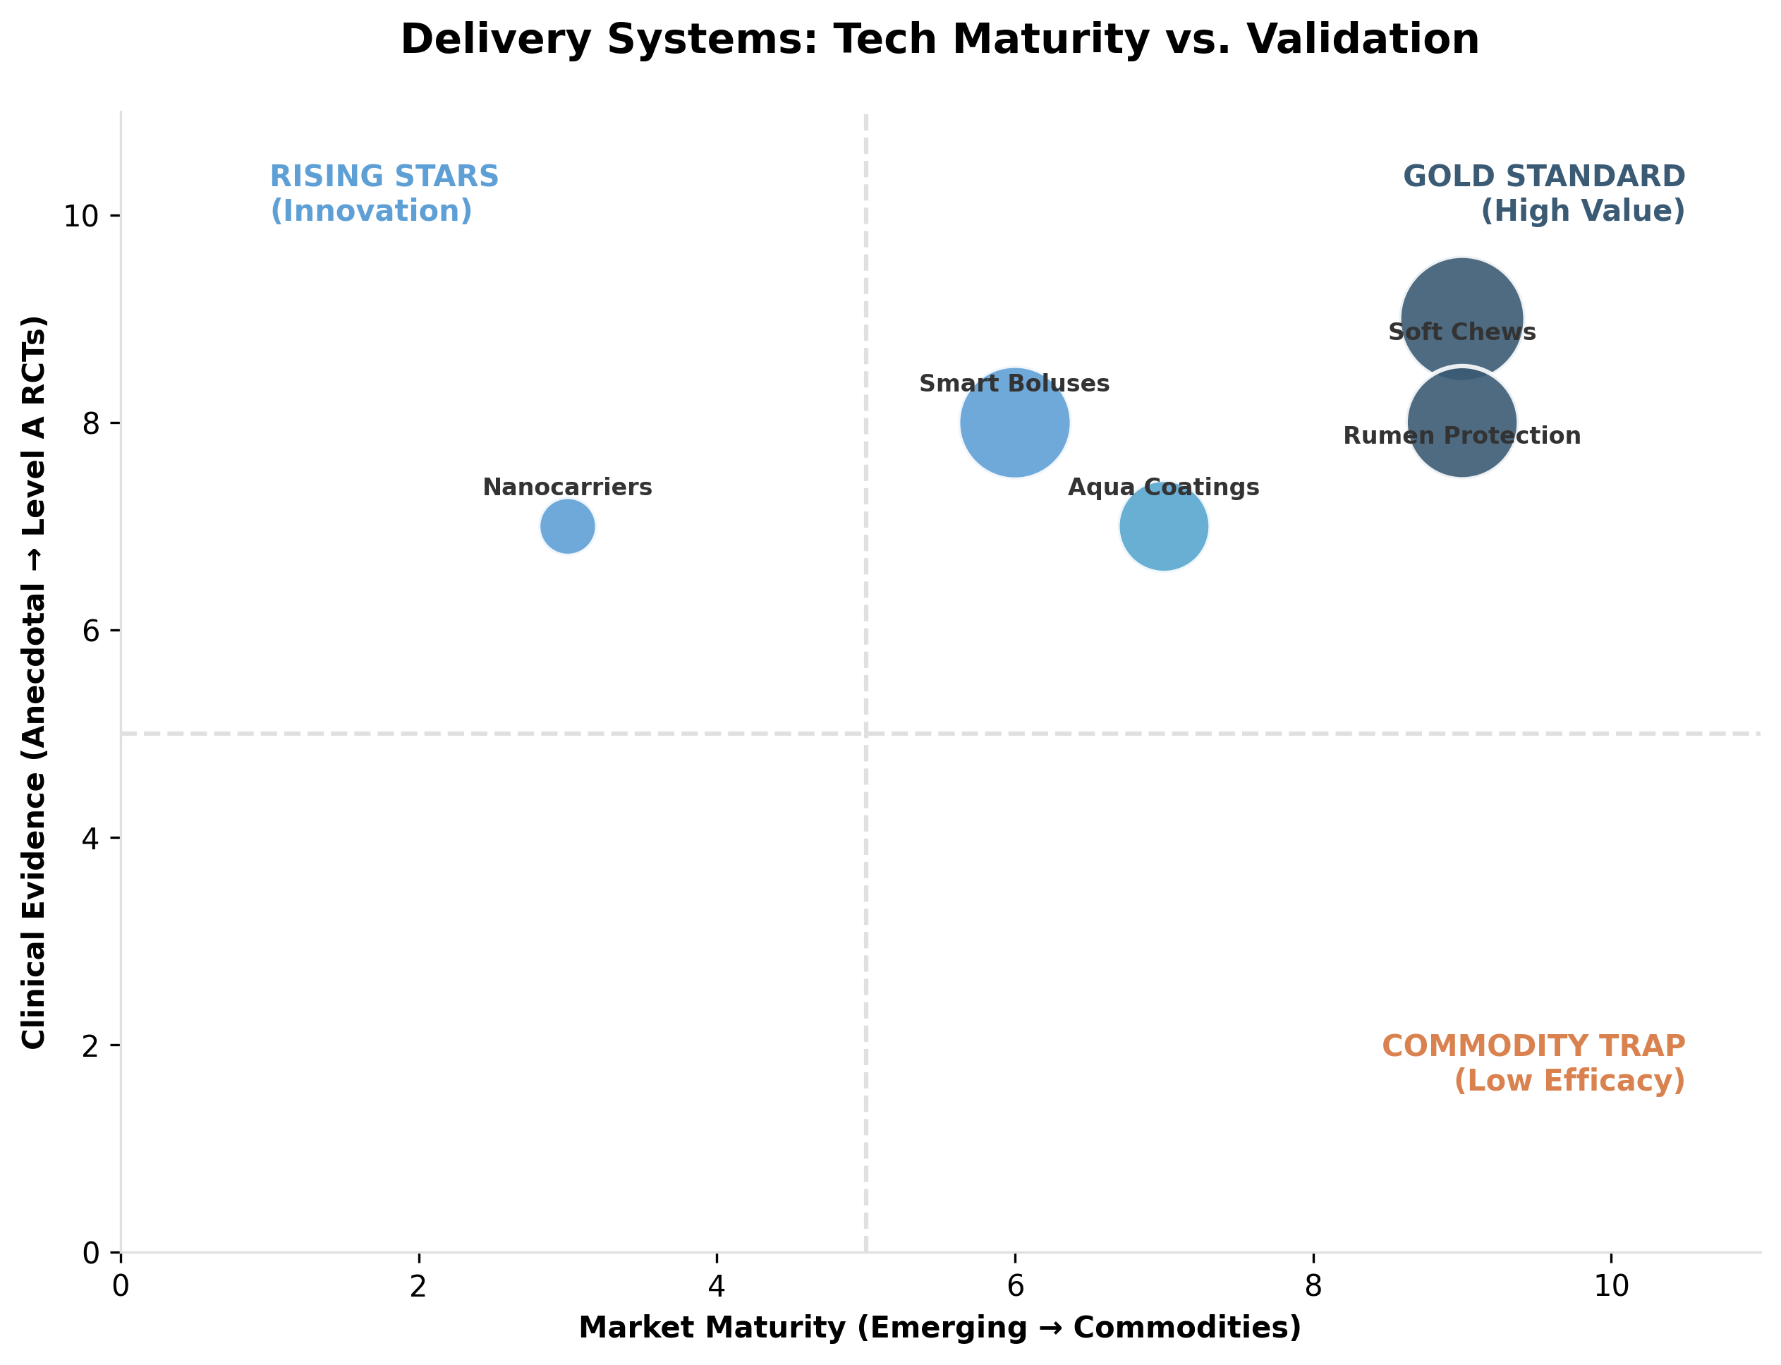 *Figure II.10: Technology maturity vs. Validation (Delivery Systems).* ***[Source: Internal Technology Audit]***

### **Table II.10: Advanced Delivery Systems**

| **Technology** | **Primary Target** | **Sector** | **Problem Solved** | **Validation (Level)** | **Est. Value ($M)** |
| --- | --- | --- | --- | --- | --- |
| **Top Dress/Powders** | Horses, Dogs | Pet | Dosing Routine | **Level B**: High practical relevance. | $73M |
| **Nanocarriers** | Poultry, Aqua | Livestock | Bioavailability | **Level B**: 85% absorption vs 15% raw. | $44M |
| **Rumen Protection** | Cattle | Livestock | Rumen Bypass | **Level B**: Mature technology for Amino Acids. | $920M |
| **Smart Boluses** | Cattle | Livestock | Monitoring | **Level B**: Enables individual precision. | $625M |
| **Soft Chews** | Dogs, Cats | Pet | Compliance | **Level A**: Critical for palatability/retention. | $593M |
| **3D Printlets** | Horses, Senior | Pet | Polypharmacy | **Emerging**: High LTV customization. | $29M |
| **Aquafeed Coatings** | Fish/Shrimp | Aqua | Leaching | **Level B**: Essential for water stability. | $271M |
| **Biofilm Probiotics** | Dogs, Poultry | Multi | Stability | **Level B**: 92% survival vs <10% in kibble. | $40M |
| **Transdermal Gels** | Cats | Pet | Pill Fatigue | **Level B**: Critical for chronic feline care. | $27M |
| **Bio-Encapsulation** | Aqua (Salmon/Shrimp) | Aqua | Bioavailability | **Level B**: **Biofeyn** uses algal nanocarriers to boost absorption 10x. | $15M |

### **II.11. Sustainability and the “Green Claim” Economy (Species: Livestock)**

The **$3.35B “Green Claim” economy** converts environmental compliance into value. **Nitrogen Efficiency** tools ($545M) and **Phytase** ($155M) lead, with **Methane Mitigation** (3-NOP) emerging as a regulatory essential.

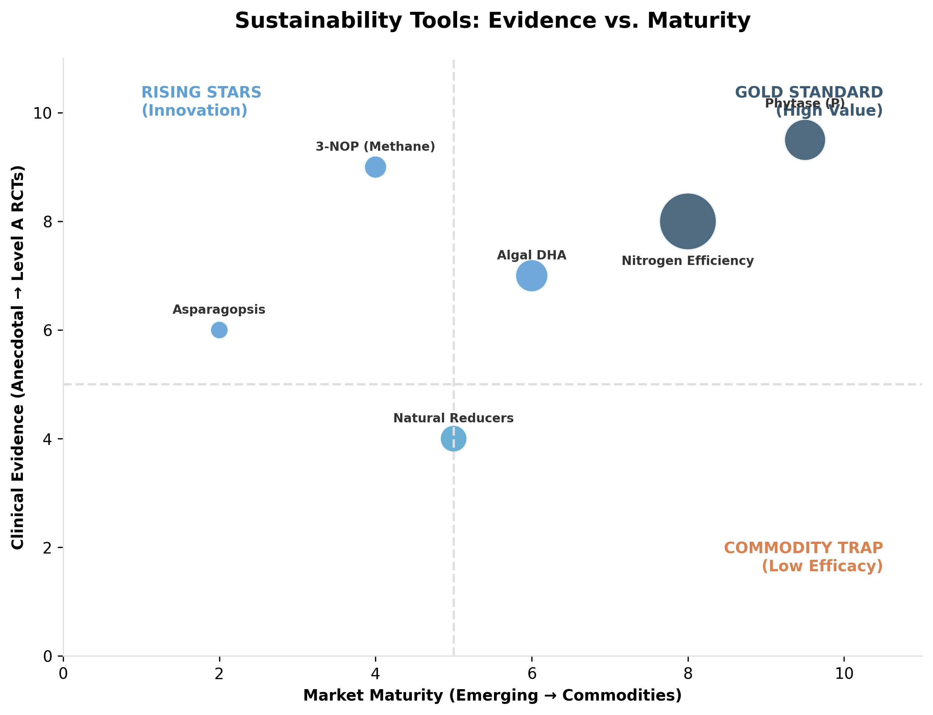 *Figure II.11: Evidence levels and market positioning of key nutraceutical ingredients (Sustainability).* ***[Source: Internal Efficacy Analysis]***

### **Table II.11: Sustainability and Green Claim Targets**

| **Strategy** | **Species** | **Agent** | **KPI** | **Validation** | **Est. Value ($M)** |
| --- | --- | --- | --- | --- | --- |
| **Methane Mitigation** | Ruminants | Asparagopsis | Methane Red. | **Level B**: Large reductions (>80%); scale gating. | $6M |
| **Methane Mitigation** | Ruminants | 3-NOP | Methane Red. | **Level A/B**: Consistent ~30% reduction. | $15M |
| **Natural Reducers** | Ruminants | Tannins | Methane Red. | **Level B/C**: Smaller reductions; practical. | $29M |
| **P-Management** | Poultry/Swine | Phytase | P-Excretion | **Level A**: Established standard. | $155M |
| **N-Efficiency** | Poultry | Protease | N-Excretion | **Level B**: Linked to footpad health/welfare. | $545M |
| **Supply Chain** | Aqua/Pet | Algal DHA | Sustainability | **Level B**: Strategic risk reduction (Fish-In/Fish-Out). | $61M |

### **II.12. Comparative Market Impact**

The following figure summarizes the total revenue potential across all functional segments, clearly differentiating between Pet/Companion driven sectors and Livestock/Efficiency markets.

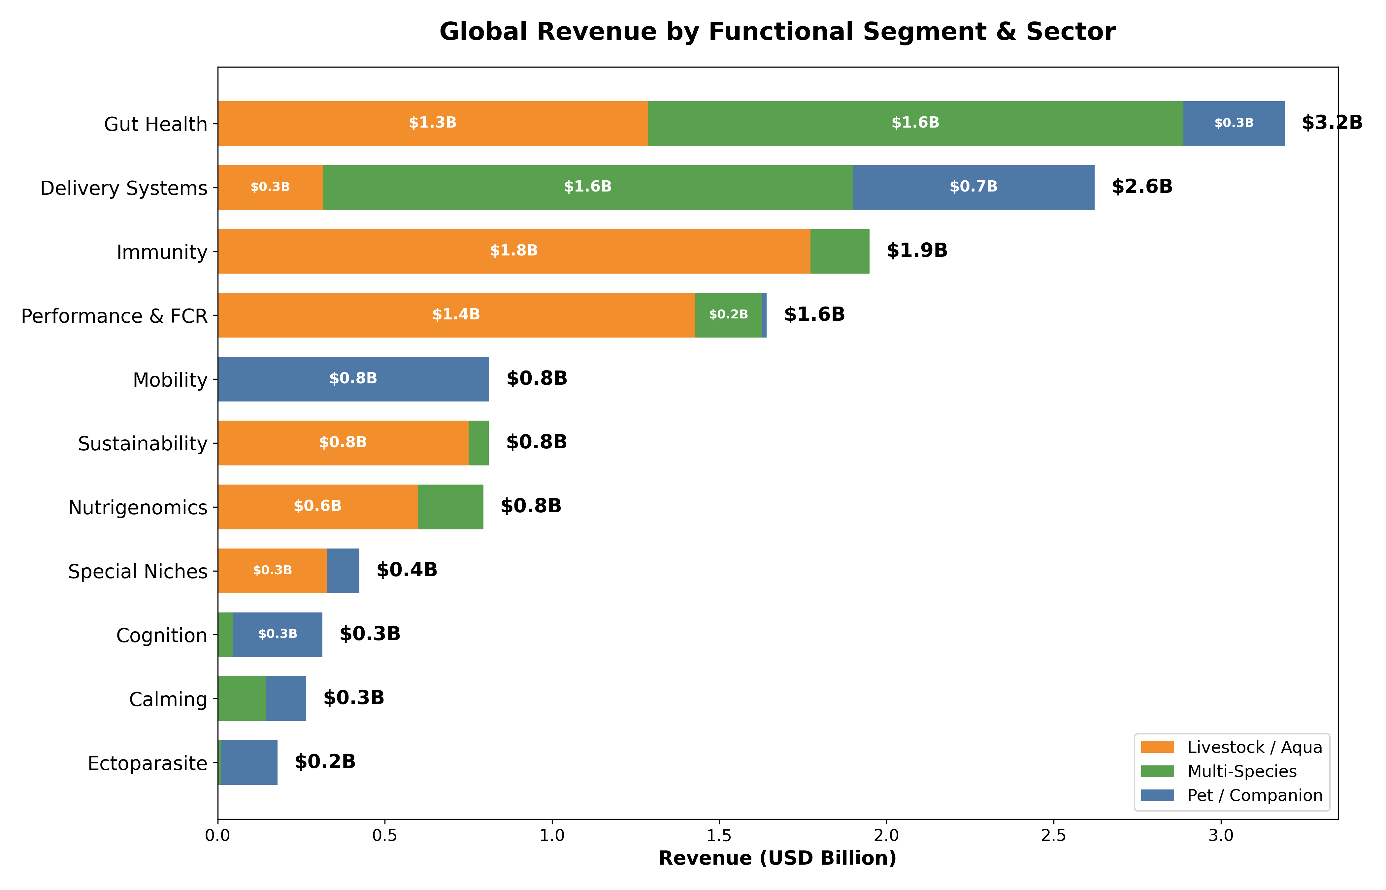 *Figure II.12: Comparative Economic Value of Functional Segments (Billions USD), differentiated by Primary Sector.* ***[Source: Internal Market Sizing Model]***

### **II.13. Ingredient Market Share**

The following breakdown illustrates the dominance of specific “Power Ingredients” within each functional category.

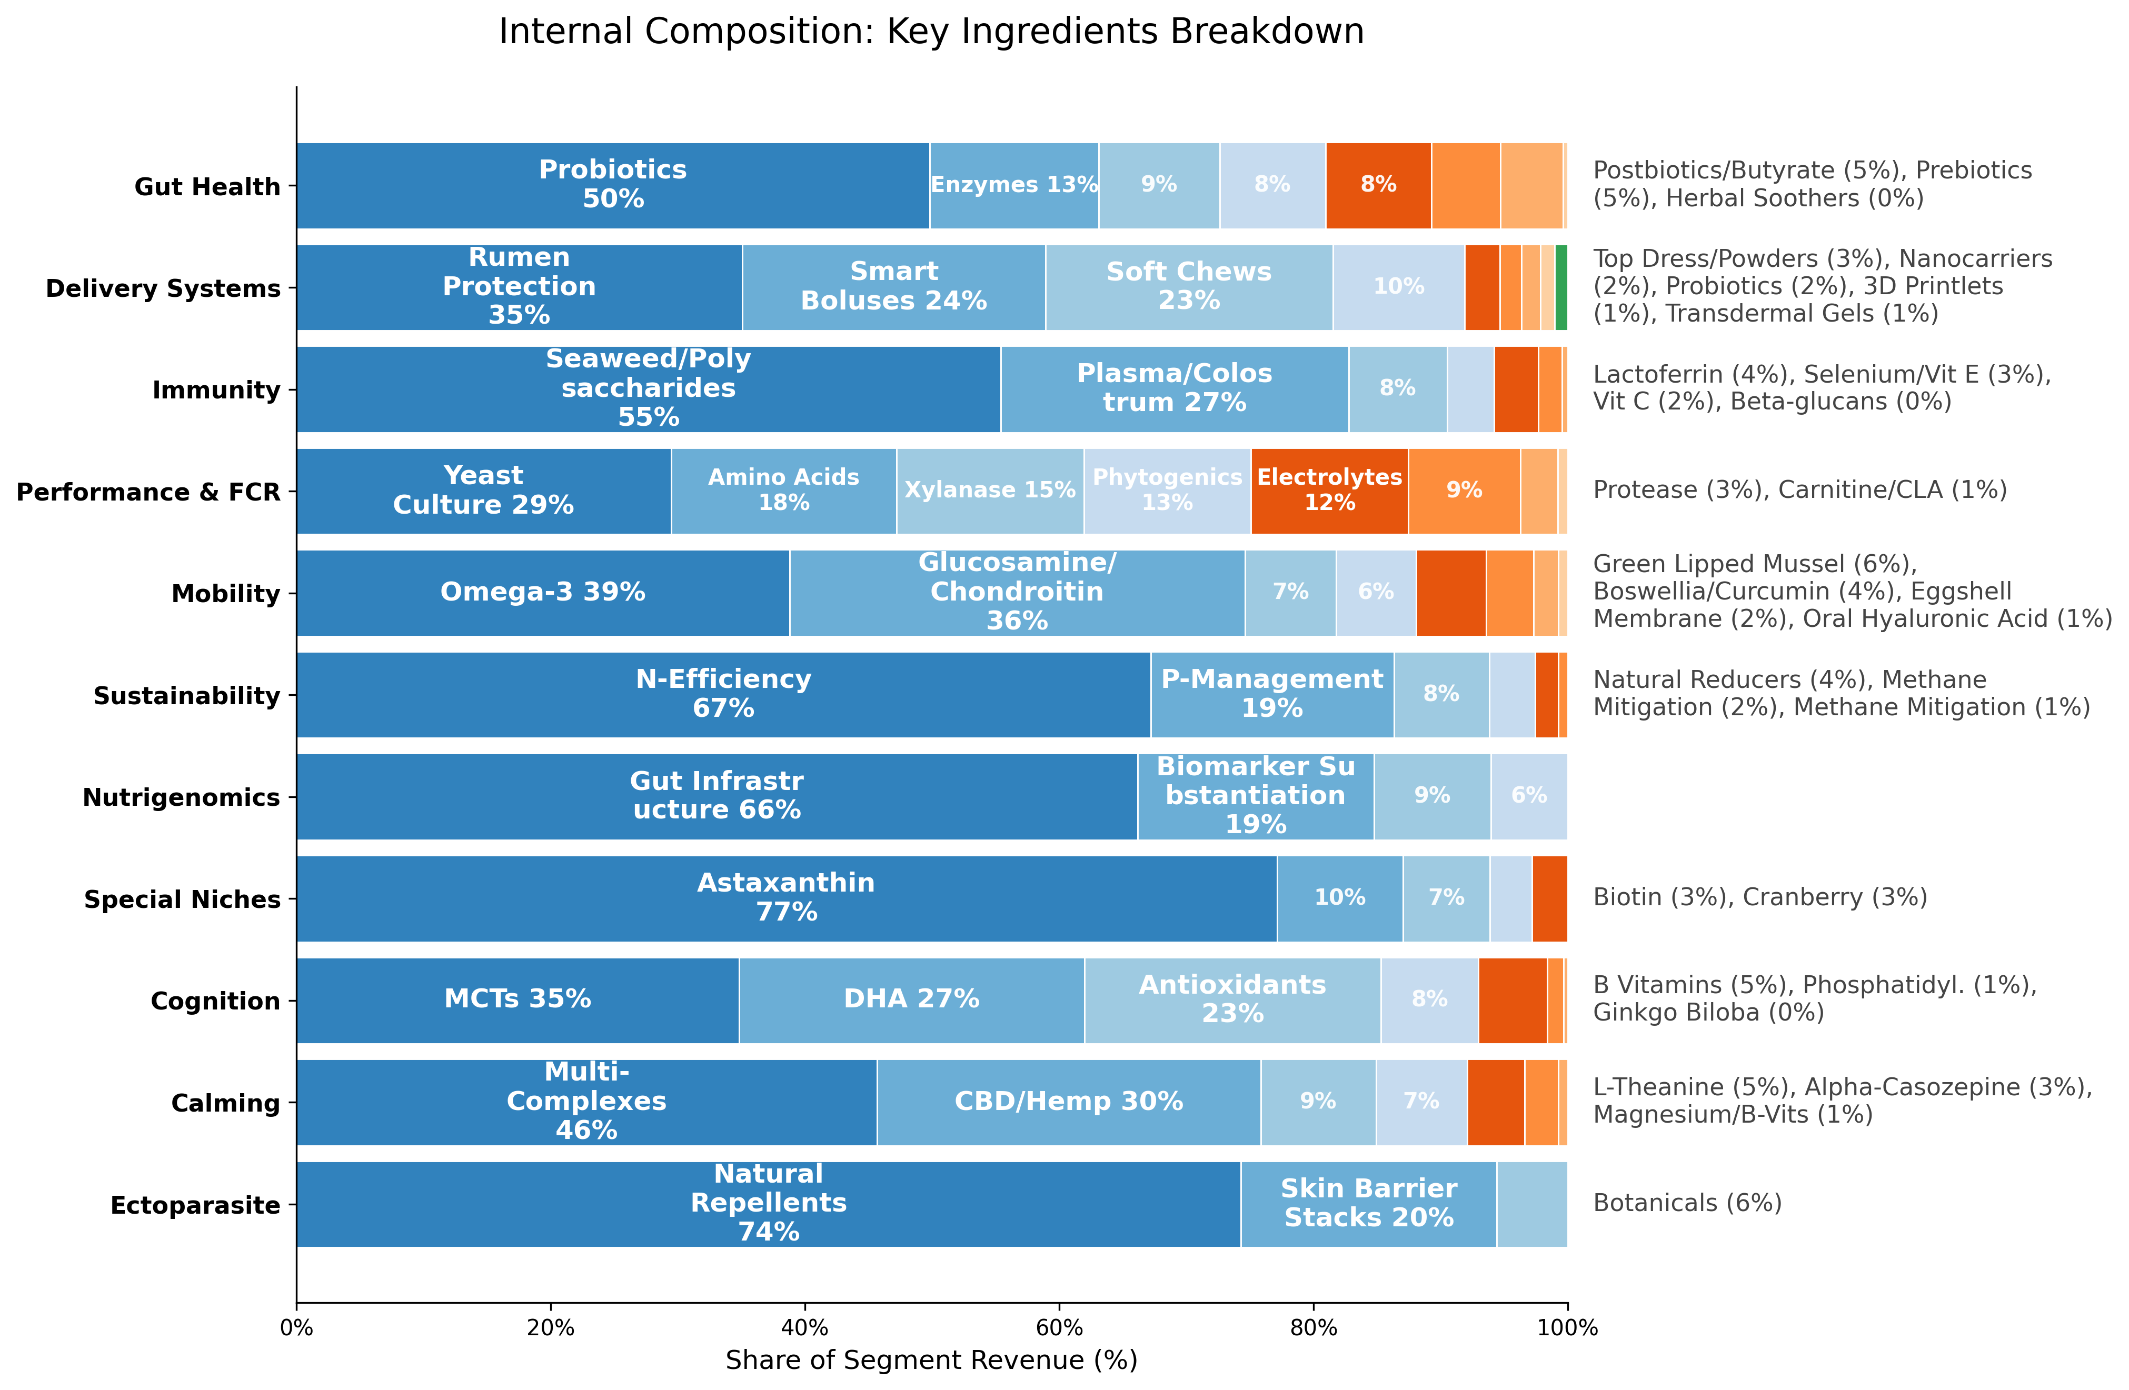 *Figure II.13: Internal Market Share of Key Ingredients within Each Functional Segment.* ***[Source: Internal Market Sizing Model]***

### **Conclusion of Part II: The Shift to Precision**

This mapping demonstrates a shift from “General Nutrition” to “Precision Intervention.” Winning categories solve specific biological problems with measurable outcomes. However, technology needs a business model. **Part III** will stress-test these segments against the “Two-Speed” economic reality of Pet vs. Livestock.

## **III. Market Structure and Value Capture**

***In this section:*** *We quantify the “Two-Speed” market dynamic—contrasting the volume-driven livestock sector with the value-driven pet economy. Key analysis includes the “Great Divergence” in herd demographics and the “Palatability Premium” in companion animal formats.*

### **III.1. Global Animal Demographics and Trends: Sizing the Opportunity**

**Methodology Note:**

* **Dual-Sourcing Strategy:** Triangulates top-down official data (Eurostat, USDA) with bottom-up revenue aggregation from public leaders (Zoetis, DSM).
* **Data Integrity:** Prioritizes Tier 1 primary sources (10-Ks, regulatory filings) over secondary intelligence.
* **Forecasting Model:** Corrects for post-pandemic pet adoption normalization and EU herd contraction policies.

The global animal health market is undergoing a **profound structural shift** characterized by a **“two-speed” dynamic**, creating distinct economic opportunities.

**Market Valuations at a Glance:**

* **Global Pet & Animal Health Market:** Valued at **~USD 123.8 billion** in 2025, projected to reach **USD 200.4 billion by 2034** (CAGR 5.5%).
* **Pet Nutraceuticals (High-Growth):** Valued at **USD 5.84–6.22 billion** (2024–2025), forecast to reach **USD 8.42–10.5 billion** by 2030–2035 (CAGR 6.4–7.6%).
* **Livestock Probiotics & Additives:** Valued at **USD 7–8 billion** presently, expanding toward **USD 10–14 billion** by the early 2030s (CAGR 6–8%).

**The Bifurcation:** These markets reflect fundamentally different value drivers:

* **Companion Animals (Pets):** The **“pet humanization”** trend drives a structural shift from *volume to value*—owners perceive animals as integral family members, justifying **premium spending** on preventive health and longevity.
* **Livestock and Aquaculture:** Markets navigate the **“Great Divergence”**—a structural contraction in Western herds driven by policy and climate, contrasted with the **relentless expansion** of poultry and aquaculture globally.

#### **III.1.1. Companion Animals (Pets): Regional Dynamics and Market Structure**

**The Global Pet Population and Ownership Landscape**

The global pet population is estimated to exceed **1 billion individual animals**:

* **Developed nations** are prioritizing **longevity and wellness**
* **Emerging markets** are experiencing rapid volume expansion driven by **urbanization** and the **“replacement child” phenomenon**
* **Global pet industry expenditure** reached **USD 136 billion in 2024**, with companion animals accounting for the majority of consumer attention and disposable income

##### **III.1.1.1. North America: The Value Leader**

The United States remains the global bellwether for pet economics and nutraceutical adoption.

**Household Ownership & Demographics:** * **94 million US households** (71%) own pets, confirming “humanization” as a secular trend. * **Species Split:** Cats (49M households) are growing faster (+22%) than dogs (68M), driven by Gen Z and urbanization. * **Gen Z:** Now 20% of pet owners, driving the “multispecies” household trend.

**Market Value:** * **US Pet Supplements:** **$1.1–1.3B (2024)**, projected to reach **$1.4–1.6B by 2030** (CAGR 5.3%). North America holds ~48% of global share.

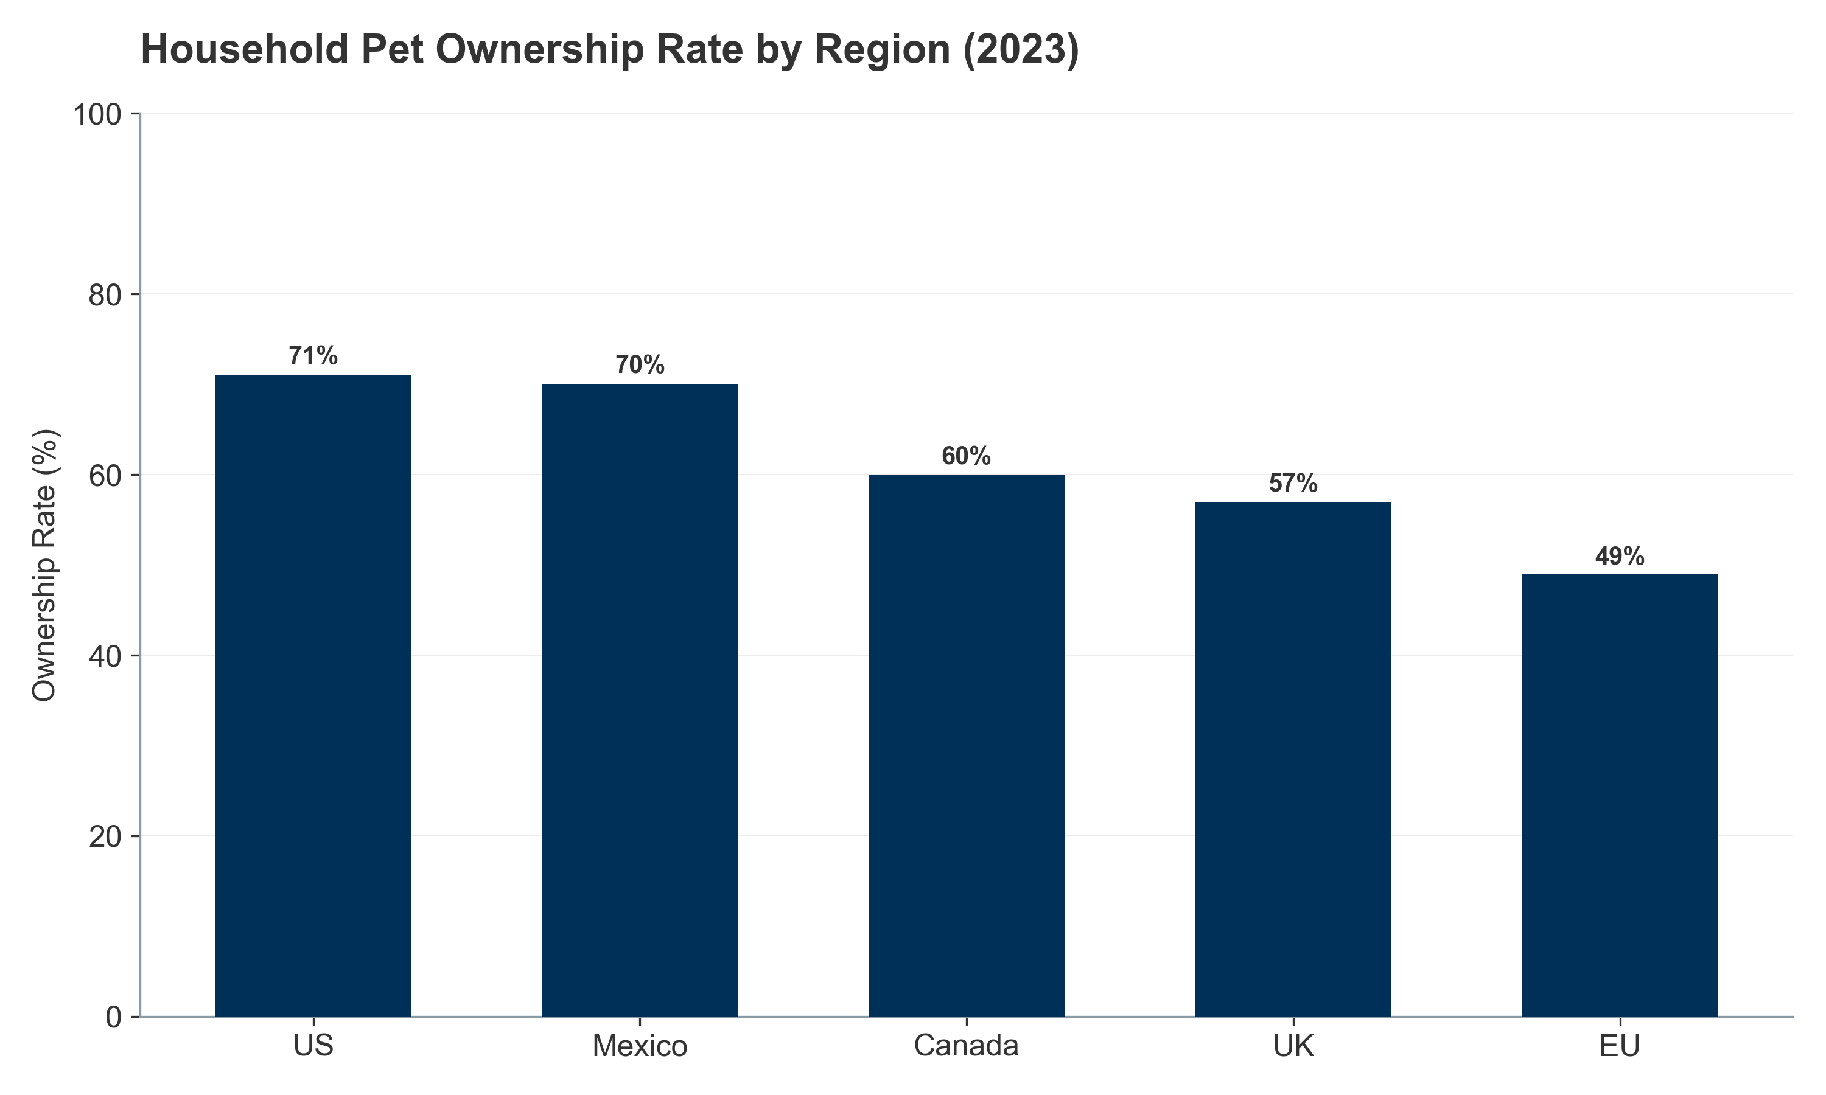 *Figure III.1: Global Pet Ownership Rates by Region (2023).* ***[Source: FEDIAF (2024), APPA (2024)]***

##### **III.1.1.2. European Union: The Cat Continent**

Europe is a cat-dominant market (127M cats vs 104M dogs). Cats represent 45% of the total pet population and grew +11% (2018-2023), outpacing dogs (+5%) due to urban suitability.

**Market Value:** * **EU Nutraceuticals:** **$1.6–1.9B (2024)**. * **Key Markets:** UK ($250-300M), Germany, France. Germany’s wellness focus is a key growth driver.

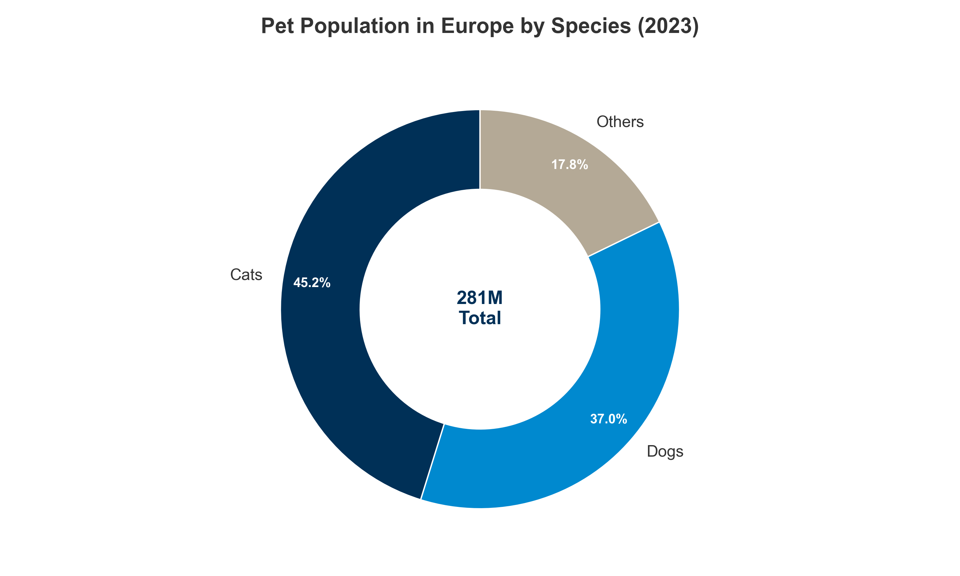 *Figure III.2: European Pet Population Structure: The dominance of cats.* ***[Source: FEDIAF Facts & Figures 2023]***

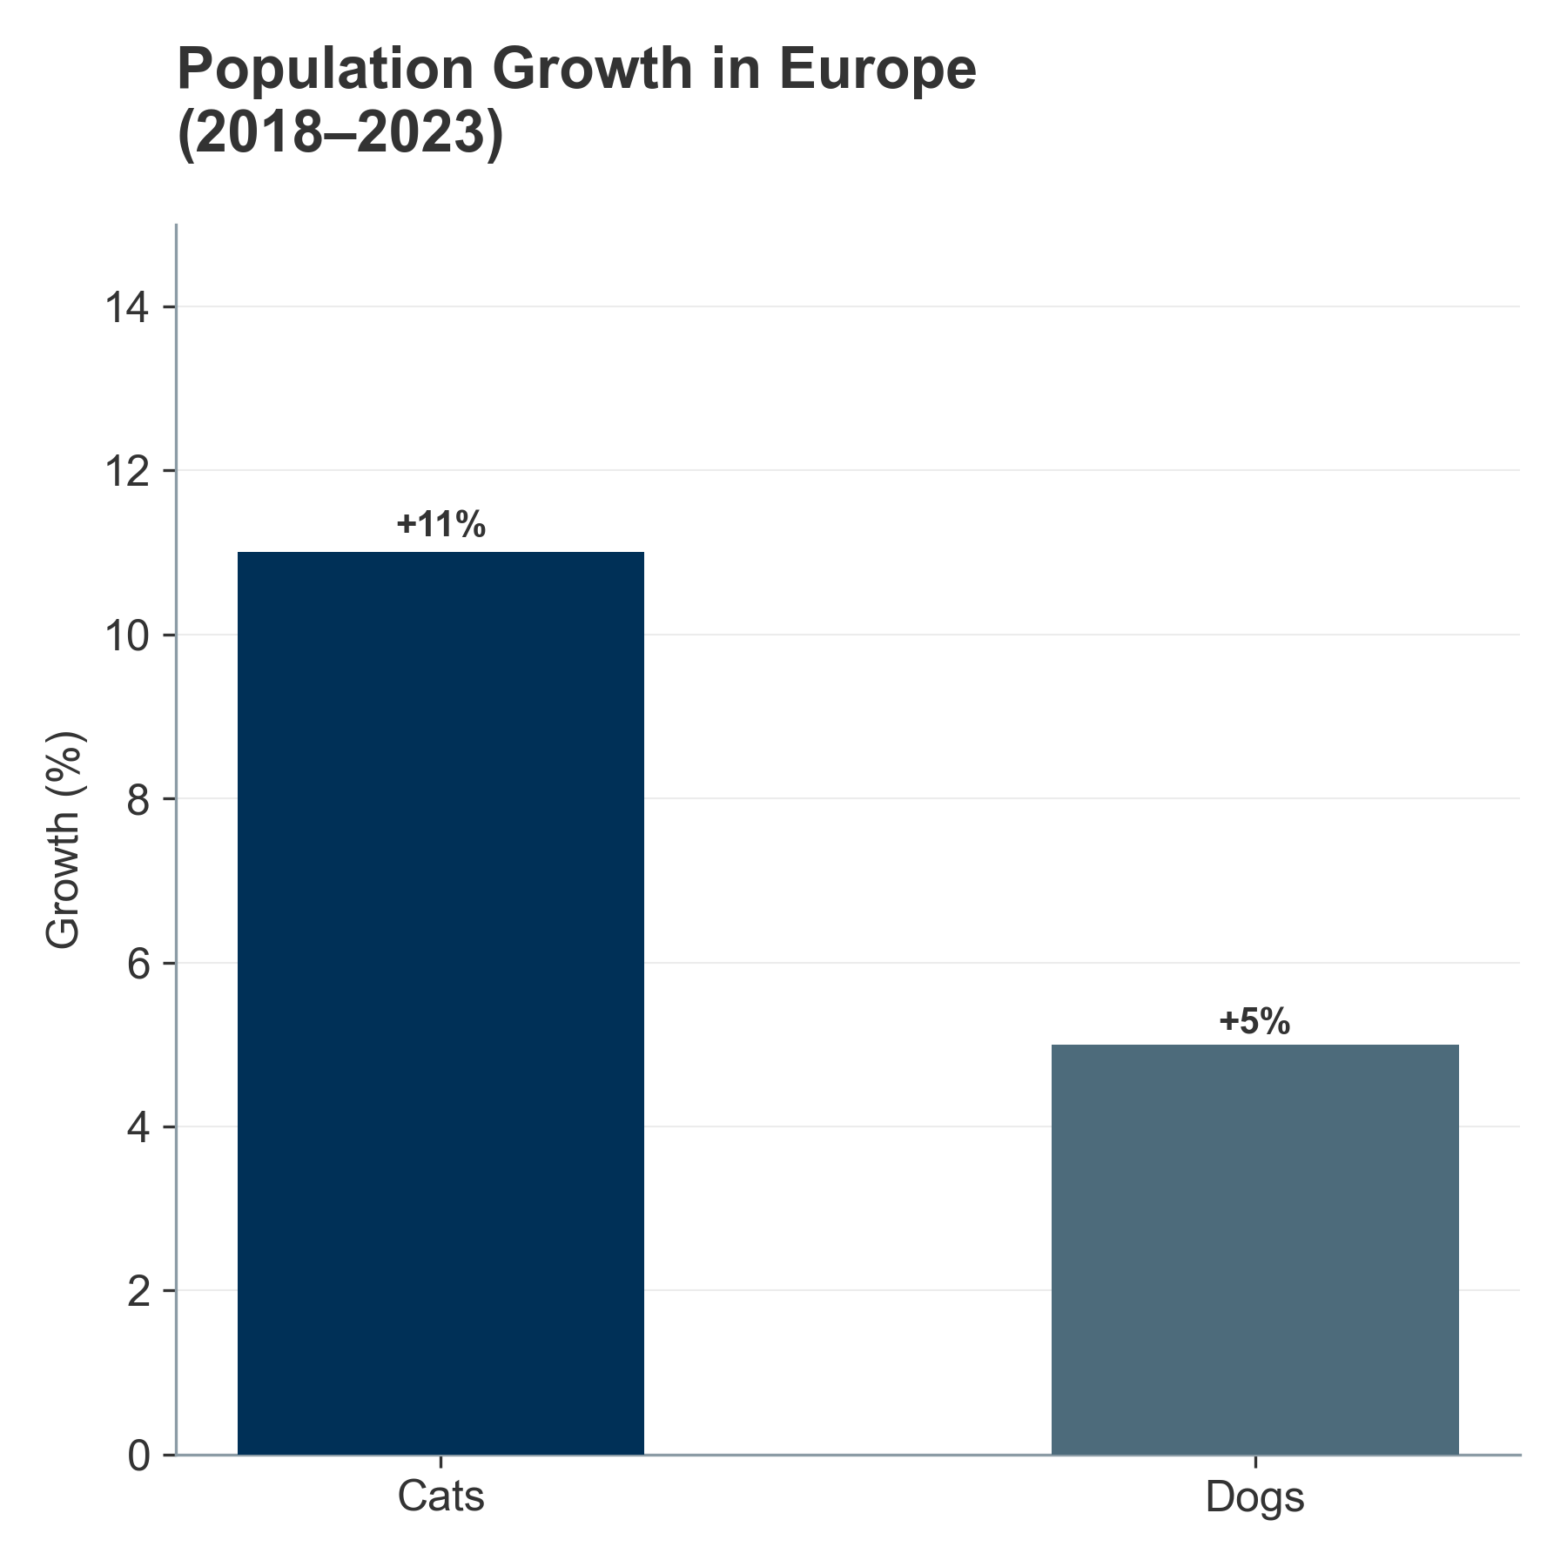 *Figure III.3: Comparative Growth Rates: Cats vs. Dogs (2018-2023).* ***[Source: FEDIAF (2024)]***

##### **III.1.1.3. Asia-Pacific: The Growth Engines**

APAC drives global volume growth via urbanization and rising incomes. * **China:** Cats overtook dogs in 2024 (71.5M vs 52.6M) due to the “996” work culture. Review estimates place the market at **$1.8–2.1B**. * **Latin America:** Brazil (3rd largest market) and Mexico are high-growth engines. * **India:** Fastest growing (**12-15% CAGR**), albeit from a smaller base ($50-80M).

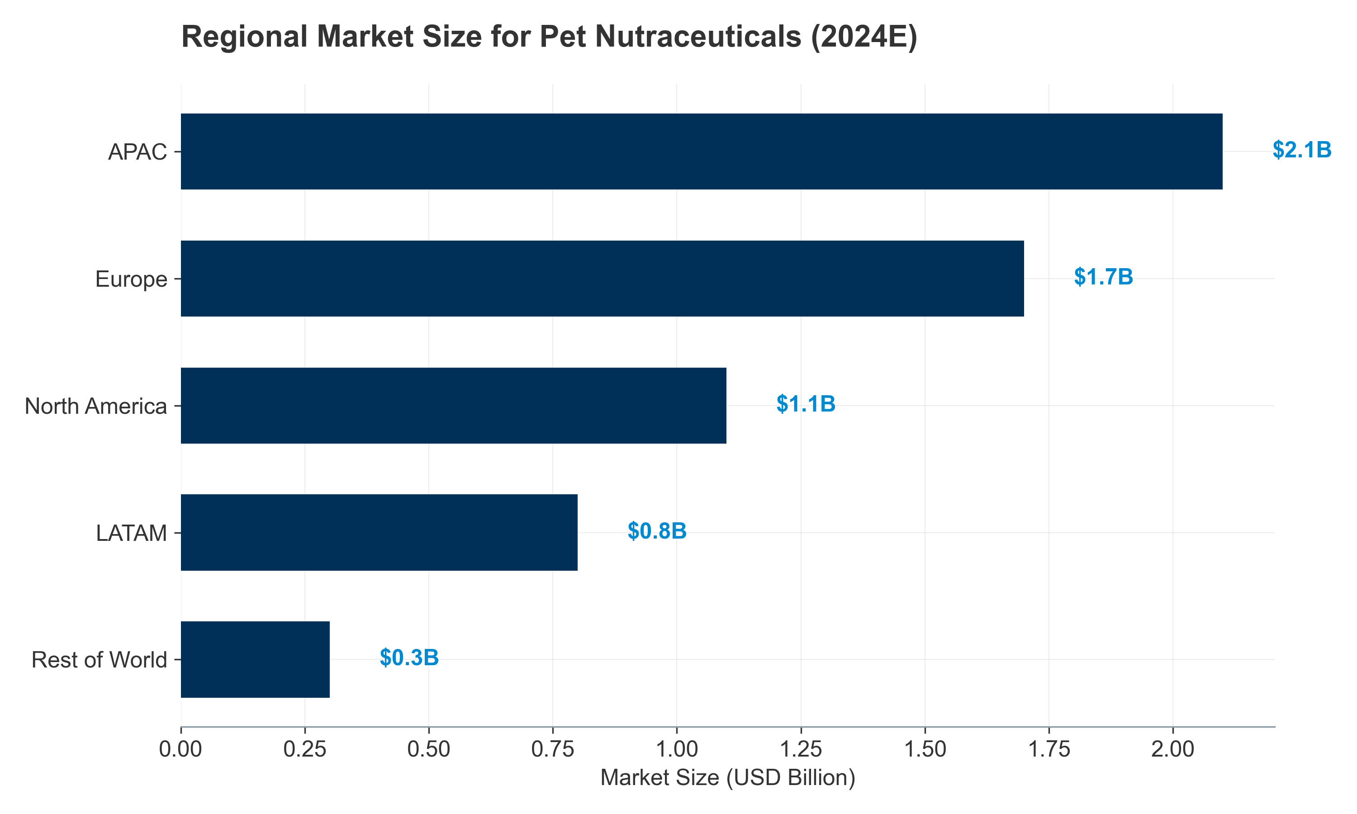 *Figure III.4: Regional Market Value Distribution (2024 Estimates).* ***[Source: Grand View Research (2024)]***

#### **III.1.2. Livestock Headcounts: The “Great Divergence”**

The sector is bifurcated: **Western Contraction** (Policy/Climate) vs. **Global Expansion** (Poultry/Aqua).

**Overview: Species-Level Market Dynamics ($4.1B Probiotics Market)** * **Poultry:** 60% volume share (~$2.5B). * **Swine:** 25% volume share (~$1.0B). * **Ruminants:** 10% share. * **Aquaculture:** 5% share (Fastest growth).

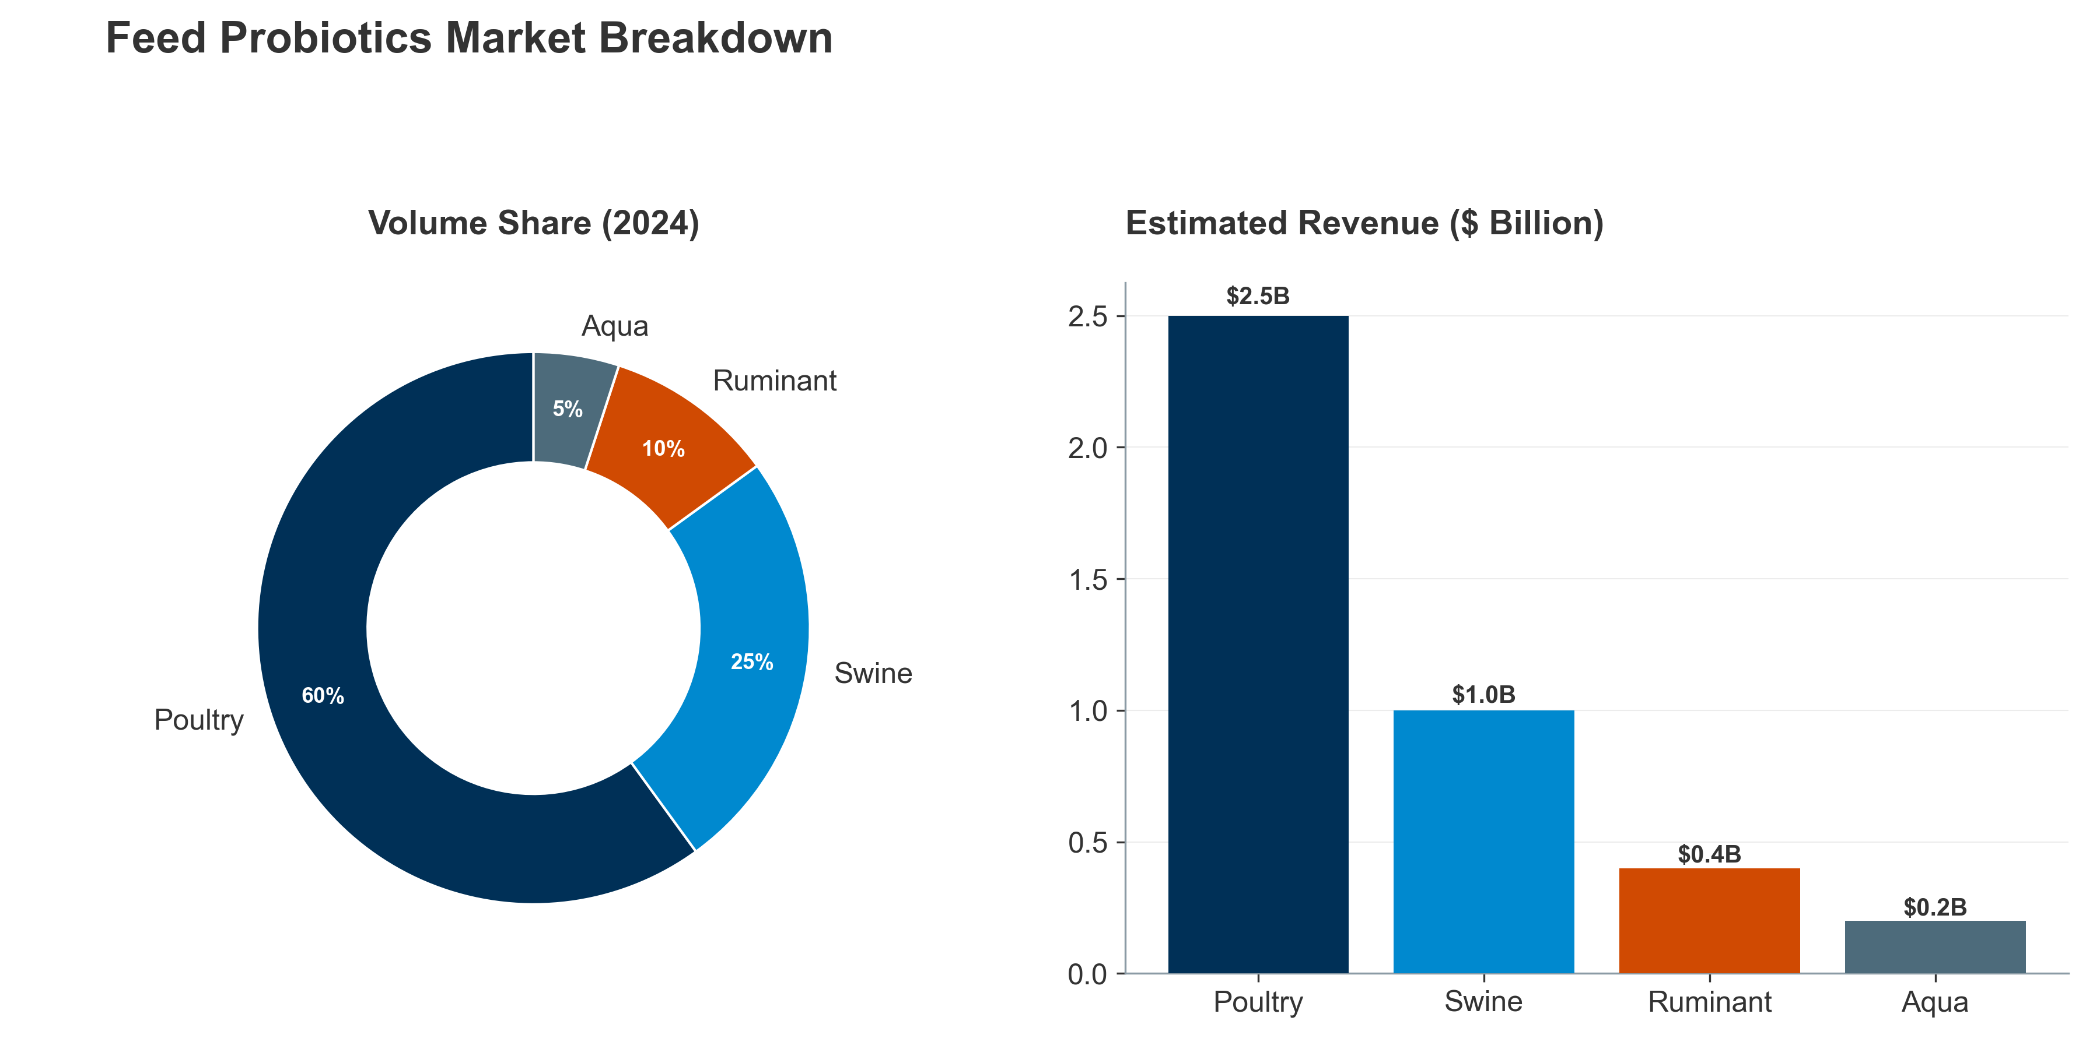 *Figure III.5: Comparative Probiotics Market Share: Volume vs. Revenue.* ***[Source: MarketsandMarkets Animal Nutrition Report 2023]***

**Poultry: The Engine of Growth** Poultry drives global meat production (365M tonnes). The **$6.8B feed additive** segment grows at 5% CAGR, fuelled by Asian demand. However, **HPAI** remains a critical constraint, driving demand for immune-support additives.

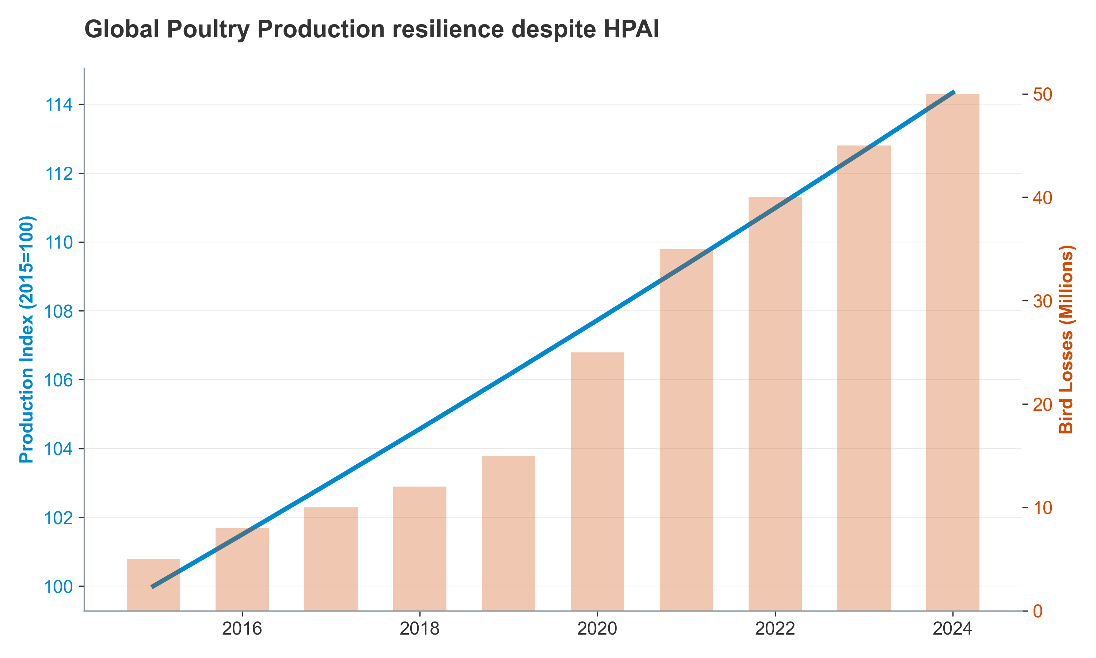 *Figure III.6: The impact of HPAI outbreaks on global poultry production (2015-2024).* ***[Source: WOAH WAHIS Situation Reports]***

**Swine: Structural Contraction vs. Asian Volatility** * **West:** EU/US herds are shrinking (EU -8.1% since 2014) due to regulations and costs. * **Asia:** China’s herd recovered (~405M head) but remains volatile. Vietnam/Thailand are growing. * **Market:** **$4.2B**, growing at 3.5% CAGR.

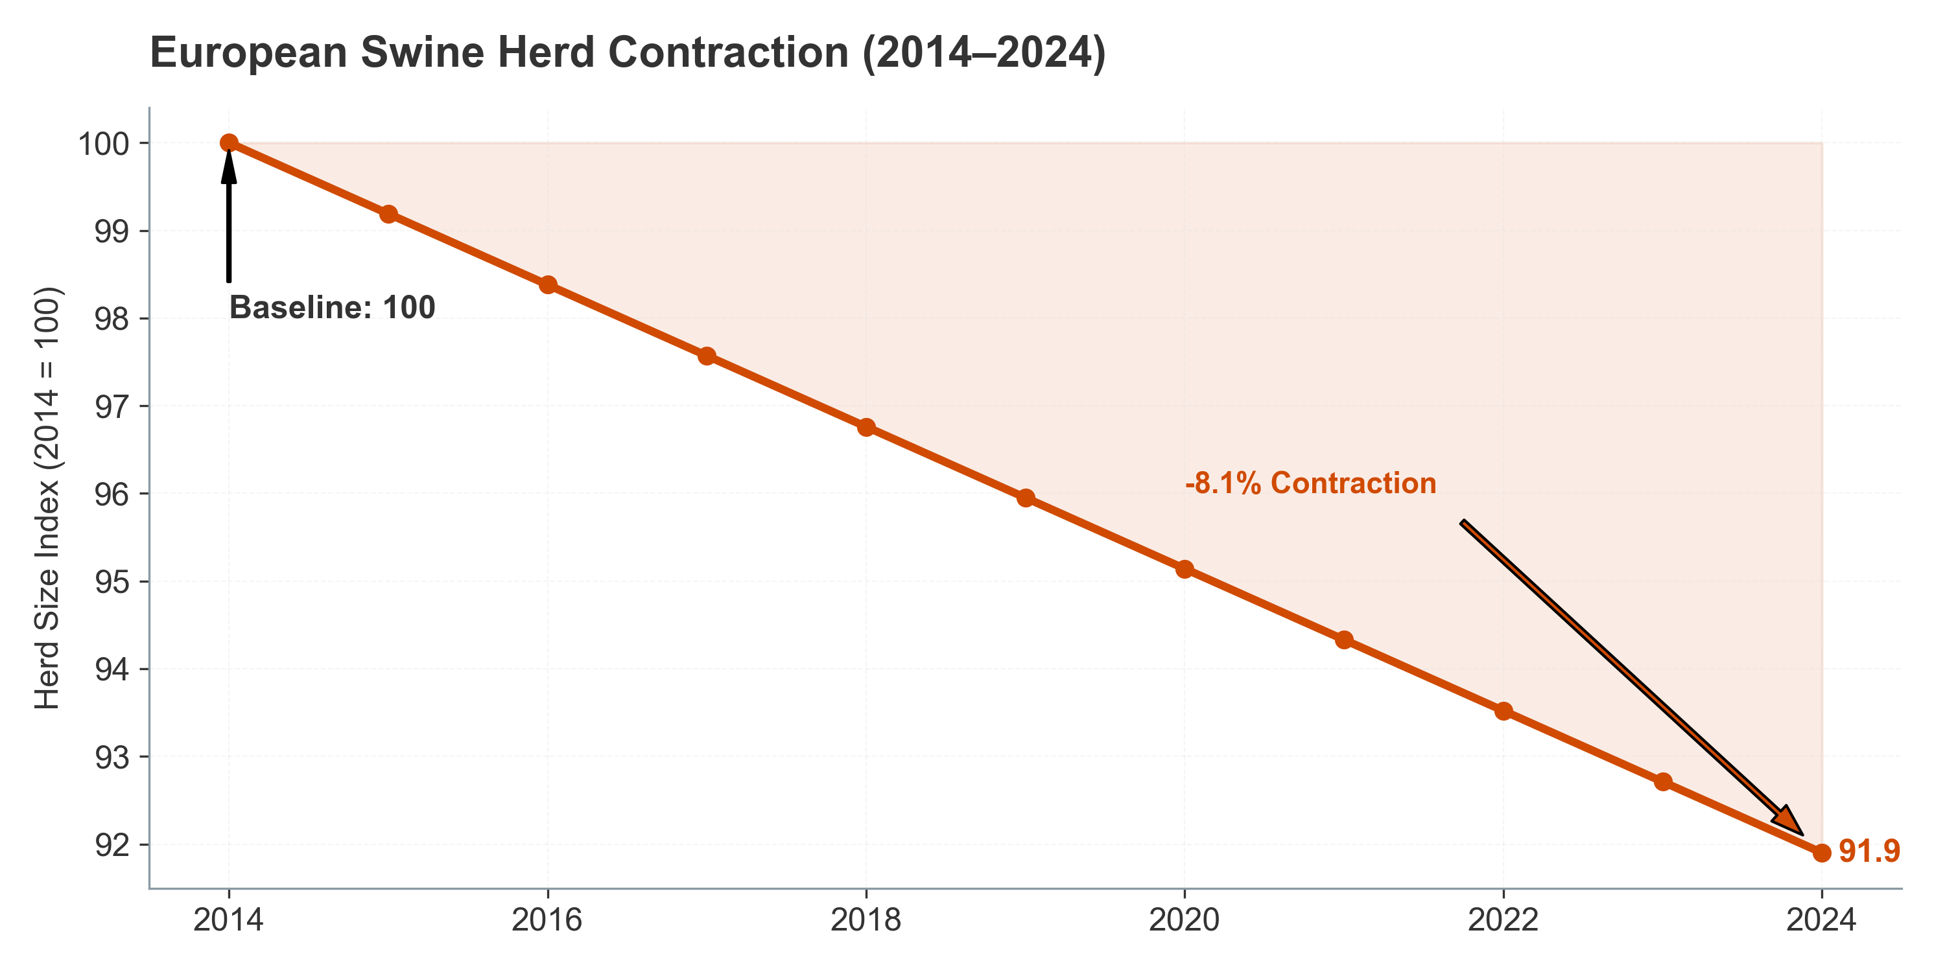 *Figure III.7: Structural decline in EU swine herds driven by regulatory pressure (2014-2024).* ***[Source: Eurostat Livestock Statistics 2024]***

**Cattle: Historic Liquidations** * **US:** Inventory at 73-year low (87.2M head) due to drought/costs. * **EU:** Persistent decline (-8.7% decade) driven by green policies. * **Opportunity:** “De-Ruminization” drives value-per-head strategies—**Methane Reducers** and **Ruminal Efficiency** tools are now essential for profitability.

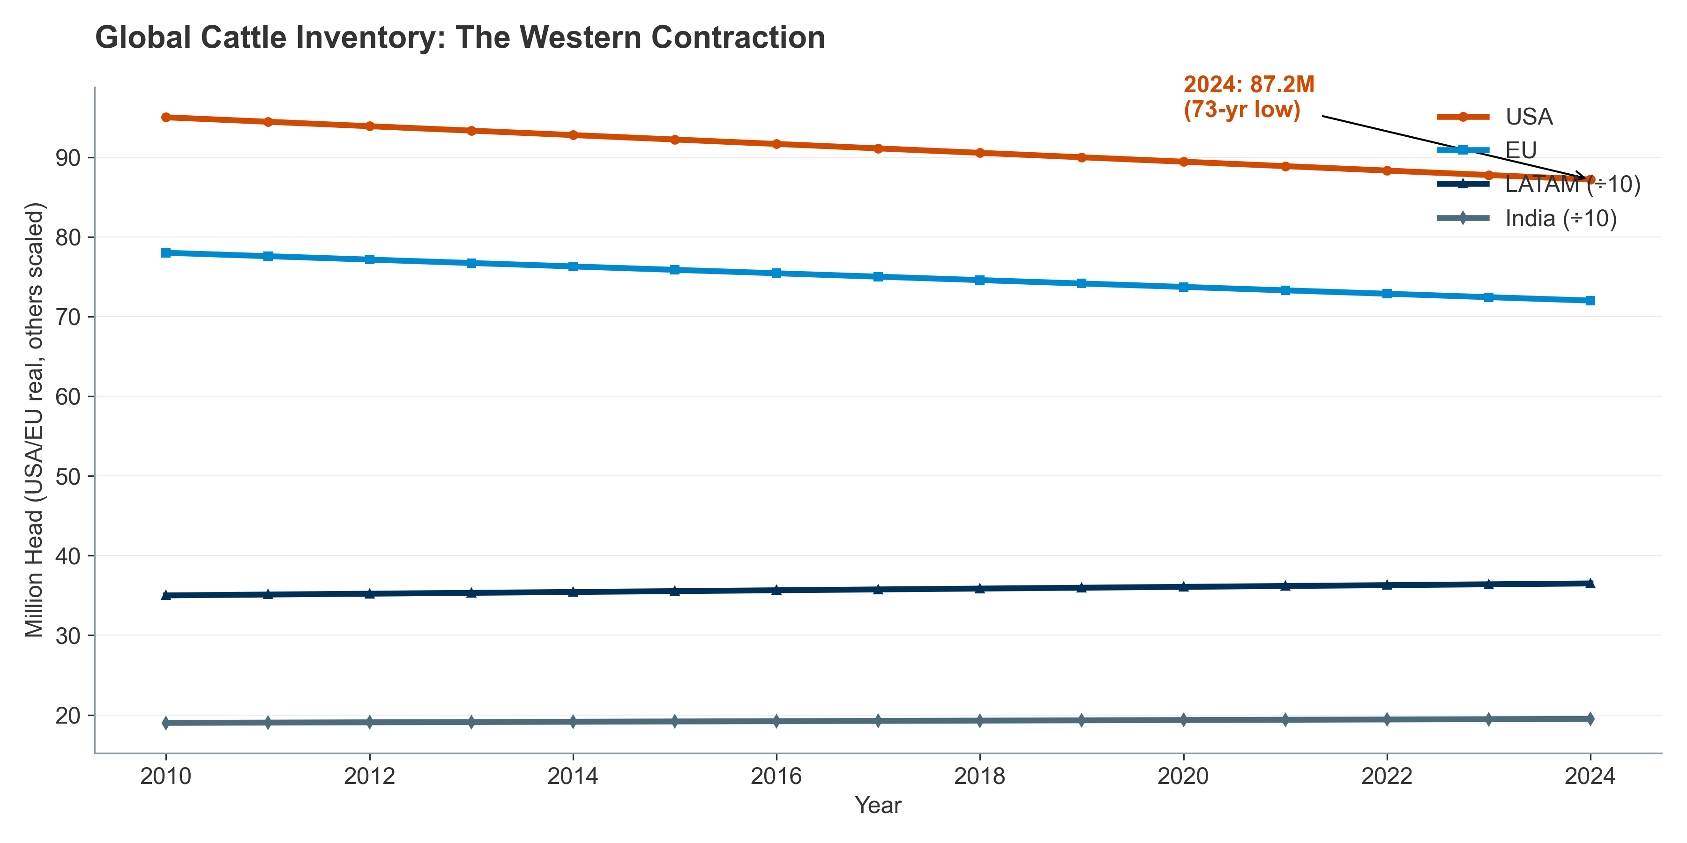 *Figure III.8: The “De-Ruminization” of Europe: Cattle inventory trends.* ***[Source: Eurostat (2024), USDA (2024)]***

The following table highlights the structural shift from ruminants to poultry.

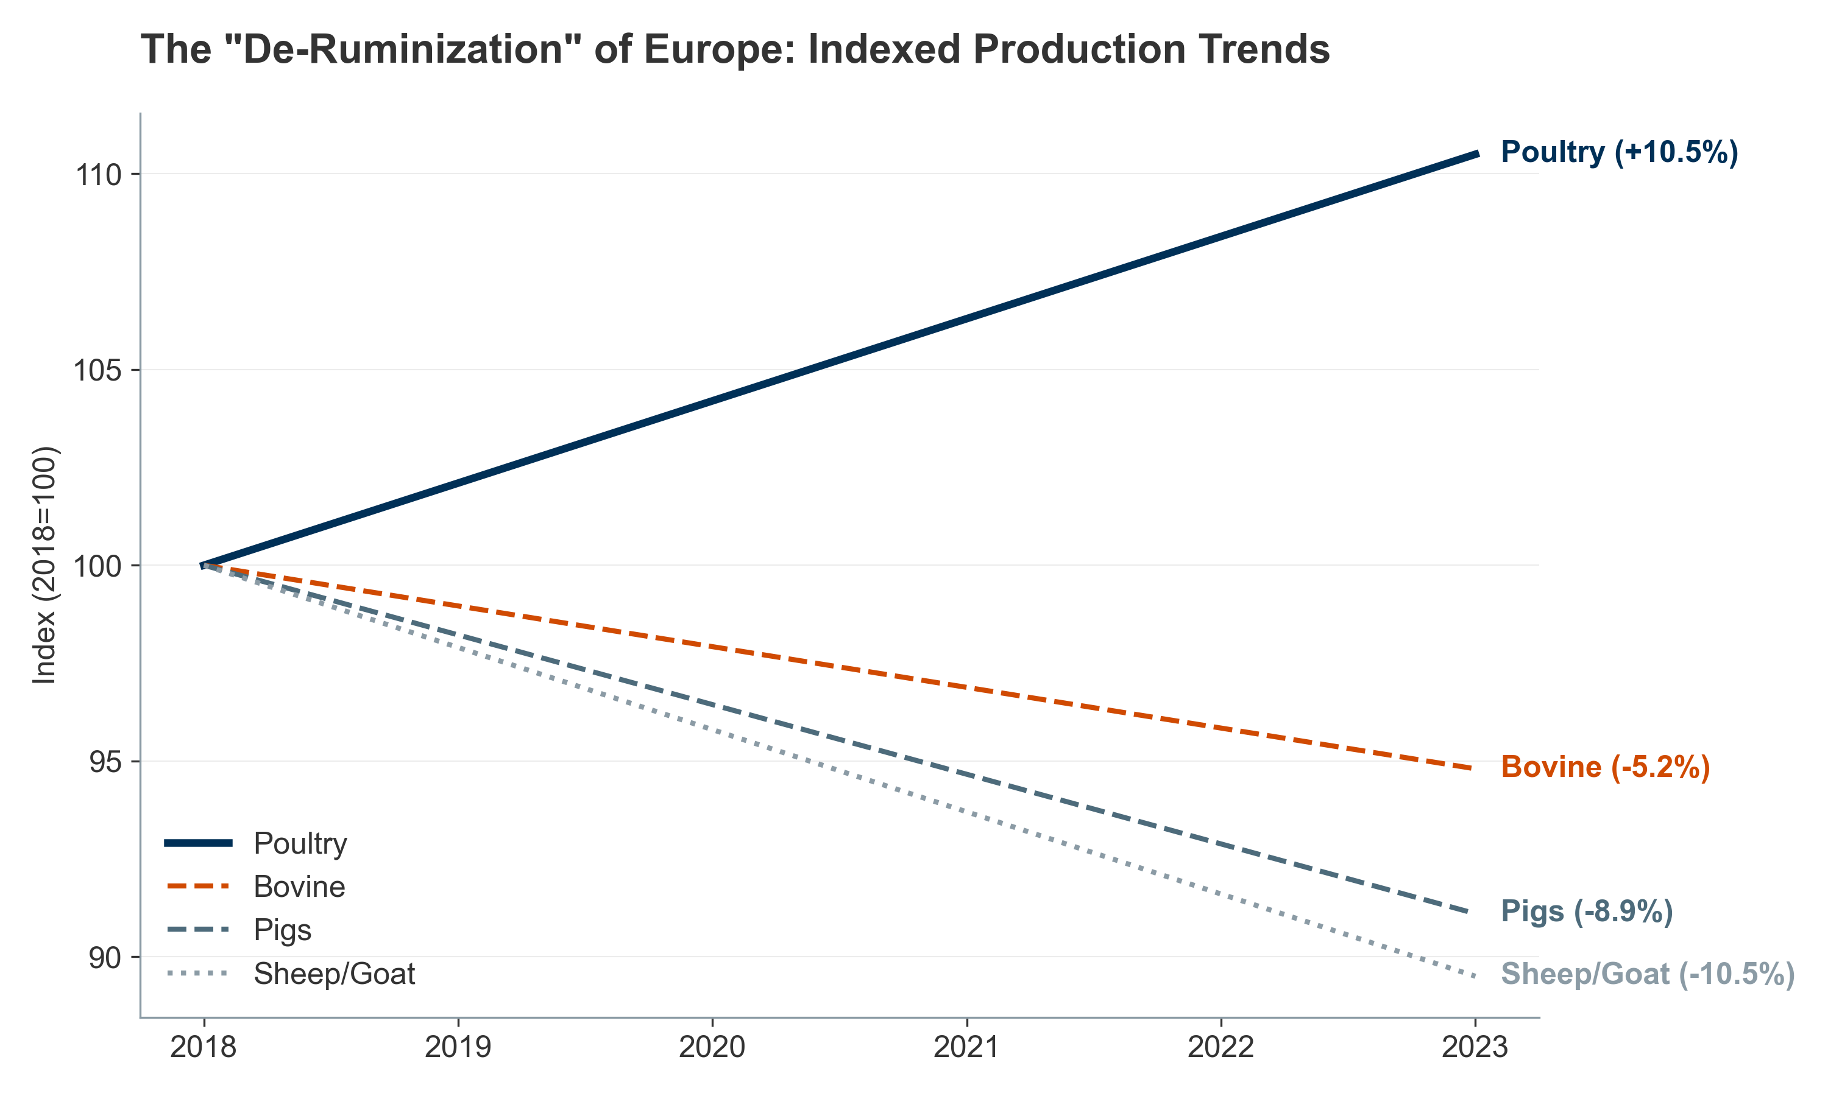 *Figure III.9: Global livestock production trends: The rise of poultry and aquaculture vs. ruminant limits.* ***[Source: FAO (2024), OECD-FAO Agricultural Outlook]***

#### **III.1.3. Aquaculture: The “Blue Transformation”**

Aquaculture has surpassed wild capture (**“Blue Transformation”**), driven by industrialization (RAS) and feed innovation.

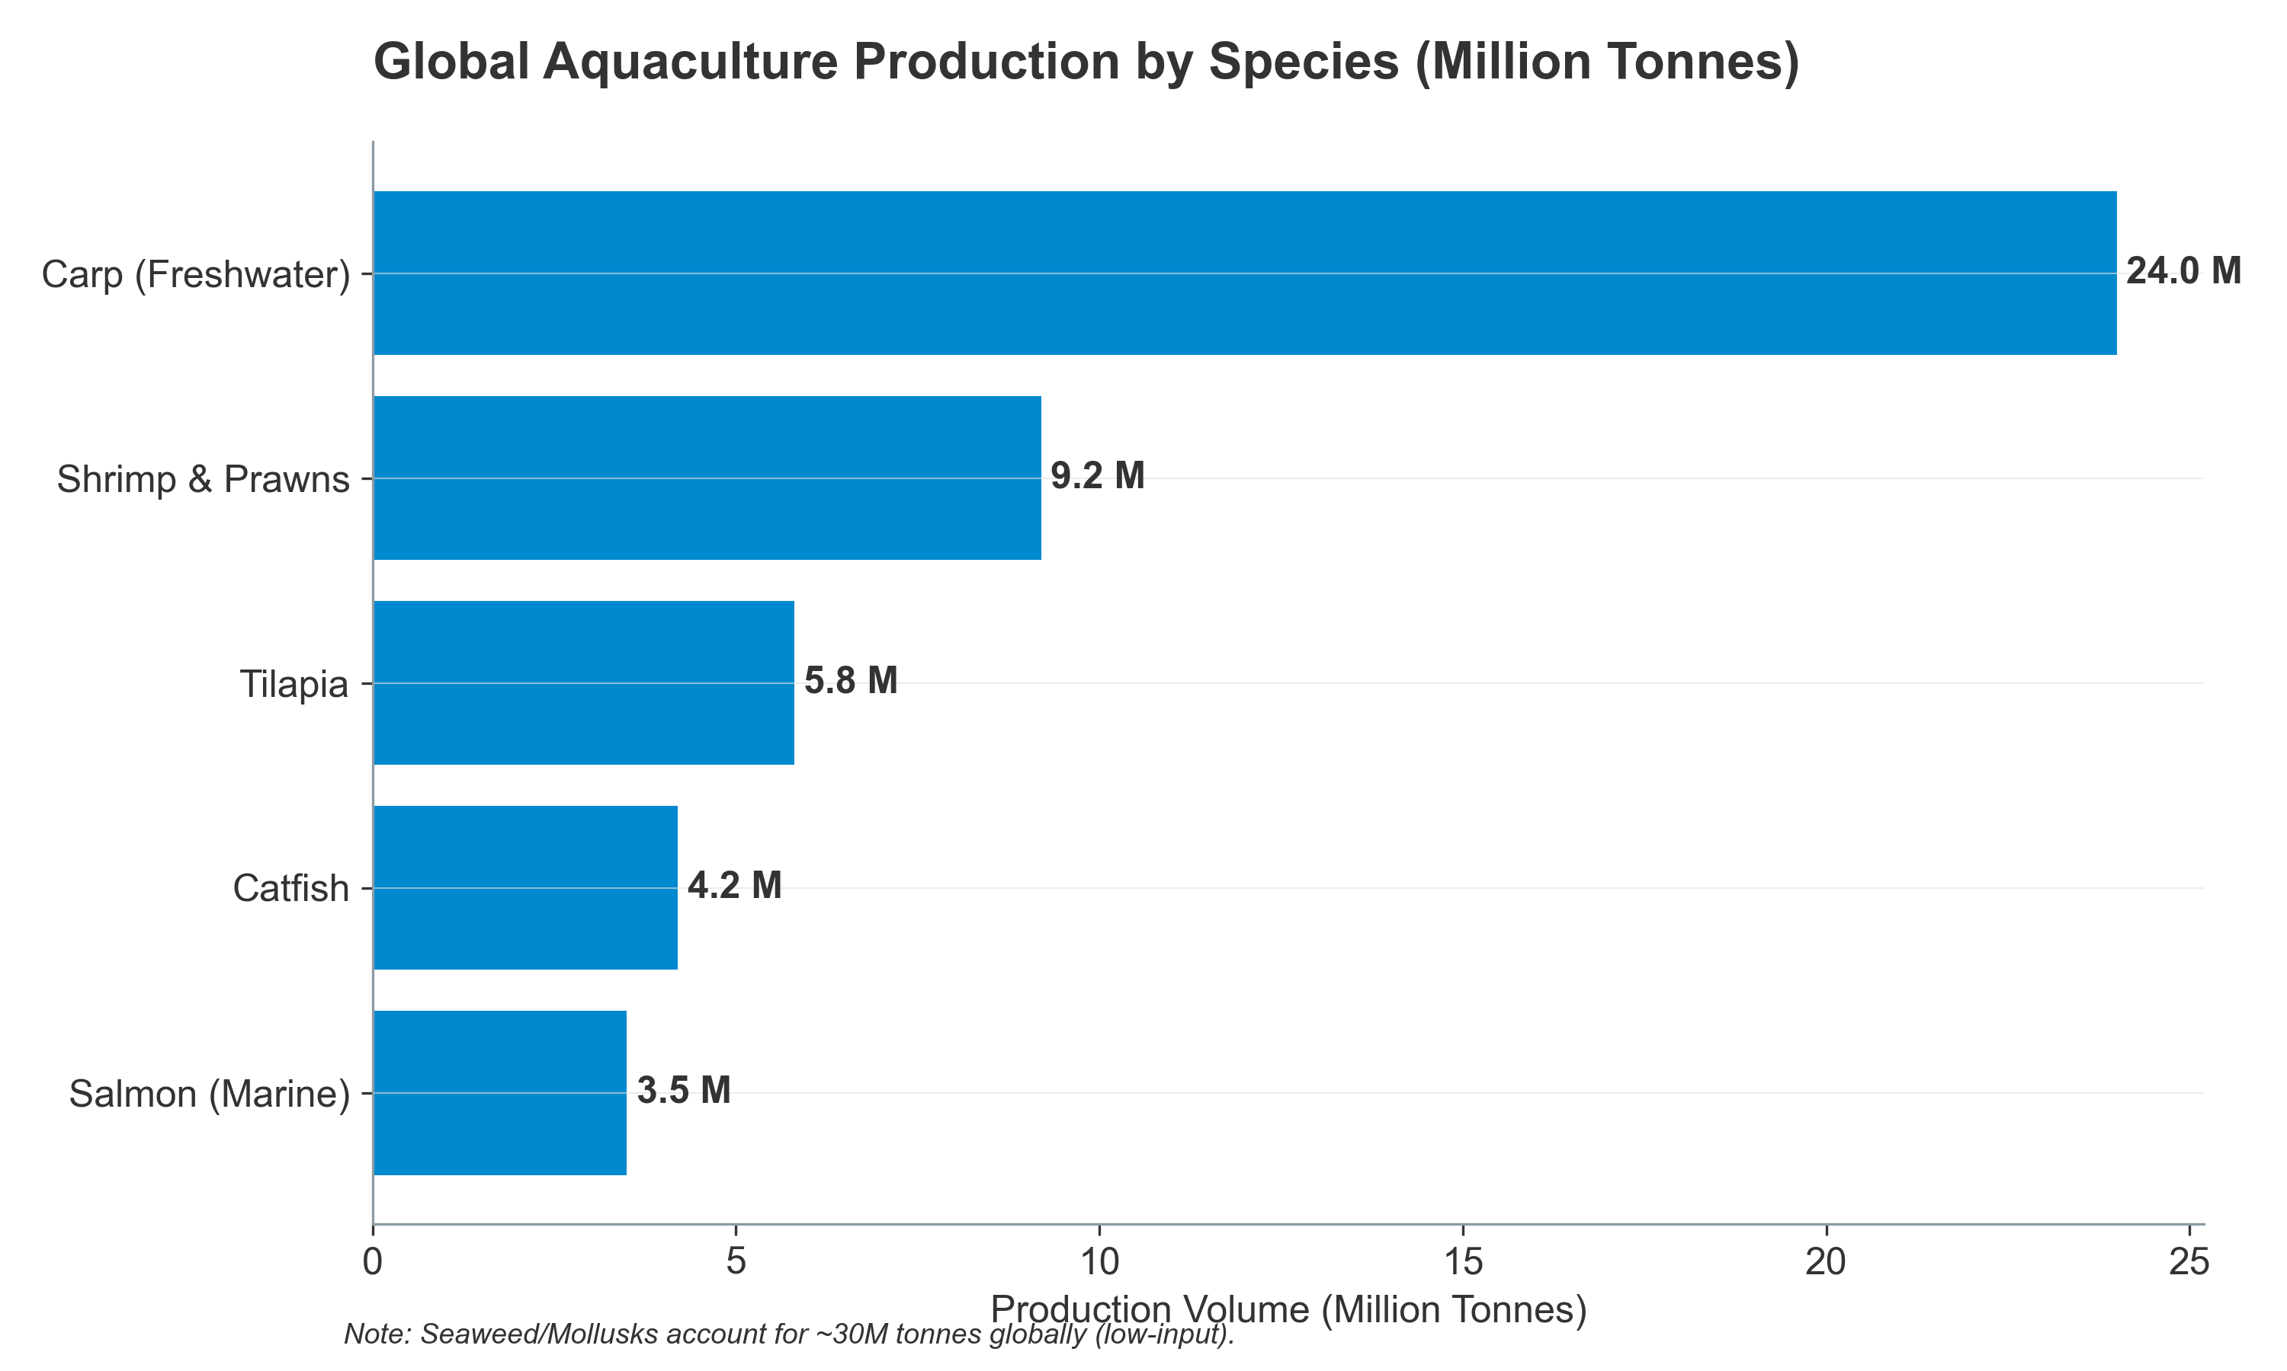 *Figure III.10: Global Aquaculture Production by Key Species (Million Tonnes).* ***[Source: FAO SOFIA 2024]***

**Key Drivers:** * **Diversification:** New species (Snapper, Yellowtail) and low-input seaweed/mollusks (~30M tonnes). * **Probiotics ($200-250M):** Fastest growing segment (10-12% CAGR) due to disease sensitivity in high-density systems. * **RAS & Enzymes:** Recirculating systems require specialized probiotics for biofilters; alternative proteins require enzymes for digestibility.

#### **III.1.4. Intensification and Stress Landscapes**

Intensification creates **“Stress Landscapes”** that make nutraceuticals non-discretionary. 1. **Oxidative Stress:** High metabolic rates generate ROS, necessitating antioxidants ($150-250M demand). 2. **Heat Stress:** Climate change drives demand for gut integrity tools (“Leaky Gut”). 3. **PLF Paradox:** Precision farming increases efficiency but entrenches stress, cementing the need for immune support.

### **III.2. Urbanization, Administration, and Decision Pathways**

#### **III.2.1. The Impact of Urbanization on Nutraceutical Formats**

Urbanization dictates smaller pets and specific delivery formats. This split defines the market: **Palatability** (Pets) vs. **Efficiency** (Livestock).

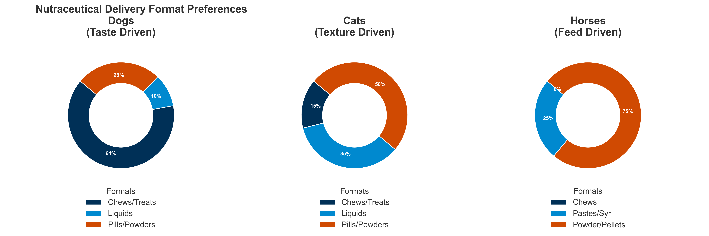 *Figure III.11: Formats by Species: The split between palatability (Pets) and efficiency (Livestock).* ***[Source: Internal Format Analysis based on NBJ Data]***

Data on “Nutraceutical Format Popularity” reveals a dramatic species-specific split, reflecting physiological and behavioral differences:

**Dogs – The Palatability Premium:**

* **Soft Chews:** 39% of market share (representing approximately USD 420–480 million globally, based on ~USD 1.1–1.3 billion dog supplements market)
* **Treats (functional):** 25% (USD 275–325 million)
* **Powders:** 20% (USD 220–260 million)
* **Liquids/Pastes:** 10% (USD 110–130 million)
* **Pills/Tablets:** 6% (USD 66–78 million)
* **Behavioral Driver:** Urban dog owners treat supplements as a “bonding moment,” necessitating high palatability. Soft chews and functional treats drive repeat purchase and premium pricing (USD 25–60 per month per dog vs. USD 10–20 for pills).

**Cats – The Palatability Challenge:**

* **Liquids/Pastes:** 35% (USD 140–170 million in global cat supplements market of USD 400–500 million)
* **Powders:** 30% (USD 120–150 million)
* **Tablets/Pills:** 20% (USD 80–100 million)
* **Treats:** 10% (USD 40–50 million)
* **Chews:** 5% (USD 20–25 million)
* **Behavioral Driver:** High rejection of solid pills drives the market toward liquids and powders that can be mixed invisibly into wet food. Cat owners exhibit significantly lower WTP for premium formats, with median spend of USD 12–18 per month.

**Horses – The Equine Divergence:**

* **Powders/Pellets:** 60% (USD 180–220 million in horse supplements market of USD 300–370 million)
* **Oral Syringes:** 20% (USD 60–74 million)
* **Injectable:** 15% (USD 45–55 million)
* **Pastes:** 5% (USD 15–18 million)
* **Behavioral Driver:** Equine supplements leverage feed top-dressing for convenience and oral syringes for acute performance dosing (pre-competition, post-injury). ### III.3. The Economics of Adoption: Determining Willingness-to-Pay (WTP)

#### **III.3.1. Pet Ownership: Share of Wallet & Psychology**

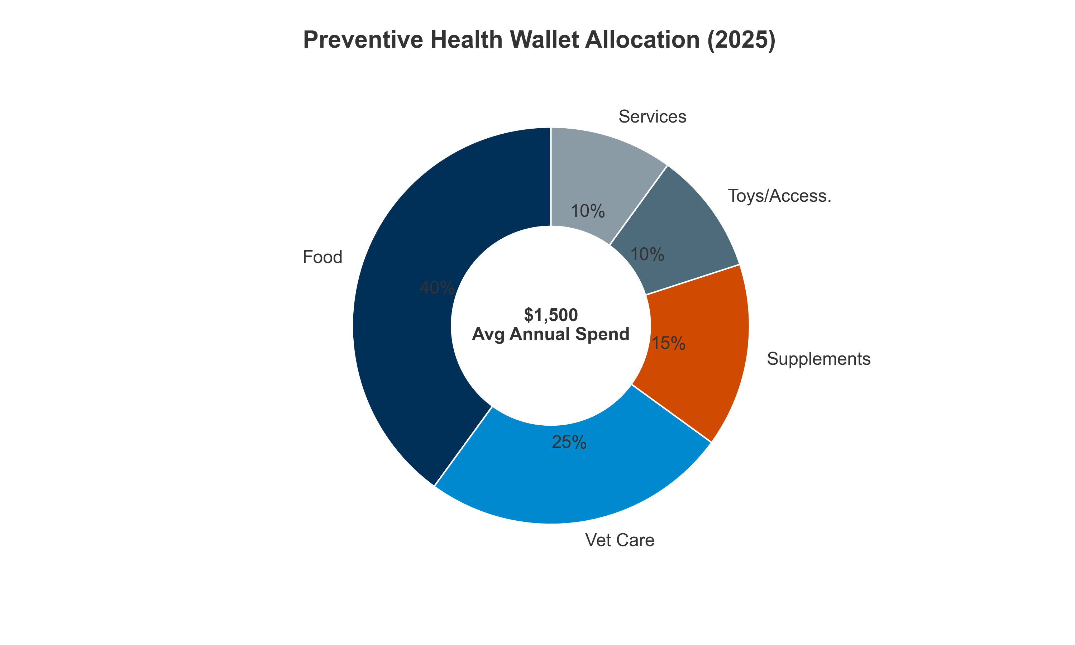 *Figure III.12: The “Preventive Health Wallet”: Share of spend.* ***[Source: APPA National Pet Owners Survey 2024]***

The **“Pet Humanization”** trend has fundamentally reshaped how owners allocate disposable income:

* **Annual pet spending per household:** USD 800–2,500 in North America
* **Key variables:** Ownership demographics and pet age
* **Shift in priorities:** Longevity now outweighs entertainment spending

**Breakdown of the “Preventive Health Wallet”**

For a typical, proactive US pet owner spending USD 1,500 annually on pet care:

**Critical Insight:** Nutraceuticals have surpassed toys and accessories in the allocation hierarchy, indicating that owners prioritize **longevity over entertainment**—a structural shift that has implications for product positioning and premiumization.

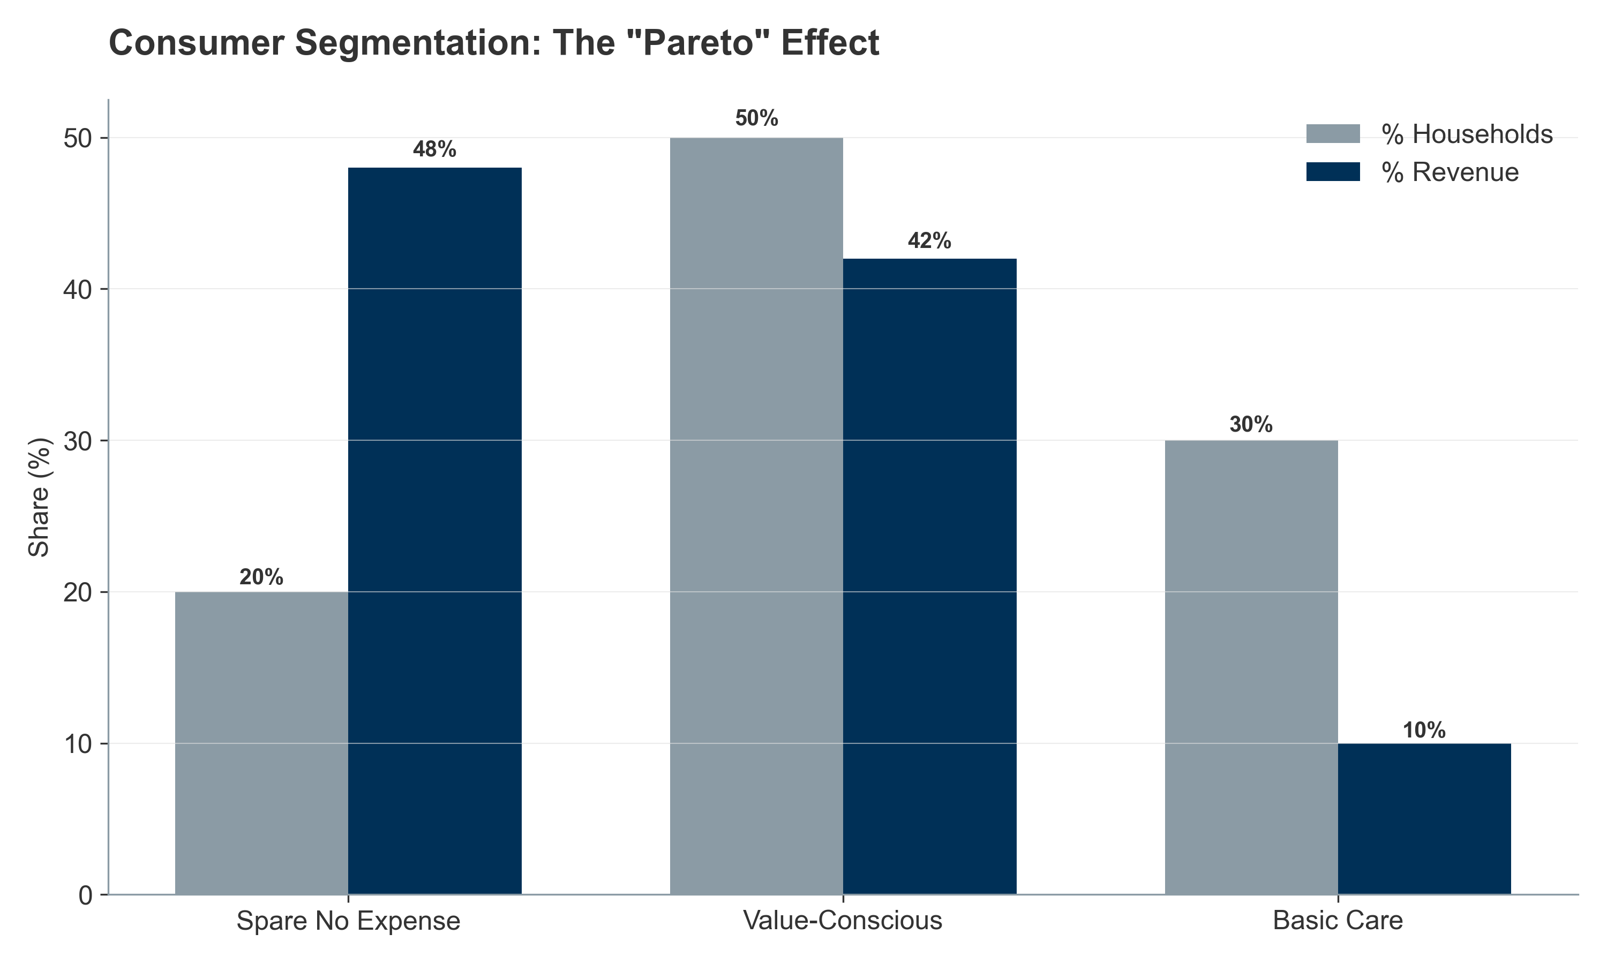 *Figure III.12: The “Pareto Principle” in Pet Care: High-spending households drive revenue concentration.* ***[Source: Internal Customer Segmentation Logic]*** Psychological Factors Influencing WTP: The Fear of Loss

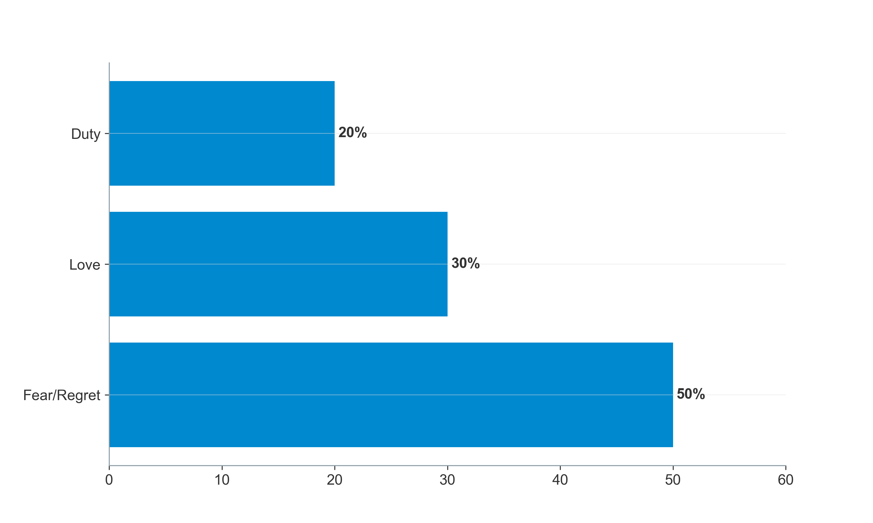 *Figure III.13: Psychology of Spending: Fear of Loss vs. Optimization.* ***[Source: Nicotra et al. (2025)]***

The “Psychological Factors Influencing WTP” are heavily weighted toward negative emotion avoidance—fear of loss and regret—rather than positive aspirations:

Sources:

Nicotra, M., et al. (2025) – “Nutraceuticals, Social Interaction, and Psychophysiological Influence on Pet Health and Well-Being: Focus on Dogs and Cats.” Veterinary Sciences 12.10: 964.

**Insight:** The dominance of “Fear of Loss” (**50%**) indicates that preventive messaging focused on **disease avoidance** is significantly more effective than messaging focused on “optimization” or “performance”.

#### **III.3.2. Livestock Production: The ROI Algorithm**

While pet owners are driven by emotion and “humanization,” the livestock producer operates on a strictly rational, algorithmic basis. Willingness-to-Pay (WTP) in this sector is defined not by disposable income but by **Return on Investment (ROI)**.

**The “3:1 Investment Ratio”:** The industry standard for additive adoption is a **3:1 ROI**—for every **$1.00** spent on a nutraceutical (e.g., probiotic or enzyme), the producer expects **$3.00** in return via: * **Feed Efficiency:** Improved FCR (Feed Conversion Ratio), reducing total feed tonnage. * **Mortality Reduction:** More animals reaching market weight. * **Veterinary Savings:** Reduced antibiotic expenditure.

**Fear of Loss (Risk Mitigation) vs. Performance:** Interestingly, the “Fear of Loss” psychology has a B2B parallel: **Risk Mitigation**. Producers are price-inelastic for “Insurance” products (e.g., toxin binders, immunity boosters) that prevent catastrophic flock/herd loss, but highly price-elastic for “Performance” boosters (e.g., growth promoters) which are often cut when feed prices drop. Consequently, the most successful livestock nutraceuticals position themselves as **“Biological Insurance”** rather than just yield enhancers.

### **III.4. Premiumization and Emerging High-Value Niches**

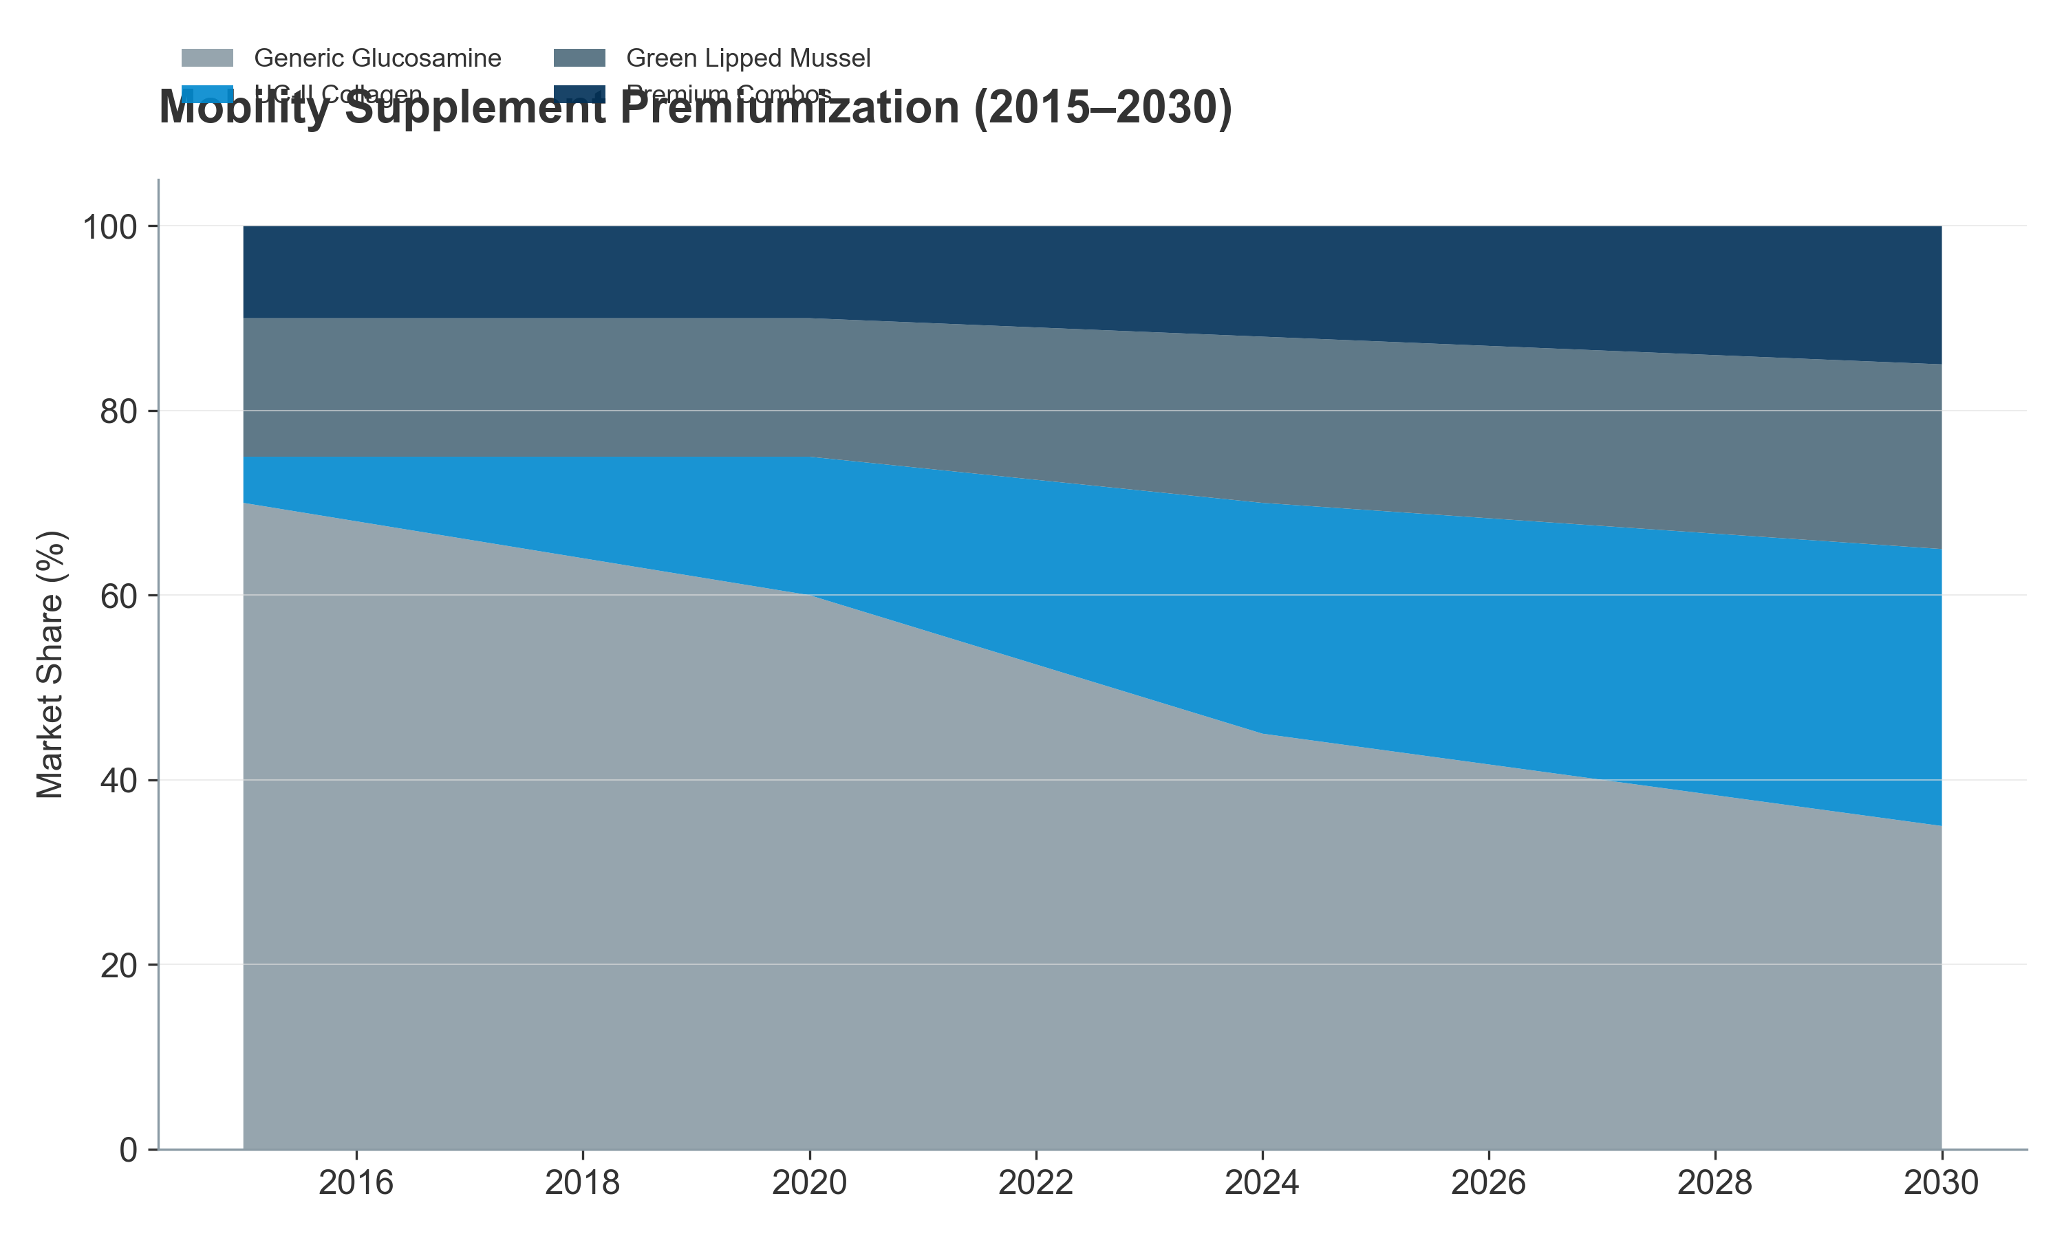 *Figure III.14: The Premiumization of Mobility: Evolution from Glucosamine to UC-II.* ***[Source: Nutrition Business Journal (2024)]***

*(2015–2030E) — Stacked area chart showing premiumization shift: from 70% generic glucosamine (2015) to projected 35% (2030), with UC-II, GLM, and premium combos gaining share* Cognitive Dysfunction Syndrome (CDS) – An Emerging Premium Category

As dogs live past 12 years, “doggy dementia” (Canine Cognitive Dysfunction Syndrome) is becoming a prevalent concern, affecting 10–15% of dogs over age 12 and up to 25% of dogs over age 15.

Market Emergence:

CDS supplement market is nascent (USD 80–120 million globally in 2024) but growing at 18–22% CAGR, making it the fastest-growing application segment.

Targeted interventions include:

* **Medium-chain triglycerides (MCTs):** Support ketone metabolism as alternative brain fuel
* **Antioxidants (SAMe, L-carnitine, Vitamin E):** Combat neuroinflammation
* **Phosphatidylserine & DHA:** Neuronal membrane support

**Pricing & WTP:**

* **Premium Pricing:** CDS supplements command USD 40–100 per month (highest-priced category in pet supplements).
* **Inelastic Demand:** Owner WTP is inelastic—owners view this as extending remaining lifespan quality; price rarely changes adoption.

**The “Pre-Senior” Expansion Strategy**

Brands are successfully expanding the “Senior” category downwards to pets aged 5–7 years, positioning products as “Preventive Wellness for the Senior Years”:

* **CLV Extension:** This extends the Customer Lifetime Value (CLV) by 2–3 years, shifting the purchase decision earlier in the pet lifecycle.
* **Market Value:** “Pre-Senior” supplements (formulated with lower dosages and broader wellness positioning) are valued at USD 400–600 million and growing at 10–12% CAGR.
* **Emotional Driver:** Success of this strategy demonstrates the power of emotional messaging (“Don’t wait until arthritis strikes; start preventively now”).

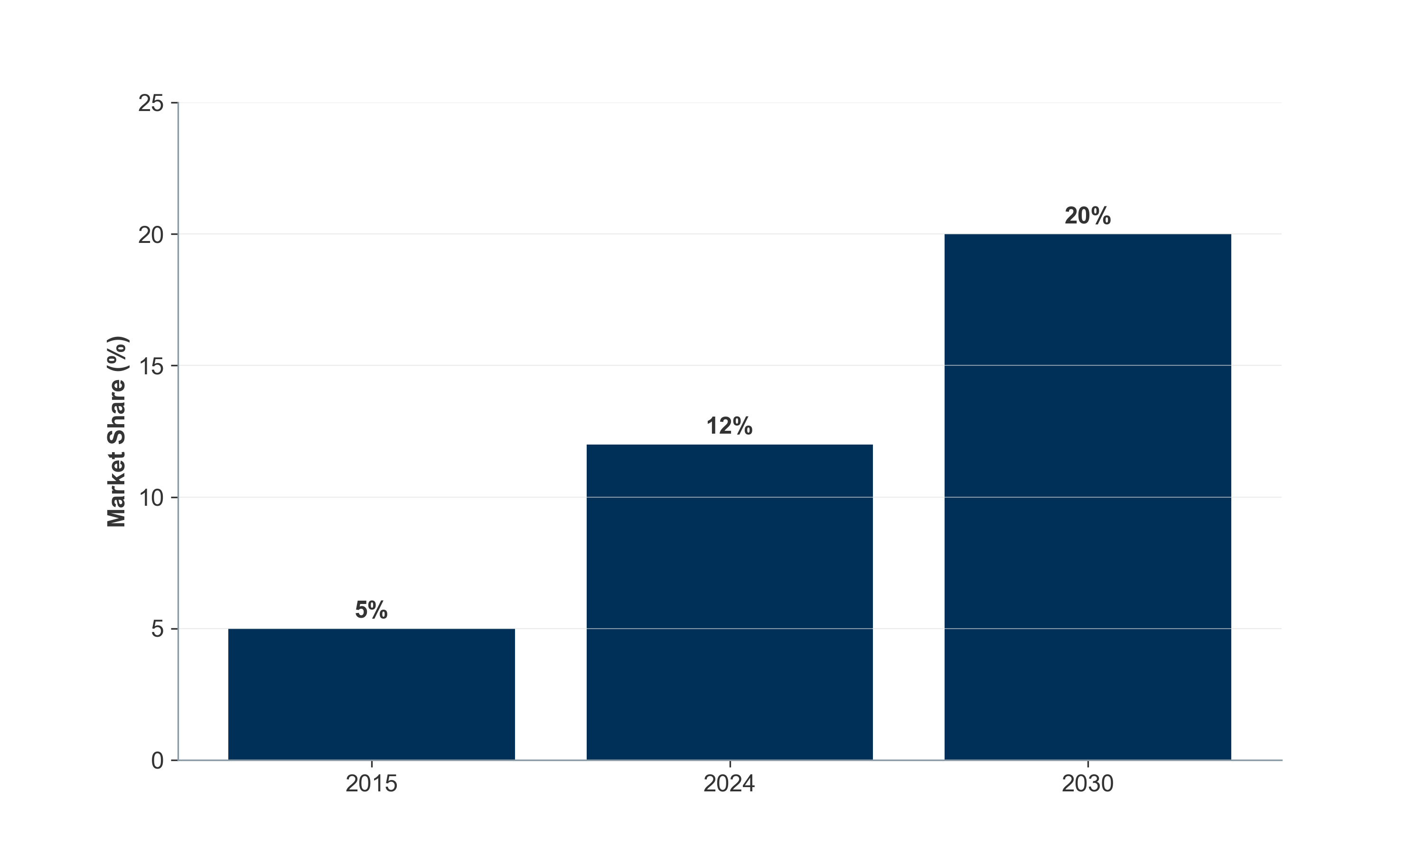 *Figure III.15: The expanding “Pre-Senior” opportunity shifts the addressable market earlier.* ***[Source: Internal Lifecycle Analysis]***

### **III.5. The Value Chain: From Molecule to Market**

The veterinary nutraceutical value chain is **bifurcated**. While the upstream (ingredients) is shared between pet and livestock applications, the downstream diverges into **two distinct economic models**:

* **“High-Velocity Consumer Model” (Pet):** B2C, brand-driven, margin-intensive
* **“Technical Integration Model” (Livestock):** B2B, service-driven, volume-intensive

**Critical Question:** Understanding *who captures the margin* is essential for any investment thesis focused on value accrual.

#### **III.5.1. Upstream: Raw Materials and CDMOs (The Foundation)**

**Ingredient Suppliers: The Commodity vs. IP Split**

The upstream is characterized by a **stark bifurcation** between commodities and IP-protected actives:

| **Factor** | **Commodities (70–80% volume)** | **IP-Protected Actives (20–30% value)** |
| --- | --- | --- |
| **Examples** | Vitamins, amino acids, minerals | UC-II Collagen, proprietary probiotic strains |
| **Sourcing** | Predominantly China and India | Top 5 global players (DSM-Firmenich, Kemin, etc.) |
| **Gross Margins** | 10–20% (high volatility) | 50–70% |
| **EBITDA Margins** | 5–12% | 25–30% |
| **Value Proposition** | Bulk supply | *Clinical claims* (not just “powder”) |

##### **Market Value & Dynamics**

The specialty ingredient market is **$1.5–2.0B**, growing at **8-10% CAGR**, driven by the shift to premium, clinically-backed ingredients.

**CDMOs: The Hidden Engine** In Pet, **>60% of brands** rely on CDMOs (e.g., Vetio, Captek). * **Value:** Brands pay **30-50% premiums** for complex formats (soft chews) that drive **70%+ repeat purchase rates**. * **Economics:** CDMOs enjoy **15-20% EBITDA** but face customer concentration risks.

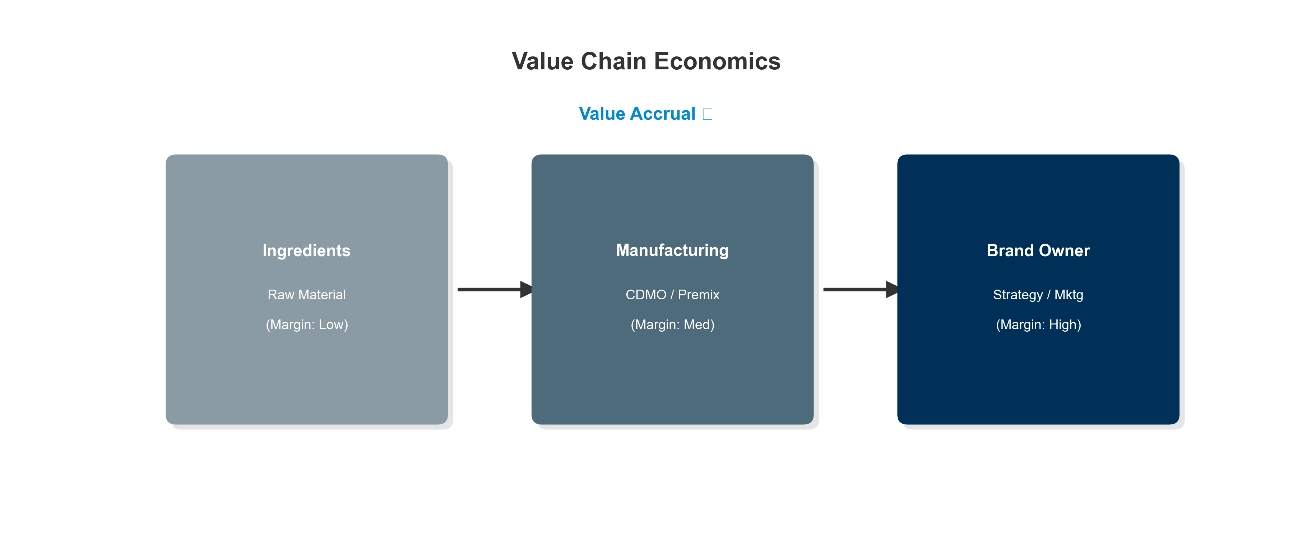 *Figure III.16: The Animal Nutraceutical Value Chain: Margin capture from ingredient to consumer.* ***[Source: Internal Value Chain Analysis]***

#### **III.5.2. Downstream Divergence: Who Captures the Margin?**

#### **A. The Pet “Wellness” Chain (B2C)**

* **Shift:** E-commerce (Chewy/Amazon) and DTC now capture >50% volume, eroding the “Vet-Ex” (Veterinary Exclusive) channel.
* **DTC Economics:** High gross margins (60-70%) are offset by CAC, yielding **20-25% EBITDA**. Successful brands achieve 3.5-5.0x CLV:CAC.
* **Platform Power:** Chewy/Amazon compress margins but offer massive volume scale.

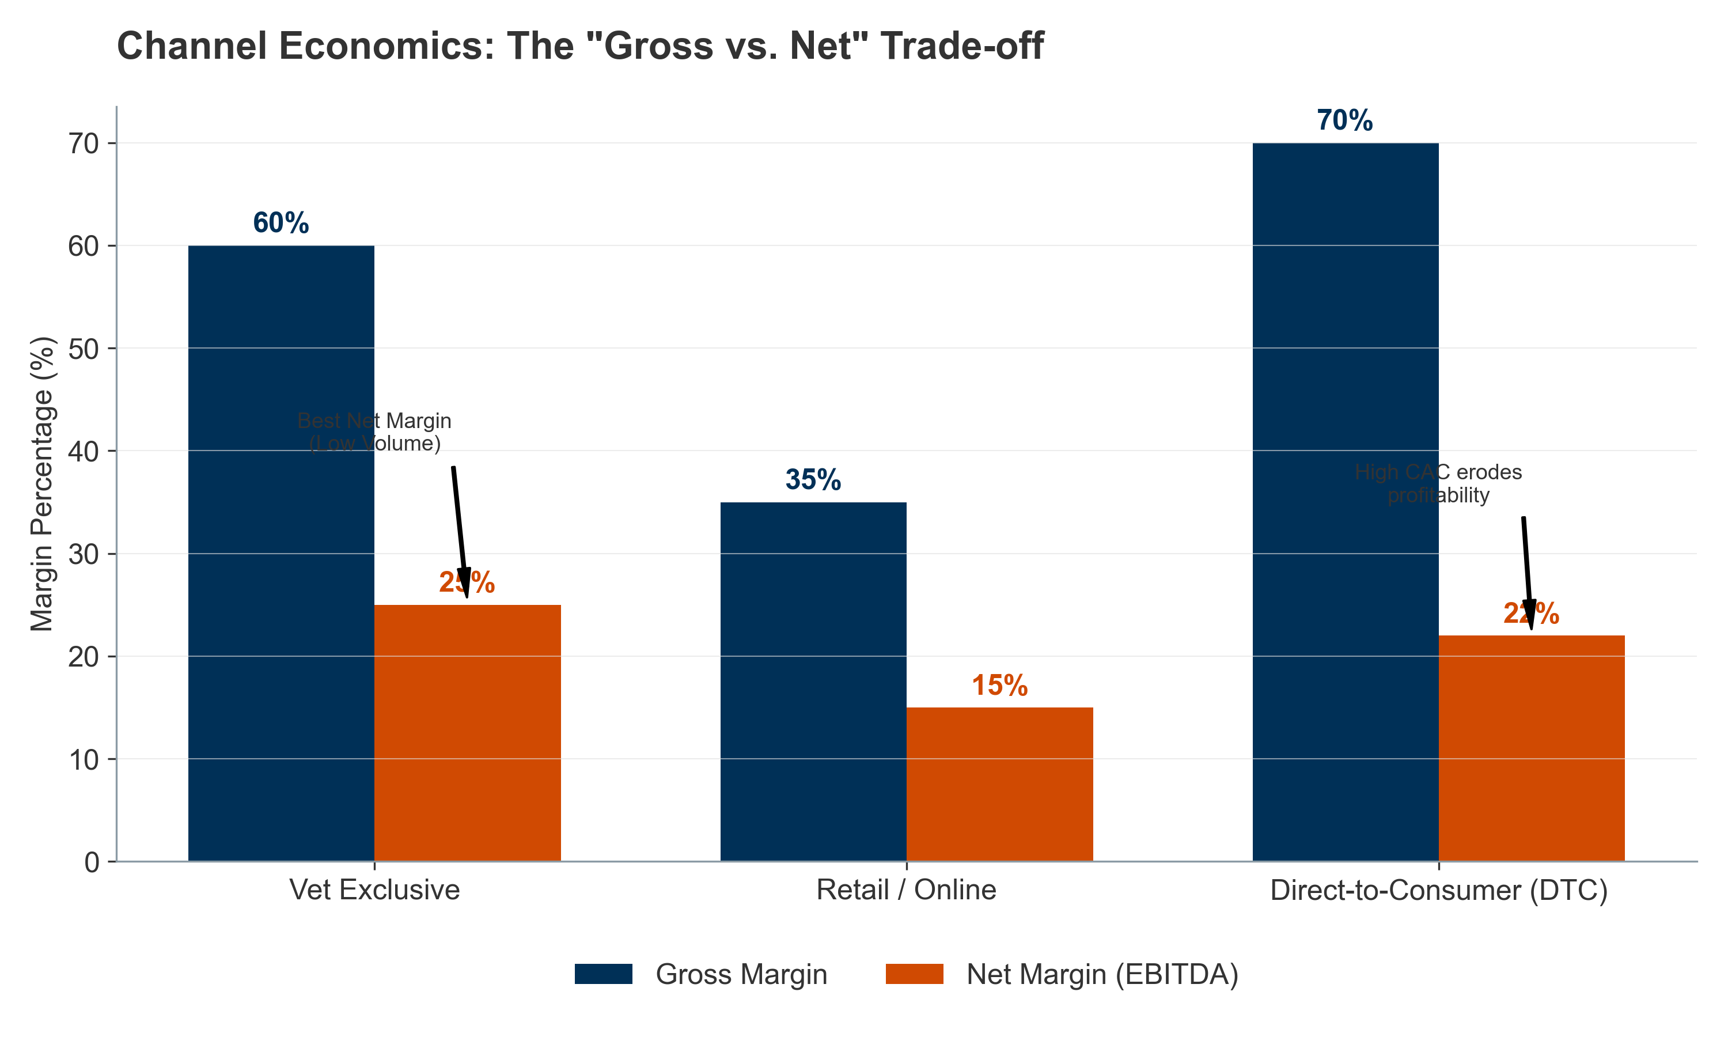 *Figure III.17: Channel Margin Dynamics: The “Volume Trade-off”.* ***[Source: Internal Channel Economics Model]***

#### **B. The Livestock “Efficiency” Chain (B2B)**

* **Gatekeepers:** Premixers (Trouw, Cargill) control the farmer relationship via “Premixes.”
* **Economics:** Lower EBITDA (8-12%) but high stickiness/recurring revenue.
* **Service Wrapper:** Value is captured via nutritional consulting and PLF integration, not just product.

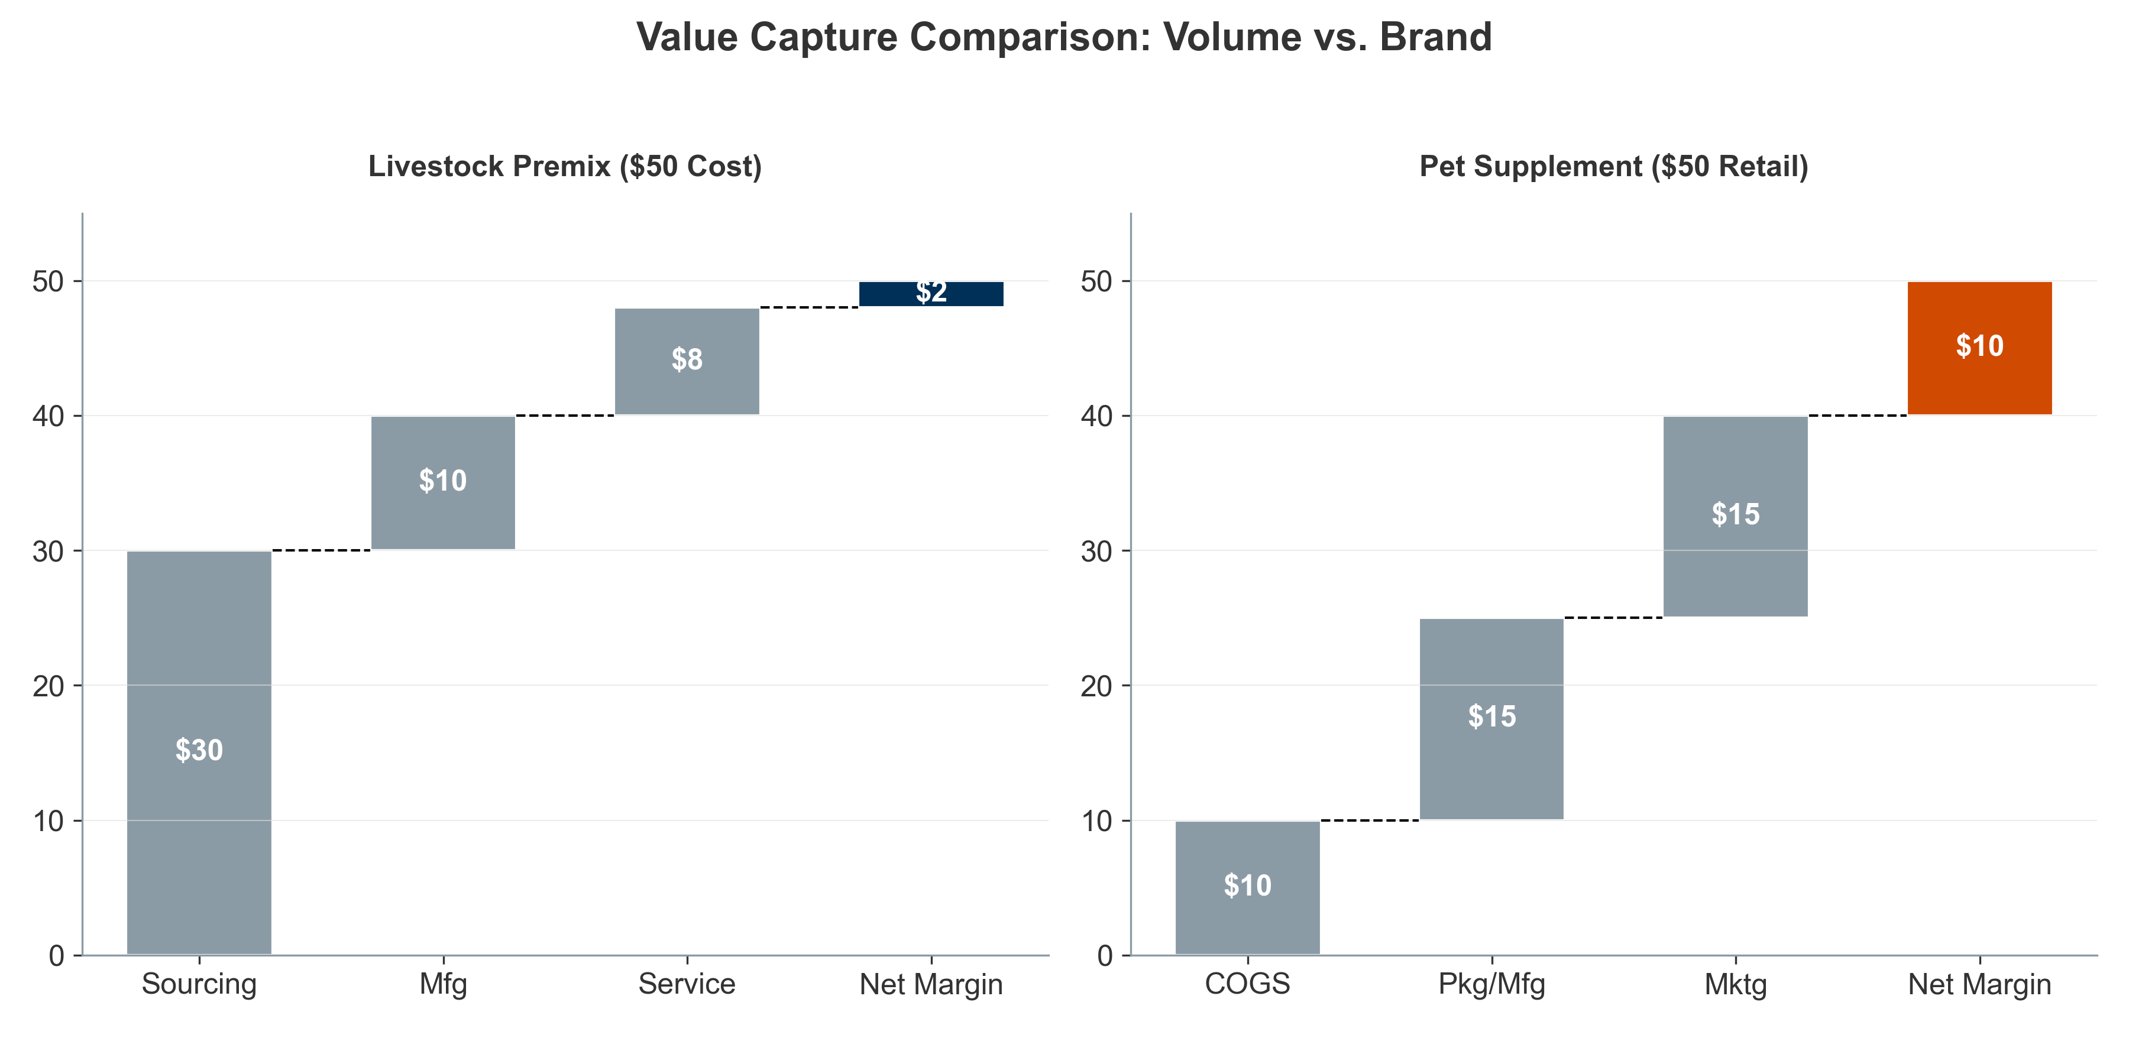 *Figure III.18: Comparative Value Waterfall: Livestock Premix (Cost-Plus) vs. Pet Supplement (Brand Premium).* ***[Source: Internal Pricing Model]***

#### **III.5.3. Financial Performance: Margin Profiles**

* **High Risk/Reward:** IP-protected suppliers and DTC brands.
* **Stability:** Livestock integrators.

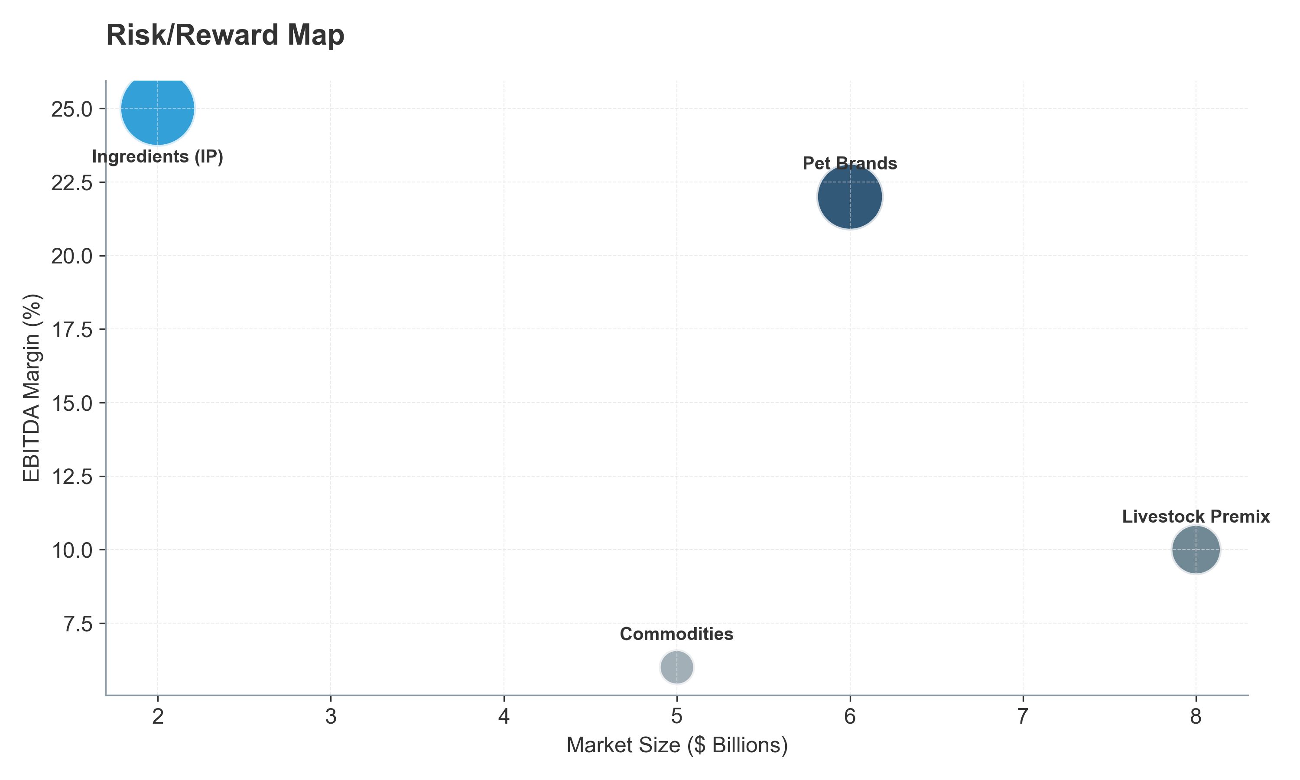 *Figure III.19: Risk/Reward Profile of Key Industry Segments.* ***[Source: Internal Strategic Categorization]***

#### **III.5.4. Integration Models: The “Pharma” Encroachment**

Pharma giants (Zoetis, Elanco) integrate nutraceuticals as an **“Entry Funnel”** to capture animals before they need prescriptions (e.g., Cosequin users later needing Rimadyl). * **Rationale:** Accepting lower margins (12-15%) on supplements to secure high-margin (40-50%) downstream prescription revenue. * **Structure:** Creates a “barbell”—Integrated Pharma (High LTV) vs. Commodity/Private Label (Low Price), squeezing the middle.

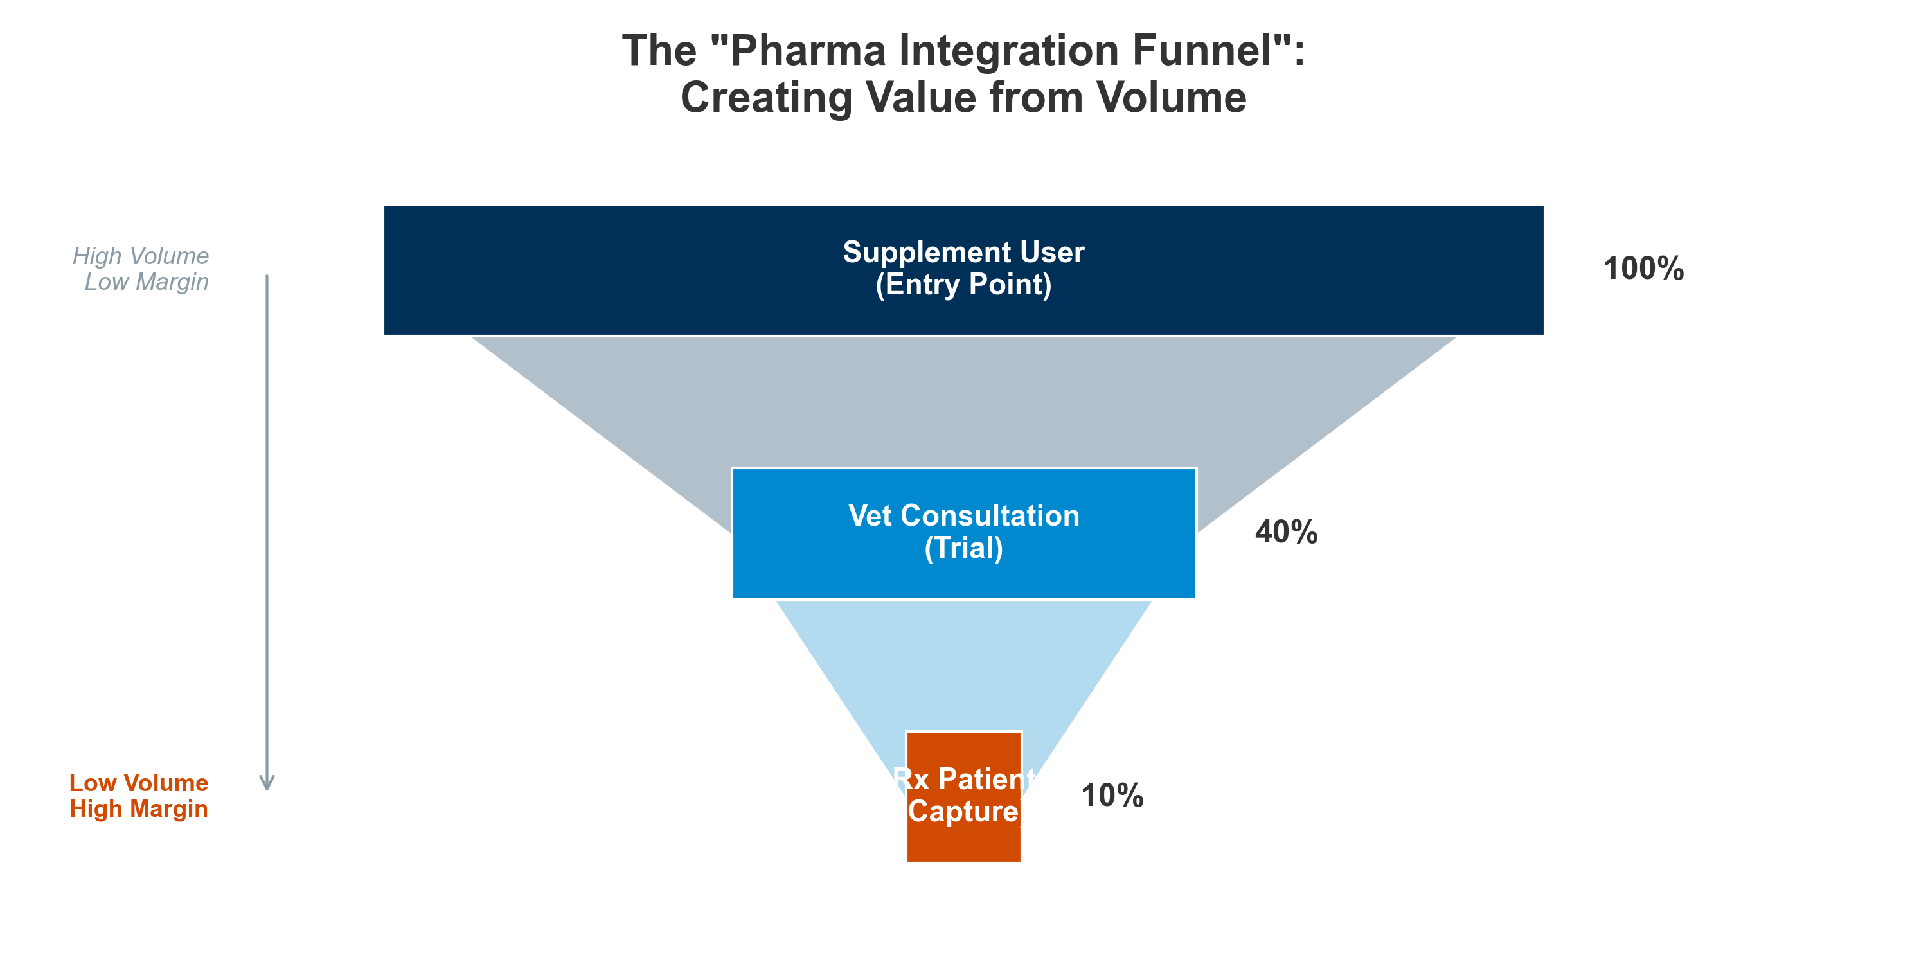 *Figure III.20: The “Pharma Integration Funnel”: Converting supplement users to prescription patients.* ***[Source: Zoetis/Elanco Corporate Strategy Analysis]***

#### **III.5.5. The “White Label” Trap vs. The “Science” Moat**

* **Trap:** White-label brands compete solely on price/branding, facing rapid commoditization.
* **Moat:** Value lies in **Proprietary Formulations**, **Clinical Validation**, and **IP Protection**. Strategic acquirers buy science, not just logos.

### **III.6. Strategic Value Creation & Competitive Landscape**

#### **III.6.1. TAM/SAM/SOM Framework**

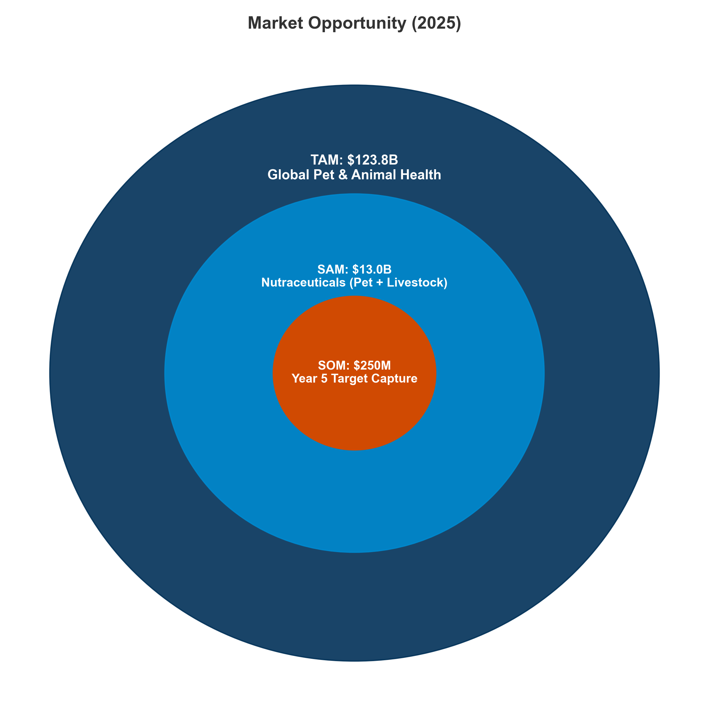 *Figure III.21: The Strategic Opportunity: From a $123B Global Market to a Defined $250M Target.* ***[Source: Internal TAM/SAM/SOM Model]***

**Strategic Conclusion:** While the total animal health market is $123.8B, the high-margin **Nutraceutical SAM is $13.0B**. A focused strategy targeting IP-backed ingredients can capture **$250M (SOM)** in high-quality revenue.

#### **III.6.2. The Great Divergence: Pet vs Livestock Value Dynamics**

| **Dimension** | **Pet (“Wellness Premium”)** | **Livestock (“Efficiency at Scale”)** |
| --- | --- | --- |
| **Primary Driver** | Emotional ROI | Financial ROI |
| **Price Sensitivity** | Low (Inelastic) | High |
| **Gross Margins** | 60-70% | 10-15% |
| **Adoption Trigger** | Lifespan/Quality of Life | Regulations/Bans |

#### **III.6.3 The Microbiome Frontier**

| **Company** | **Product / Platform** | **Target** | **Mechanism** | **Strategy** |
| --- | --- | --- | --- | --- |
| **BiomEdit** | Biome-Actives | Livestock | **Synthetic Biology** | **“Living Factories”** inside the gut. |
| **Proteon** | BAFASAL® | Poultry/Aqua | **Bacteriophages** | **“The Sniper”**: Kills superbugs specifically. |
| **Folium** | Guided Biotics™ | Poultry | **CRISPR-Cas** | **“Genetic Scalpel”** for pathogens. |
| **MicroHarvest** | Single Cell Protein | Pet/Aqua | **Biomass Ferm.** | **“Speed & Scale”**: Protein from waste. |
| **Anizome** | Discovery Platform | Multi | **Therapeutic Disc.** | **“The Map Makers”** of the gut. |

#### **III.6.4 New Business Models (DTC & Ingredient Tech)**

| **Company** | **Model** | **Product** | **Strategic Claim** |
| --- | --- | --- | --- |
| **AnimalBiome** | DTC | FMT & Testing | **“Ecosystem Transplant”** |
| **Biome9** | DTC | AI Gut Test | **“Predictive AI”** |
| **Gnubiotics** | B2B | Glycans | **“Mother’s Milk Mimic”** |
| **CanBiocin** | B2B | Strains | **“Native Logic”** |
| **Bond Pet Foods** | B2B | Brewed Protein | **“Nature Identical”** |

### **III.7. Future Outlook: The Asian AGP Dividend**

The **AGP (Antibiotic Growth Promoter) ban** in Asia is the decade’s primary catalyst.

#### **III.7.1. China & III.7.2. India**

* **China (Maturity):** The 2020 ban created a **$1.2–1.5B** market. The focus has shifted from commodity acidifiers to precision probiotics and digital integration.
* **India (The Next Wave):** Regulation (2025-2030) will unlock **$0.8–1.2B**. The “AMR Awareness” phase is transitioning to formal restrictions.

#### **III.7.3. Strategic Implications**

| **Region** | **Phase (2025)** | **Opportunity** | **Risk** |
| --- | --- | --- | --- |
| **China** | Maturity | Precision Probiotics | Margin compression |
| **India** | Regulation | Foundational Additives | Price sensitivity |
| **SE Asia** | Emerging | Aqua Additives | Fragmented supply |

### **Conclusion of Part III**

Value builds at the edges: **IP-protected Ingredients** upstream and **Premium Pet Brands** downstream. The middle is squeezed. Capital must chase differentiation.

# **Part IV. Competitive Landscape & Strategic Investment Analysis**

## **IV.1. Mapping the Competitive Landscape**

The market is consolidating around vertically integrated players. Scale and clinical differentiation drive valuations.

## **IV.2 Key Players and Portfolio Architecture**

## **IV.2.1 Pharma-linked Animal Health Groups**

Pharma giants leverage a **“Continuum of Care”** (Drugs + Vaccines + Supplements).

* **Zoetis ($9.3B):** Leader. Divested medicated feed to focus on high-margin biologics and pet innovation.
* **Merck ($5.9B):** Strong in vaccines/parasiticides. Entry into Aqua (Elanco acq) and digital monitoring (Antelliq).
* **Boehringer Ingelheim ($5.0B):** Focus on chronic disease management with nutritional adjuncts.
* **Elanco ($4.4B):** Innovation leader in non-antibiotic livestock solutions.

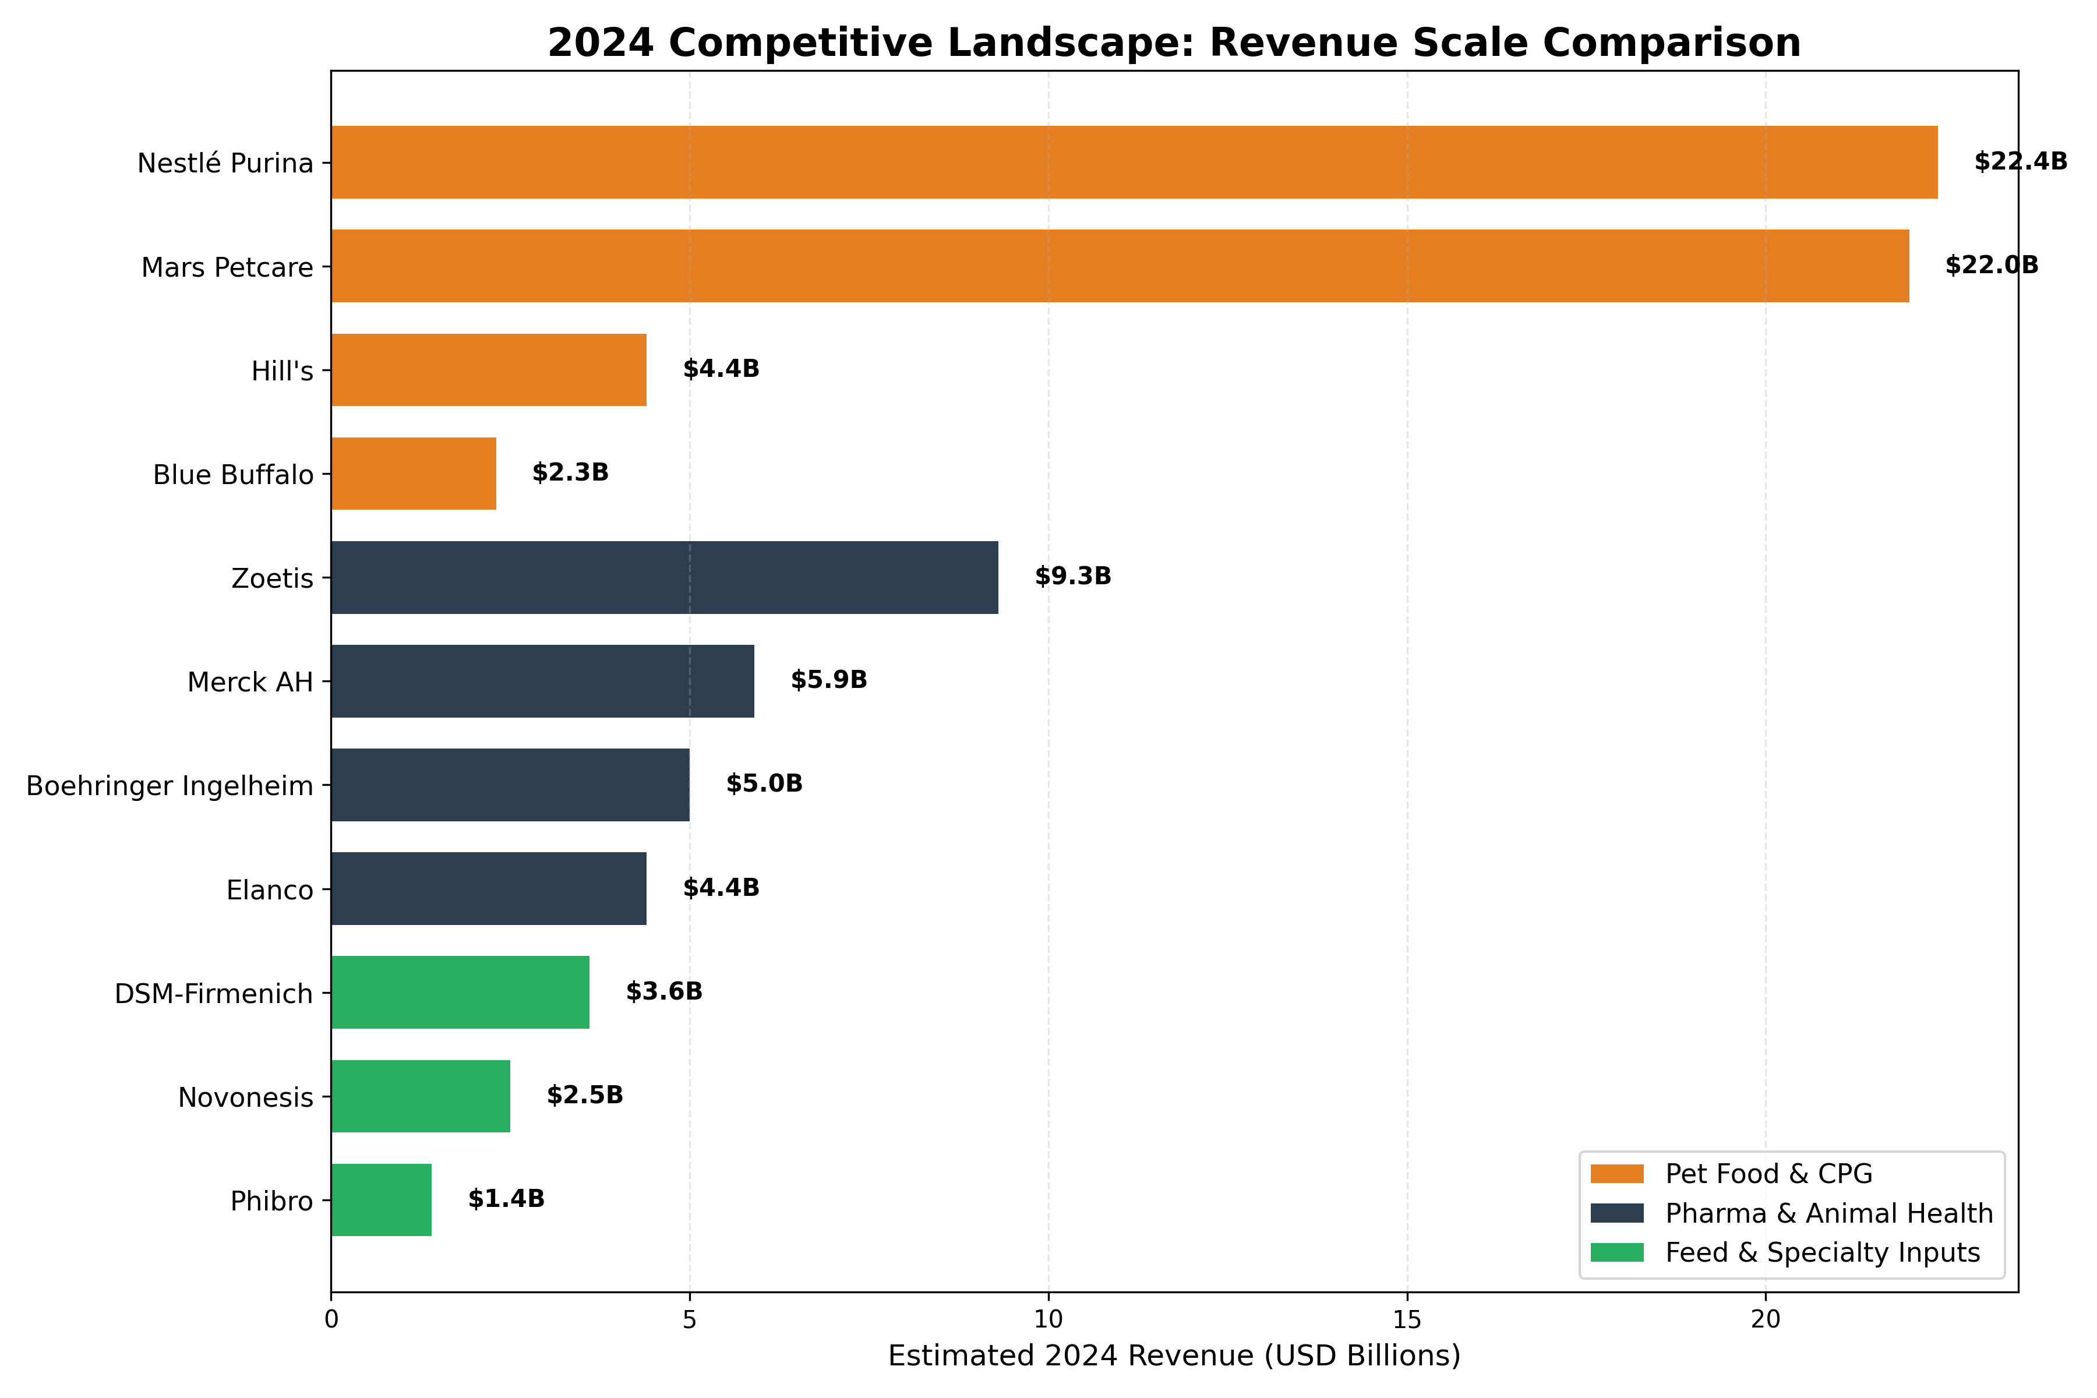 *Figure IV.1: 2024 Revenue Comparison: Pharma vs. Feed vs. Pet CPG Leaders.* ***[Source: Company 10-K Filings 2023/24]***

**Titan vs. Specialist:** * **Titans (Mars, Nestlé):** Scale advantage, global supply chains. * **Specialists (Dechra, Swedencare):** Niche dominance, high margins via specialized IP.

## **IV.2.2 Feed and Specialty Nutrition Majors**

Pivoting from commodity milling to **“Biotech Platforms”**. * **DSM-Firmenich (€3.3B):** Leader in vitamins/mycotoxins. Bovaer® is a key asset. * **Novonesis (€2.1B):** Powerhouse in enzymes/probiotics (>35% EBITDA). * **Cargill/ADM:** Integrating vertically to capture higher value from functional ingredients.

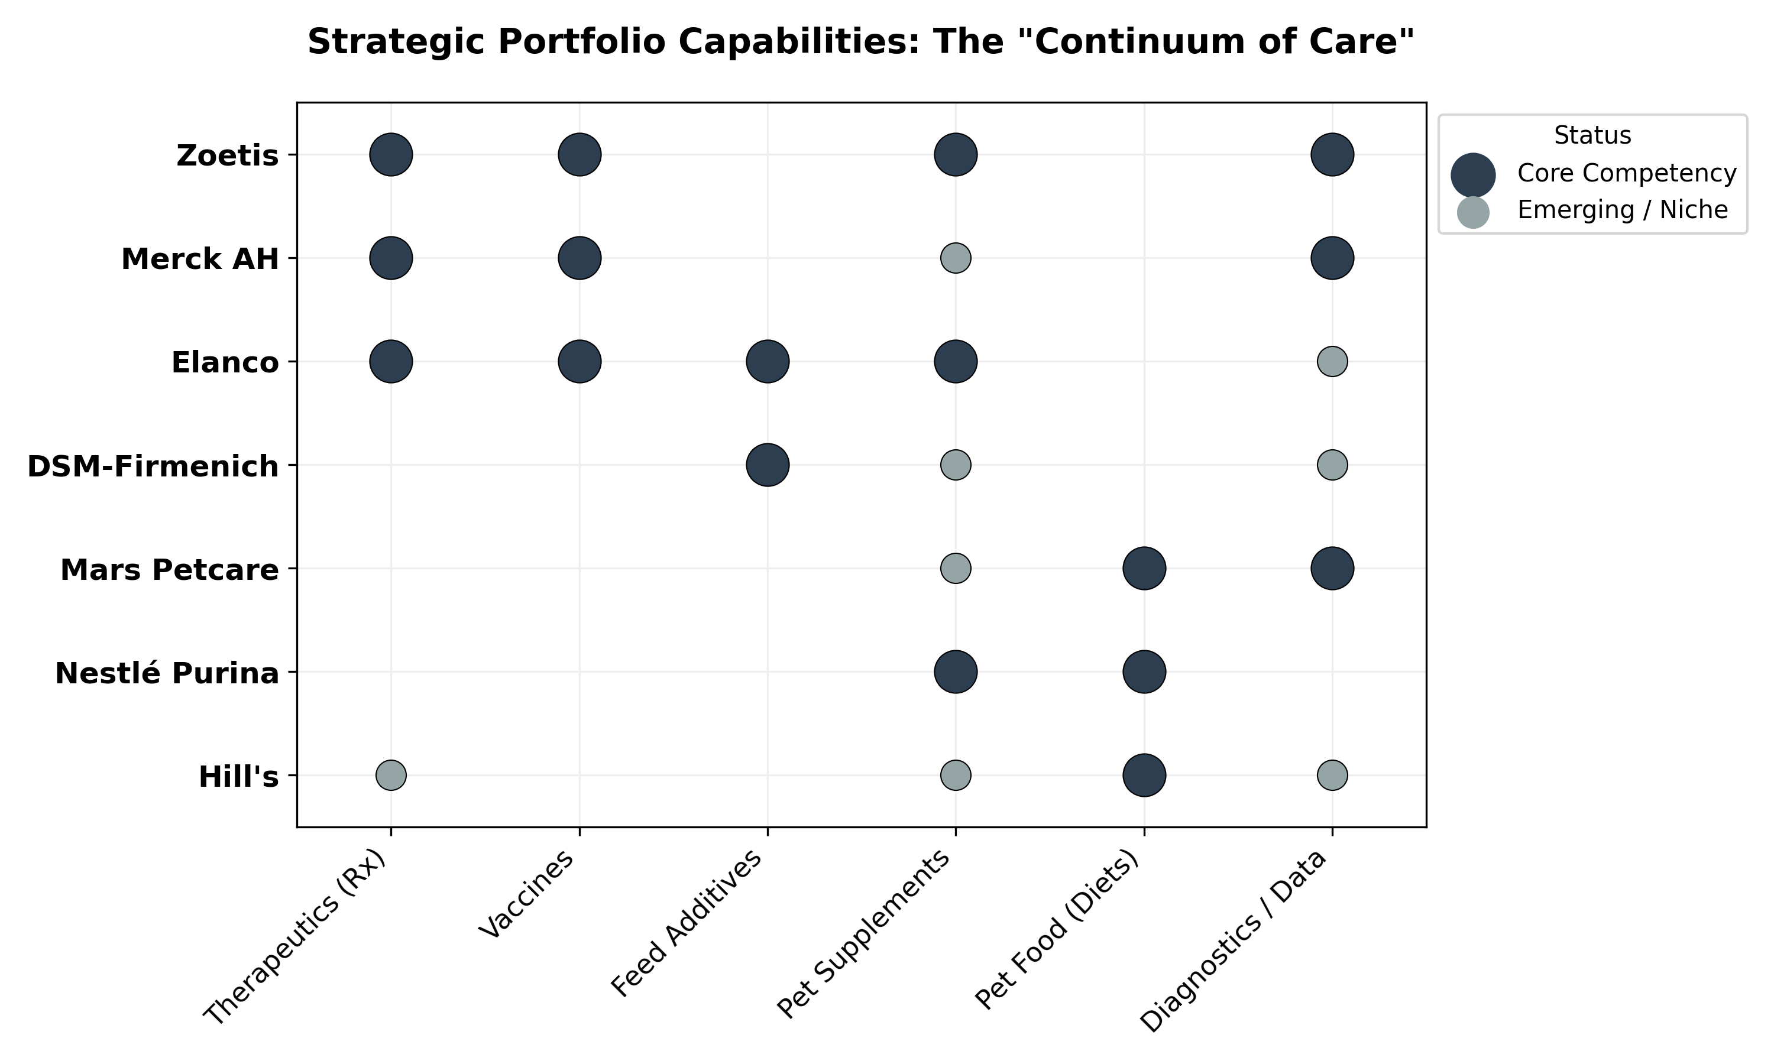 *Figure IV.2: Strategic Capability Matrix: How key players span the full Continuum of Care.* ***[Source: Company Filings and Annual Reports]***

**Strategic Positioning:** * **Vertical Integrators (Nutramax, Zinpro):** Own the stack, capture **25%+ EBITDA**. * **Asset-Light Marketers (Zesty Paws):** agile “Licensing & Assembly” model, but lower barrier to entry.

## **IV.2.3 Consumer-Facing Pet Nutrition Brands**

* **Nestlé Purina ($22.4B):** Pro Plan & FortiFlora are industry standards.
* **Mars Petcare ($22B):** integrated ecosystem (Food + Clinics + Data).
* **Hill’s ($4.4B):** Dominates “Prescription Diet” channel.
* **Challengers:** **Freshpet** (Fresh), **Swedencare** (Oral Health), and DTC brands compete on freshness and personalization.

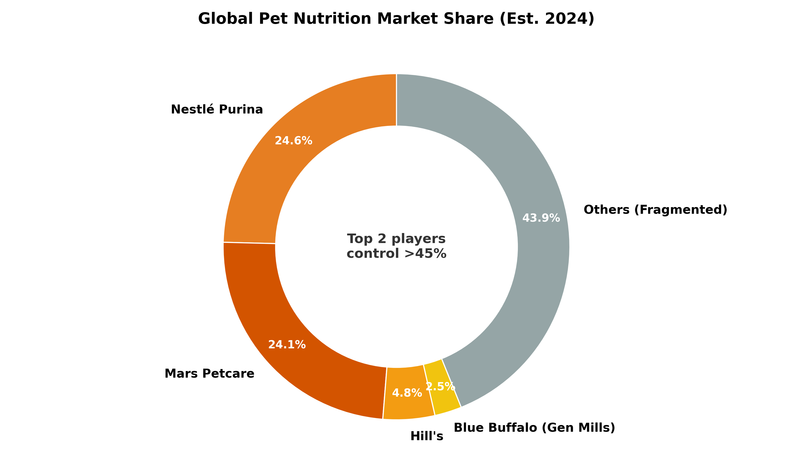 *Figure IV.3: Global Pet Nutrition Market Share: The “Long Tail” of Disruption.* ***[Source: Euromonitor International (2024)]***

**IV.2.4 Distribution Gatekeepers** * **Vet Channel:** Corporatized (IVC Evidensia). * **Retail:** PetSmart/Petco vs. Regional Champions (Musti). * **E-commerce:** Chewy (US) and Zooplus (EU) drive private label and data ecosystems.

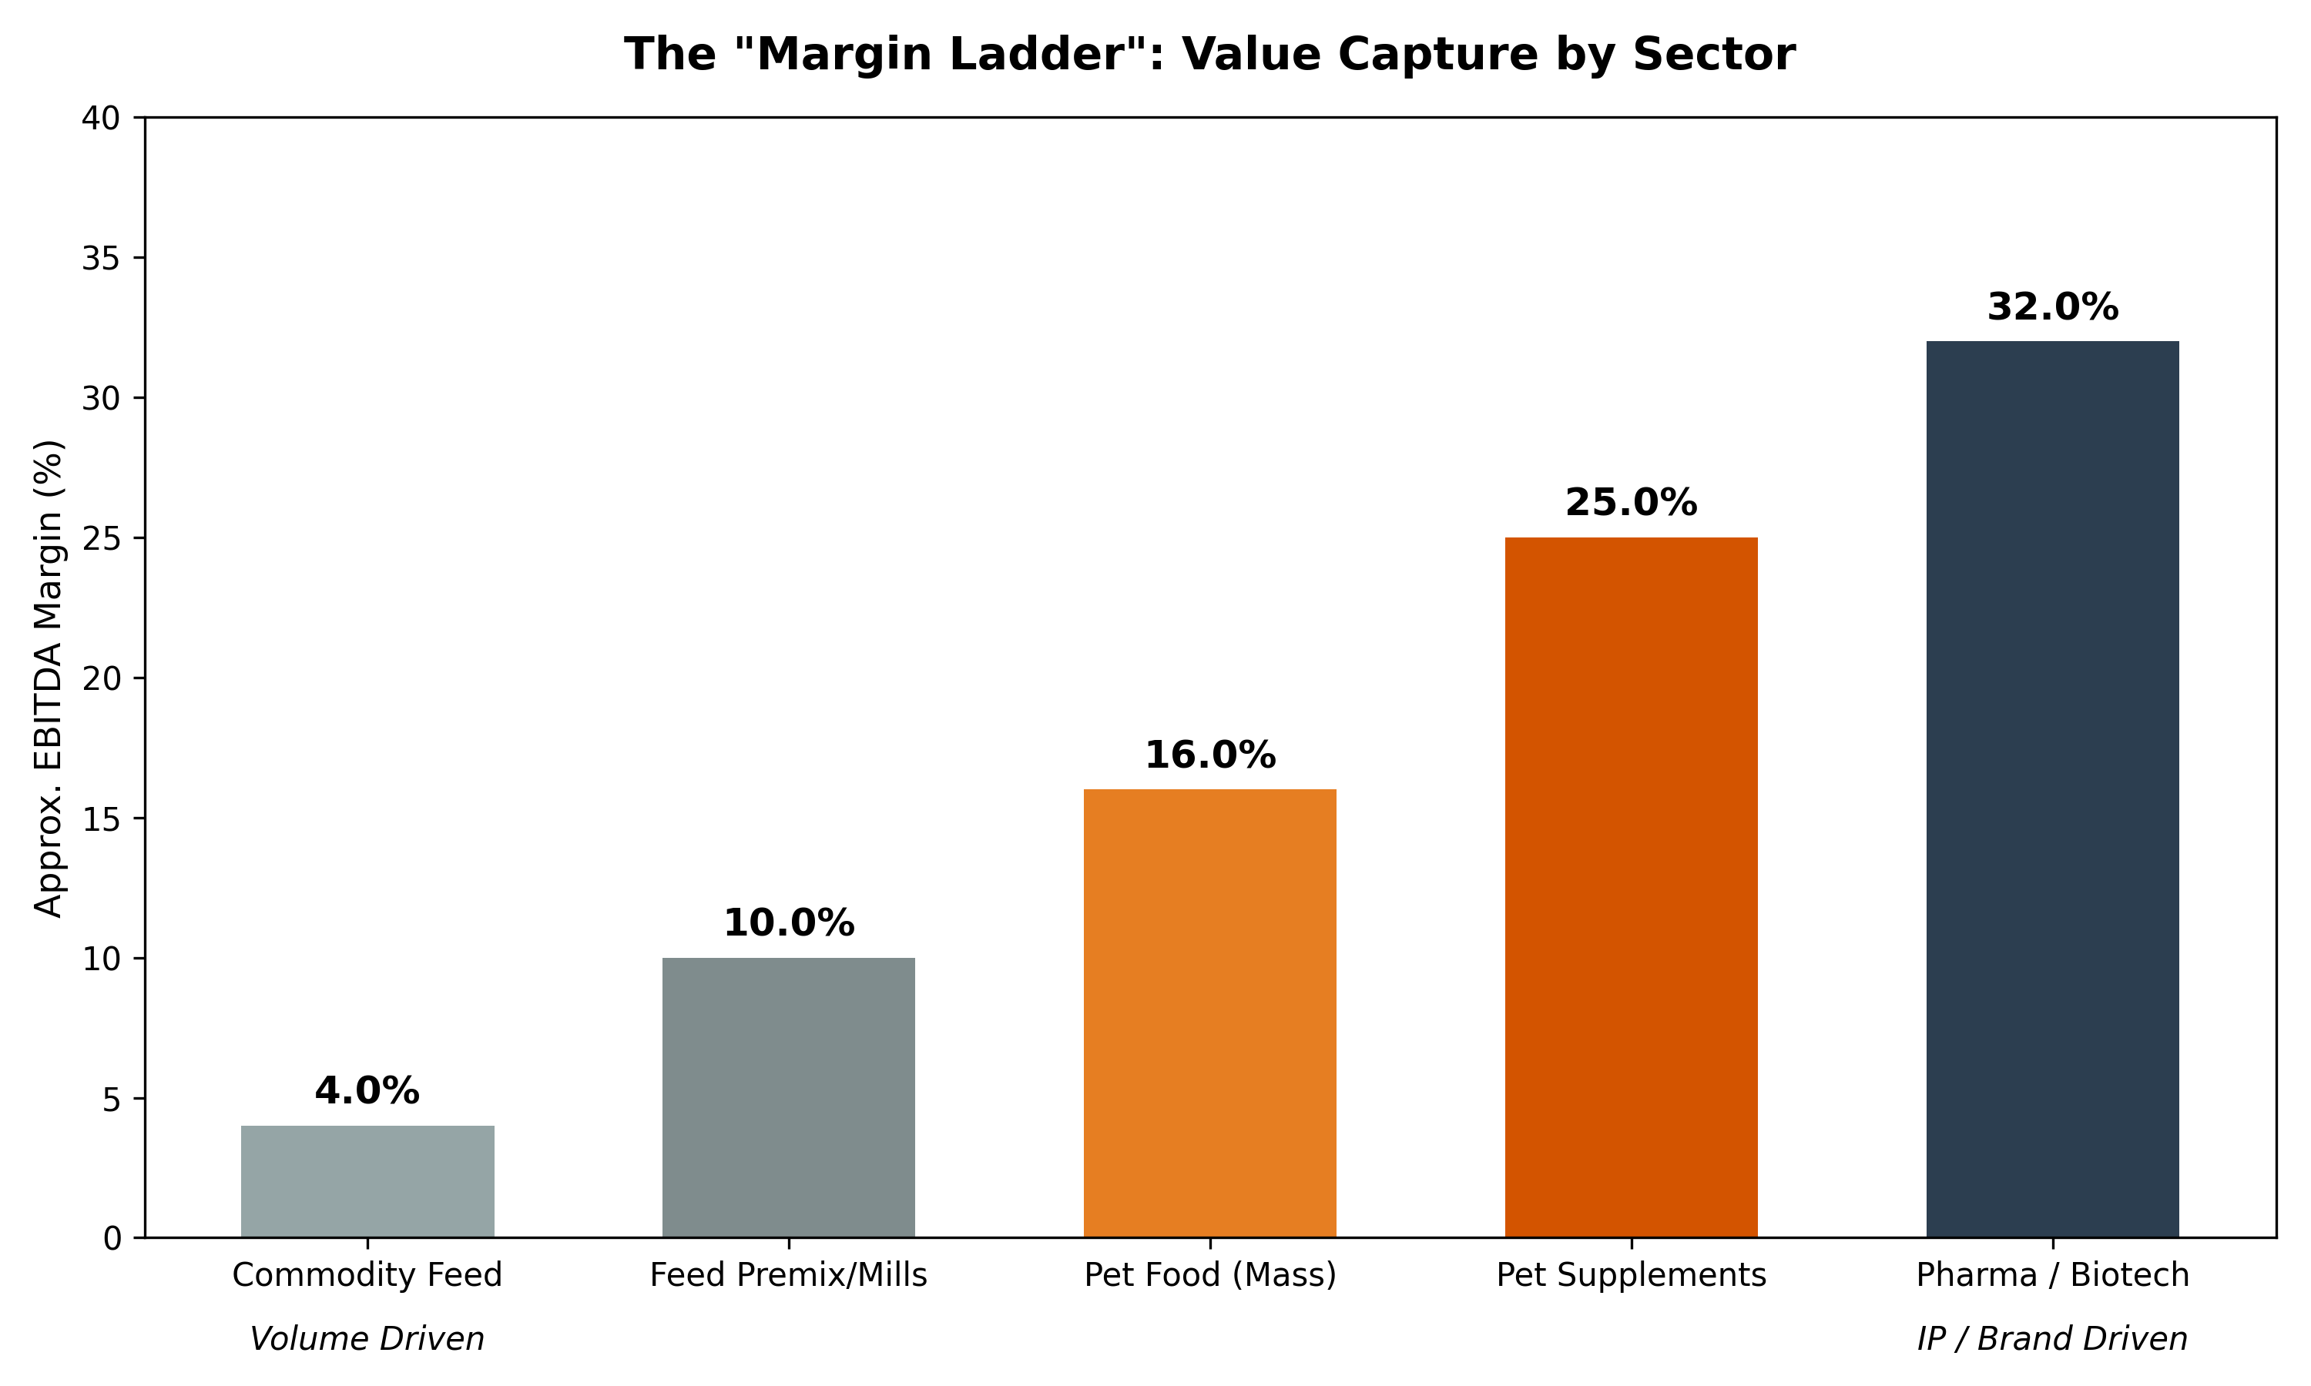 *Figure IV.4: The “Margin Ladder”: Comparative Value Capture by Value Chain Step.* ***[Source: Internal Margin Analysis]***

## **IV.3. Notable Transactions and Investment Landscape (2015-2025)**

Since 2015, the market has shifted from fragmented asset-gathering to a structured deal ecosystem. Transactions now signal where value is created: **Science-backed Pet Brands** (15-25x EBITDA) and **Functional Livestock Inputs** (10-15x EBITDA).

### **Table IV.1: Major Transactions >$100M (2015-2025)**

| **Year** | **Target** | **Acquirer** | **Deal Value** | **Category** |
| --- | --- | --- | --- | --- |
| **2018** | **Blue Buffalo** | General Mills | **$8.0B** | Pet Nutrition (Mass Premium) |
| **2018** | **Neovia** | ADM | **€1.5B** | Livestock Premix & Additives |
| **2020** | **Erber Group** | DSM | **€980M** | Eubiotics & Mycotoxin Risk |
| **2021** | **Zesty Paws** | H&H Group | **$610M** | Pet Supplements (E-Commerce) |
| **2022** | **Nom Nom** | Mars Petcare | **~$1.0B**\* | Fresh Pet Food (*Est.*) |
| **2022** | **NaturVet** | Swedencare | **$447M** | Pet Supplements (Manufacturing) |
| **2024** | **Aker BioMarine** | AIP | **$590M** | Upstream Ingredients (Krill) |
| **2024** | **Zoetis MFA** | Phibro | **$350M** | Medicated Feed Additives |

**(Note: Values based on enterprise value at time of announcement).**

### **IV.3.1. Companion Animals: The “Pet Premium” (Brands & Platforms)**

Consolidation in the pet sector is driven by the race for “recurring revenue” assets—brands with strong manufacturing moats, veterinary endorsement, and omnichannel velocity.

**1. Swedencare acquires NaturVet (USA, 2022)** * **Deal Value:** ~$447.5M. * **Valuation:** **21.4x EBITDA** (on 32.7% margin). * **Rationale:** A benchmark for premium soft-chew platforms. It demonstrated that high-margin manufacturing combined with strong retail/e-commerce velocity commands top-tier multiples.

**2. H&H Group acquires Zesty Paws (USA, 2021)** * **Deal Value:** $610M. * **Valuation:** Implies a rich revenue multiple (Revenue >$100M). * **Rationale:** Validated the “Digital-First” model. Zesty Paws dominated Amazon search rankings for “dog probiotics,” proving that digital shelf space is as valuable as physical distribution.

**3. Vetnique Labs (Gryphon) acquires Lintbells/YuMOVE (UK, 2024)** * **Deal Value:** Undisclosed (Reported 5.5x ROI for Inflexion). * **Context:** A transatlantic platform merger. * **Rationale:** Creates a chronic-care powerhouse. By combining Vetnique’s Glandex (gut/anal gland) with YuMOVE (mobility), the platform owns the “Senior Pet” wallet share.

**4. Morgan Stanley Capital Partners acquires FoodScience (USA, 2024)** * **Deal Value:** Undisclosed. * **Assets:** VetriScience, Pet Naturals. * **Rationale:** A “Sponsor-to-Sponsor” exit confirming institutional appetite for vertically integrated manufacturing assets.

### **IV.3.2. Livestock & Aquaculture: Precision & Scale**

The livestock thesis is distinct: deals focus on “biological infrastructure” that improves feed efficiency and regulatory compliance.

**1. Phibro acquires Zoetis MFA Portfolio (2024)** * **Deal Value:** $350M. * **Scale:** ~$400M in revenue. * **Rationale:** A classic “Asset Efficiency” play. Zoetis divested non-core feed additives to focus on biologicals; Phibro acquired entrenched cash-flow assets to scale its core nutrition business.

**2. DSM acquires Erber Group (Biomin/Romer Labs) (2020)** * **Deal Value:** €980M (~20x EBITDA). * **Rationale:** The definitive “Eubiotics” pivot. This acquisition anchored DSM’s move away from bulk vitamins toward high-value mycotoxin management and gut health solutions.

**3. Novonesis formed via Novozymes/Chr. Hansen (2024)** * **Merger Value:** ~$12.3B. * **Impact:** Consolidates the world’s largest microbial and enzyme libraries. * **Strategic Signal:** The future of feed efficiency lies in fermentation and biological solutions, not chemical synthesis.

### **IV.3.3. Upstream & Ingredient Platforms**

Investors are now securing the “inputs” to the value chain—specifically sustainable lipids and proteins.

**1. Aker BioMarine sells Feed Ingredients (Aker QRILL) (2024)** * **Deal Value:** $590M Enterprise Value. * **Buyer:** American Industrial Partners (AIP). * **Rationale:** Monetizes the “Krill Moat.” Signals PE willingness to own upstream biological supply chains that feed both aquaculture and pet markets.

**2. DSM-Evonik Veramaris JV** * **Investment Value:** $200M (Shared CapEx). * **Focus:** Algal Omega-3 (EPA/DHA). * **Rationale:** Strategic hedging against collapsing fish oil supply. It allows major feed players to claim specific “Fish-In/Fish-Out” sustainability metrics.

### **IV.3.4. Valuation Benchmarks & Deal Psychology**

The “Two-Speed” valuation reality is now established:

| **Metric** | **Pet / Companion** | **Livestock / Feed** |
| --- | --- | --- |
| **Typical Multiple** | **15x - 25x EBITDA** | **8x - 12x EBITDA** |
| **Driver** | Brand Equity, Recurring Revenue, DTC Data. | IP Protection, Regulatory Barrier, Volume Scale. |
| **Key Example** | **NaturVet (21.4x)**: Manufacturing + Brand. | **Erber (20x)**: Tech Moat (Mycotoxins) command premium. |
| **Buyer Type** | **70% PE / Financial**: Seeking growth. | **80% Strategic**: Seeking synergies/efficiency. |

**Strategic Conclusion:** The era of generic “asset aggregation” is fading. The highest returns now flow to **Thematic Plays**: * **Vertical Integration:** Owning the factory (FoodScience, NaturVet). * **Cross-Border Platforms:** Merging EU/US leaders (Vetnique/Lintbells). * **Deep Tech:** Owning the biological IP (Biomin, Novonesis).

### **IV.3.5. Key Investor Profiles**

A “barbell” landscape: **Mega-PE** consolidates channels (JAB, EQT), while **Specialized VCs** fund biotech innovation.

### **Table IV.2: Key Investor Profiles & Portfolios**

| **Investor** | **Key Assets** | **Focus** |
| --- | --- | --- |
| **JAB Holding** | NVA, Ethos | **Vet Services Consolidation** (#2 Global). |
| **Gryphon** | Vetnique, YuMOVE | **Platform Building** (Vet-endorsed brands). |
| **MSCP** | VetriScience | **Manufacturing & Scale**. |
| **EQT Group** | **~€270B** | **IVC Evidensia**, **Zooplus**, **Dechra** |
| **BC Partners** | **>$40B** | **PetSmart**, **Gambol Pet Group** |
| **Cinven** | **€44B** | **Arcaplanet**, **Partner in Pet Food** |
| **Advent International** | **~$100B** | **Seek Pet Food**, **Felix Pharms** |
| **Clearlake Capital** | **>$90B** | **Wellness Pet Company** |
| **Verlinvest** | **>€2B** | **Tom & Co**, **Nesto** |
| **Vestar Capital Partners** | **$3.2B** | **PetHonesty** |
| **Digitalis Ventures** | **>$800M** | **Native Pet**, **Ancestral**, **Gallant**, **Astra Therapeutics** |
| **Ani.VC** | **Undisclosed** | **The Cat Health Company**, **MI:RNA**, **Vetmab** |
| **Borealis Ventures** | **>$300M** | **Embark**, **Fidocure**, **Vetcove** |
| **S2G Investments** | **>$2B** | **Enthos**, **Pasture Bio**, **Kingdom Supercultures** |
| **Seventure Partners** | **~$1.1B** | **ViroVet**, **Proteon** |
| **Anterra Capital** | **>$400M** | **BiomEdit** |
| **Aqua-Spark** | **~€500M** | **Protix**, **Sea6 Energy** |
| **Five Seasons Ventures** | **>€250M** | **Mammaly**, **Butternut Box** |
| **Blue Horizon** | **~$300M** | **Wild Earth**, **Mosa Meat** |
| **Ocean 14 Capital** | **~€200M** | **SyAqua**, **Enthos** |
| **Stray Dog Capital** | **Undisclosed** | **Wild Earth**, **Bond Pet Foods** |
| **Cavallo Ventures** | **Corp. VC** | **Native Microbials**, **Bond Pet Foods** |

### **IV.3.6. Competitive Analysis Summary**

**Key Insights from Competitive Analysis:**

1. **Margin Bifurcation**: Pharma-linked players command 30-40% EBITDA margins on Rx products vs. 6-12% for feed commodity players
2. **Pet Premium**: Consumer-facing pet nutraceutical brands sustain 20-25% EBITDA with premium pricing power
3. **Scale Advantage**: Top 5 feed additive players control ~55% of global market, creating significant barriers to entry
4. **Clinical Moat**: Companies with published efficacy data (Nutramax, Hill’s) command 20-40% price premiums
5. **Channel Power**: E-commerce growth (Chewy, Amazon) is compressing traditional vet-channel margins by 100-200 bps

## **IV.4 Valuation Dynamics and Margin Analysis**

### **IV.4.1 Pet-focused consumer brands: “The Wellness Premium”**

Consumer-facing pet nutrition businesses typically sustain **EBITDA margins in the 20–25% range** and command **15x–20x+ EBITDA multiples**. This premium is driven by inelastic consumer spending and the “humanization” of pet health. The upper end of this valuation range is reserved for brands that demonstrate:

* **Clinical Moats:** Differentiated efficacy backed by published data (e.g., *Hill’s Science Diet*, *Dasuquin*).
* **Recurring Revenue:** Strong subscription models with high retention (e.g., *Chewy*, *Butternut Box*).
* **Professional Trust:** Endorsement by veterinarians, creating a defensible barrier to entry.
* **Measurable ROI:** Products delivering visible health outcomes (e.g., improved mobility, coat shine) that justify premium pricing.

### **IV.4.2 Livestock and specialty-ingredient platforms: “Efficiency at Scale”**

Upstream ingredient providers (enzymes, probiotics) typically post **15–25% EBITDA margins** and trade on **high-single to mid-10s multiples**. * **Key Driver:** IP protection and regulatory barriers (e.g., *Novonesis* with >35% margins). * **Constraint:** Exposure to commodity cycles and on-farm ROI scrutiny.

### **IV.4.3 Key Valuation Drivers: The 4 Accelerators (2024–2025)**

Investors are currently paying a premium for assets aligned with four specific catalysts:

1. **Clinical Evidence & Differentiation**

* *The Driver:* Peer-reviewed efficacy data (e.g., methane reduction stats, joint mobility scores).
* *The Impact:* Validates “Science-Inside” claims, supporting premium pricing over generics.

1. **Regulatory De-risking**

* *The Driver:* Clear pathways (e.g., Innovative FEED Act in the US, EU harmonization).
* *The Impact:* Shortens time-to-market for novel functional additives.

1. **Sustainability & ESG Integration**

* *The Driver:* Resource efficiency tools (e.g., *Bovaer* for methane).
* *The Impact:* Positions additives as essential “Scope 3” decarbonization assets for global food giants.

1. **E-commerce & Data Integration**

* *The Driver:* Direct ownership of the consumer relationship and first-party data.
* *The Impact:* Increases Customer Lifetime Value (CLV) and reduces reliance on traditional retail intermediaries.

## **IV.5 Market Structure Summary: The “Margin Ladder”**

The competitive landscape is structured into four distinct layers of value capture:

* **Layer 1: The IP Engines (Ingredients & Tech)**
* *Focus:* Fermentation, active molecule synthesis.
* *Financials:* **15–25% EBITDA**. High checking barriers.
* *Examples:* *Novonesis*, *DSM-Firmenich*.
* **Layer 2: The Infrastructure (Premix & Feed)**
* *Focus:* Milling, blending, bulk manufacturing.
* *Financials:* **3–7% EBITDA**. Capital intensive, volume-driven.
* *Examples:* *ForFarmers*, regional feed mills.
* **Layer 3: The Brand Builders (Consumer Channels)**
* **Strategy**: “Clean Label” transparency and specific condition targeting (e.g., Allergy, Mobility).
* **Examples**: **Native Pet** & **PetHonesty** (DTC “Clean” Supplements).
* **Specialists**: **YuMOVE** (Mobility Leader), **ElleVet** (Clinical Hemp/CBD), **Earth Animal** (Holistic & No-Hide).
* **Risk**: High CAC (Customer Acquisition Cost) dependency on Meta/Google ads.
* **Layer 4: The Gatekeepers (Distribution & Data)**
* *Focus:* Aggregating demand, owning the “last mile”.
* *Financials:* **12–15% EBITDA**. Value derived from ecosystem lock-in.
* *Examples:* *Chewy* (USA), *Zooplus* (EU), *PetSmart* (Omni-channel Network).

Capital flows are increasingly bypassing Layer 2 to target the **IP (Layer 1)** and **Brands (Layer 3)**, where differentiation is strongest.

## **IV.6. Strategic Implications for Investors**

For banking clients, investors, and corporate strategists, several high-level takeaways emerge from this competitive mapping:

Two-speed market: Pet nutraceuticals (20–25% margins, 15–20x multiples) command a structural premium over livestock additives (3–10% margins, 1–15x multiples). Pet brands are the “trophy assets”; livestock feed is the “essential infrastructure.”

Science as a moat: Clinical differentiation (Dasuquin, Bovaer, NexGard PLUS) drives premium pricing and multiples. Companies investing in efficacy data and IP will command sustained pricing power.

Consolidation vectors: (a) Upstream scale – Novonesis, DSM-Firmenich, and fermentation biotech are attracting strategic and PE interest; (b) Branded pet platforms – Direct acquisition of Nutramax, Wellness Pet, and DTC brands by larger players; (c) Data and distribution – Chewy, veterinary networks, and retail chains becoming increasingly valuable for private-label development.

Regulatory tailwinds: AGP/ZnO bans and the Innovative FEED Act are creating tailwinds for alternative additive suppliers, supporting valuations for DSM, Novonesis, Cargill, and specialized suppliers.

ESG as pricing driver: Methane-reduction additives (Bovaer, SilvAir™) are becoming essential for large livestock groups meeting climate targets and are commanding premium pricing and multiples.

## **IV.7. Strategic Capital Allocation Matrix**

**The “Winner’s Matrix” (Strategic Positioning)**

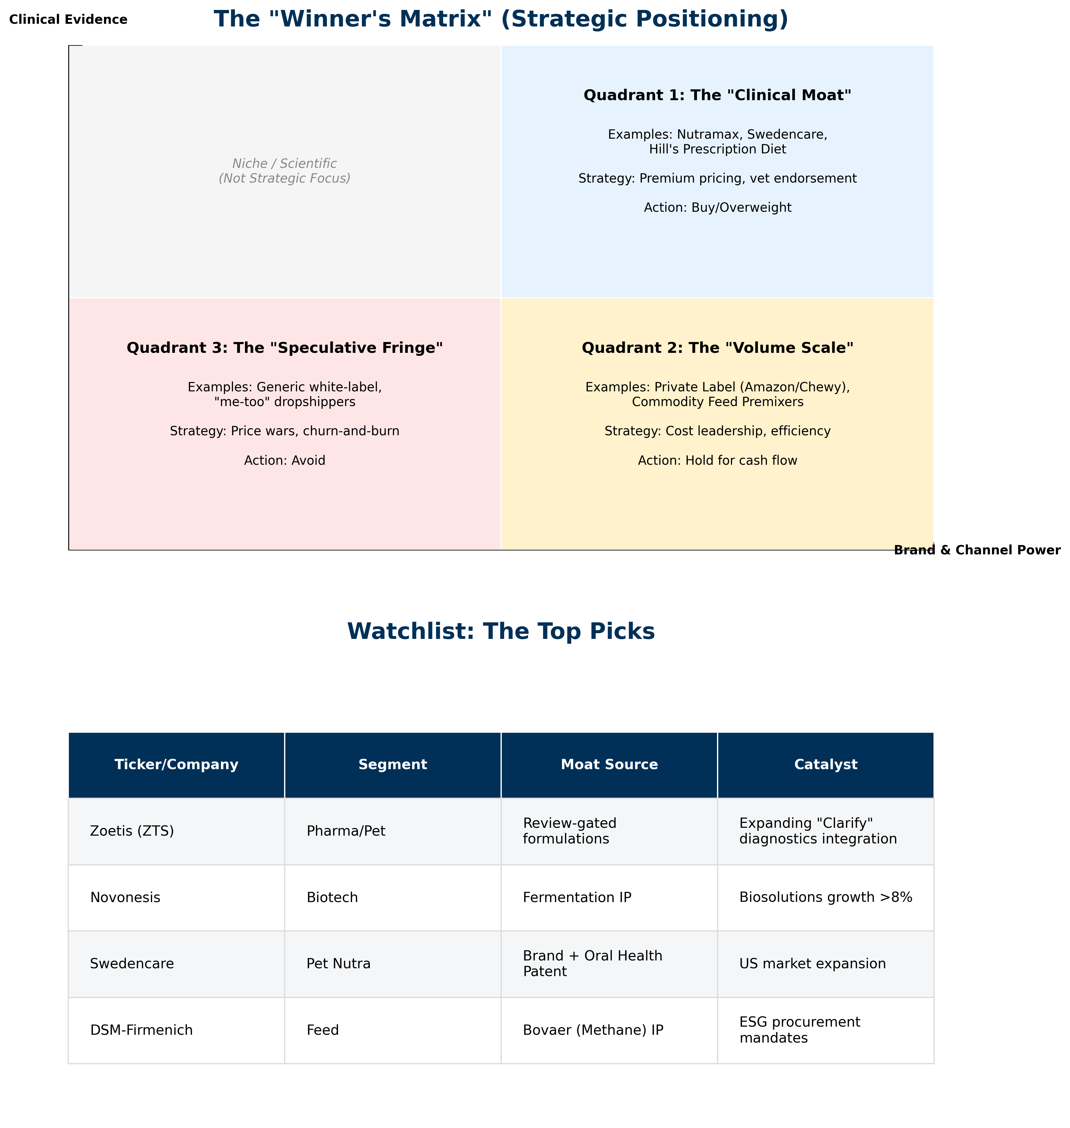 > *Figure IV.5: Strategic Capital Allocation Matrix and Watchlist: Mapping the “Clinical Moat” against commercial volume scale.* ***[Source: Internal M&A Database]***

### **IV.7.1 Quadrant Analysis**

The competitive landscape is defined by two critical axes: **Clinical Evidence** (the ability to prove efficacy) and **Brand & Channel Power** (the ability to reach the customer). This creates three distinct investable zones:

**Quadrant 1: The “Clinical Moat” (High Evidence / High Power)** * **Examples:** Nutramax, Swedencare, Hill’s Prescription Diet * **Strategy:** Premium pricing, veterinary endorsement, recurring revenue. * **Action: Buy/Overweight**

**Quadrant 2: The “Volume Scale” (Low Evidence / High Power)** * **Examples:** Private Label (Amazon/Chewy), Commodity Feed Premixes * **Strategy:** Cost leadership, efficiency, supply chain dominance. * **Action: Hold for cash flow**

**Quadrant 3: The “Speculative Fringe” (Low Evidence / Low Power)** * **Examples:** Generic white-label, “me-too” dropshippers * **Strategy:** Price wars, churn-and-burn marketing. * **Action: Avoid**

*(Note: The Top-Left quadrant “Niche / Scientific” represents high-science ventures that lack commercial scale, typically acquisition targets rather than standalone investments.)*

### **IV.7.2 Watchlist: The Top Picks**

| **Ticker/Company** | **Segment** | **Moat Source** | **Catalyst** |
| --- | --- | --- | --- |
| **Zoetis (ZTS)** | Pharma/Pet | Review-gated formulations | Expanding “Clarify” diagnostics integration |
| **Novonesis** | Biotech | Fermentation IP | Biosolutions growth >8% |
| **Swedencare** | Pet Nutra | Brand + Oral Health Patent | US market expansion |
| **DSM-Firmenich** | Feed | Bovaer (Methane) IP | ESG procurement mandates |

### **Conclusion of Part IV: The Consolidation Landscape**

The competitive landscape is actively bifurcating. On one side, **Global Titans** (Mars, Zoetis) are industrializing the “Continuum of Care,” using nutraceuticals as the entry funnel for their ecosystem. On the other, **Specialized Innovators** are building high-margin “Clinical Moats” in niches like oral health or methane reduction. The era of the “average” supplement company is over; survival now requires either massive scale or undistributed IP. **Part V** turns to the future, analyzing the two “Disruptive Frontiers”—Green Labels and Nutrigenomics—that will determine the *next* generation of winners in this consolidating field.

## **V. Emerging Strategic Frontiers (2026-2030)**

***In this section:*** *We analyze the two most disruptive vectors reshaping the industry: The institutionalization of sustainability credentials (“Green Labels”) and the biological precision of Nutrigenomics (“Biology as Software”).*

### **V.1. The Institutionalization of Green Labels**

*The shift from marketing optionality to regulatory “license to operate.”*

#### **V.1.1 The Regulatory Squeeze: A Multi-Regional Landscape**

The era of self-declared “Eco-Friendly” claims is ending, but the rules of the road vary significantly by geography. Winning organizations are tailoring their evidence strategies to four distinct regulatory blocs:

**A. European Union: The “Hard Line” (EmpCo)** The EU represents the strictest regime globally. The **Empowering Consumers for the Green Transition (EmpCo)** Directive (fully applicable by late 2026) fundamentally reshapes the shelf: * **Bans Generic Claims:** Terms like “Green”, “Nature-Friendly”, or “Eco” are prohibited unless linked to demonstrated excellent performance (e.g., EU Ecolabel). * **Restricts Offsets:** “Carbon Neutral” claims based on offsetting are effectively banned in B2C, forcing brands to compete on *actual* lifecycle reductions.

**B. United States: The Functional Gateway (FEED Act)** While the **FTC Green Guides** remain the baseline for marketing compliance, the proposed **Innovative FEED Act** (H.R. 2203) promises a structural shift. It creates a regulatory pathway for “Zootechnical” ingredients to make substantiated **environmental effectiveness claims** (e.g., “Reduces Methane”) without being classified as drugs, unlocking R&D investment.

**C. United Kingdom: The Principles-Based Approach (CMA)** Post-Brexit, the UK follows the **Competition and Markets Authority (CMA) Green Claims Code**. Unlike the prescriptive EU directives, the CMA relies on **6 Key Principles** (e.g., “Claims must be substantiable,” “Must not omit important information”). Enforcement is active, with the CMA explicitly targeting “vague” sustainability language in the FMCG sector.

**D. APAC: The “Safety-First” & Fragmented West** * **China:** Regulation focuses primarily on **Food Safety** and strict **Advertising Laws** (banning superlatives like ” #1 Green”). Sustainability claims are emerging but secondary to safety. * **Australia (ACCC):** The ACCC has recently released strict guidance cracking down on “greenwashing,” closely mirroring the US FTC approach but with increased audit activity on “Net Zero” targets. * **Japan/Korea:** Voluntary industry standards dominate, often linked to “Circular Economy” initiatives.

**E. Latin America (LATAM): The “Export Visa” Market** In LATAM, the “Green Label” is effectively a “License to Export,” shaped entirely by external pressure (EUDR). * **The Mandate:** To access European markets, Brazilian and Argentine beef/soy producers must prove their supply chain is **“Deforestation-Free.”** This is a binary compliance requirement, not a consumer preference. * **Innovation:** Institutions like **Embrapa** have developed “Carbon Neutral Brazilian Beef” and “Low Carbon Beef” protocols, turning sustainability certifications into quasi-official export visas. This drives demand for “Intensification Tools” (additives that produce more beef on less land).

#### **V.1.2 Summary: Regional Regulatory Winners & Losers**

| **Region** | **The “Green” Definition** | **Winner (Product Type)** | **Loser (Product Type)** |
| --- | --- | --- | --- |
| **US** | **“The Scope 3 Reducer”** | Methane Inhibitors (e.g., 3-NOP) | Generic Probiotics (unproven claims) |
| **EU** | **“LCA Verified”** | Nitrogen-Smart Enzymes & Proteins | Vague “Eco-Friendly” Brands |
| **UK** | **“Precise & Honest”** | Insect Protein (proven data) | “Ocean Safe” Whitefish (hard to prove) |
| **APAC** | **“Efficient/Credit”** | Low-Soy Diets & Yield Boosters | Imported Premium Grains |
| **LATAM** | **“Deforestation-Free”** | Intensification Tools (Growth Promoters) | Extensive Grazing (Land heavy) |

#### **V.1.3 The Green Label Evidence Hierarchy**

To navigate this shift, winning organizations are adopting a tiered evidence model, moving away from high-risk generic claims toward data-backed substantiation. **This hierarchy has effectively been institutionalized by the convergence of legislative mandates (EU EmpCo) and technical standards (PEFCR, ISO 14067).**

| **Tier** | **Claim Category** | **Risk Level** | **Evidence Requirement** | **Examples** |
| --- | --- | --- | --- | --- |
| **5** | **Multi-Attribute Proficiency** | 🔴 **High Risk** | Recognized excellence across *all* impact categories. Almost impossible to substantiate fully. | “Planet Positive”, “Sustainable Product” |
| **4** | **Certified Seals** | 🟡 **Med Risk** | Third-party audit, strict chain-of-custody, complying with scheme rules. | **MSC**, **Upcycled Certified**, **ISCC** |
| **3** | **Aggregated Footprint** | 🟢 **Low Risk** | LCA aligned with **PEFCR** (EU) or ISO 14067. Requires primary data. | “Product Carbon Footprint: 5kg CO2e” |
| **2** | **Comparative Claims** | 🟢 **Low Risk** | Consistent boundaries & functional units. Strict baseline controls. | “30% Lower Carbon vs. Standard Diet” |
| **1** | **Specific Attributes** | 🟢 **Low Risk** | Supplier documentation & batch traceability. | “Made with 50% Recycled Plastic” |

*Figure V.1: The 5-Tier Evidence Hierarchy: Moving from generic risk (Tier 5) to granular data (Tier 1-3).* ***[Source: Adapted from EU Green Claims Directive (2024)]***

#### **V.1.4 Strategic Innovators: The Divergence into “Climate Compliance” vs “Eco-Purity”**

The market is being reshaped by companies that convert sustainability attributes into measurable, verifiable value. This has led to a bifurcation between “Climate Compliance” (Livestock) and “Eco-Purity” (Pet).

**Category A (Livestock): Climate Compliance & The Methane Battleground** **DSM-Firmenich** defined the category with **Bovaer® (3-NOP)**, validating a ~30% methane reduction claim that transformed a “soft” ESG goal into a “hard” Scope 3 asset for dairy cooperatives. However, agile challengers are emerging: **Rumin8** is solving the “seaweed scalability” problem by pharmaceutically *synthesizing* bioactive bromoform, while **Hoofprint Biome** offers a “biological” alternative via novel enzymes—both targeting the same outcome with next-generation delivery mechanisms.

**Category B (Pet): Eco-Purity & Circular Architectures** In pet food, the “Green” label is merging with “Human-Grade Purity.” **Native Pet** has effectively monetized the “Clean Label” trend by limiting formulas to <5 recognizable ingredients. **Chippin** (silver carp/insect protein) and **Bond Pet Foods** (precision fermentation) are proving that consumers will pay a 20–30% premium for “Science-backed Sustainability.” Behind the scenes, industrial scalers like **InnovaFeed** (Insects) and **Veramaris** (Algal Oil) are breaking reliance on marine fish oil, positioning their “Scope 3 Essential” ingredients as the backbone for modern, sustainable aquaculture and premium pet diets.

**Institutionalizing Trust:** The **Upcycled Food Association (UFA)** provides a critical governance layer. By creating the **“Upcycled Certified”** standard, they legitimized the use of “waste” (e.g., spent grains) as a premium attribute, protecting brands from greenwashing accusations while appealing to the “Zero Waste” consumer.

#### **V.1.5 Strategic Synthesis: How Green Labels Reshape the Market**

1. **De-Commoditization:** Green attributes (e.g., “Deforestation-Free”) sell *outcomes*, not just *inputs*, commanding premiums.
2. **Data as Gatekeeper:** MRV (Measurement, Reporting, Verification) control is key. Verified data packets lock in customers.
3. **“Carbon Luxury”:** In pet food, “Low-Carbon” is the new “Grain-Free,” favoring incumbents who can afford complex supply chains.

### **V.2. The Nutrigenomics Frontier: Biology as Software**

*Investment Thesis: Feeding by measurable biology (Genotype, Phenotype, Microbiome).*

**1. Genomic Profiling (DNA as a Service):** * **Embark (USA):** *Risk Radar.* Genotyping to detect risks (HUU) and validate diet pipelines. * **Orivet (Global):** *Lifestyle Architect.* Automated “LifePlans” based on breed mix and risk.

**2. Microbiome Profiling & Restoration:** * **Biome9 (UK):** *Predictive AI.* Pre-symptomatic health prediction via gut sequencing. * **AnimalBiome (USA):** *Restoration.* FMT capsules to restore microbiome diversity. * **Native Microbials (USA):** *Rumen Native.* Species-specific “native” strains. * **Gnubiotics (Switzerland):** *Structural Architect.* HMO mimics (Glycans) for immunity.

**3. Synthetic Biology & Discovery:** * **BiomEdit (USA):** *Biome-Active Engineer.* Synthetic biology for novel bio-actives (methane reduction). * **Rumin8 (Australia):** *Methane Hunter.* Pharma-grade bromoform (seaweed active) synthesis. * **Hoofprint Biome (USA):** *Probiotic Engineer.* Engineered probiotics to eliminate methanogens. * **Anizome (Global):** *Discovery.* Bridging academic research and commercial pipelines.

**4. Nutrigenomic Additives:** * **Alltech:** Gene expression verification for additives. * **Phytobiotics:** Standardized botanical additives (Sangrovit®).

**Strategic Implication:** Value lies in the **“Translator”**—the algorithm converting data into product recommendations—not the test itself.

### **V.3. The Regulatory Grey Zones (Future-Proofing)**

#### **V.3.1 Novel Foods & Alternative Proteins**

* **Bond Pet Foods (USA):** “Nature-identical” chicken protein via fermentation. Partnered with Hill’s.
* **Innovafeed (France):** Industrial insect protein (BSF) for aqua/pet. “Carbon-Negative.”
* **Veramaris (Netherlands):** Algal Omega-3 oil, replacing wild fish oil.
* **MicroHarvest (Germany):** Single-cell protein (5000x faster than soy).
* **Wild Earth (USA):** Fungi-based (Koji) dog food.

#### **V.3.2 The “Longevity” Regulatory Path**

**Loyal (Cellular Longevity):** Frontrunner in “Dog Longevity.” FDA concurrence for **LOY-001** creates a new category: *Lifespan Extension Drugs.*

#### **V.3.3 The Gene-Editing Frontier (CRISPR)**

**Folium Science (UK):** Uses **CRISPR-Cas** (“Guided Biotics™”) to selectively remove pathogens (Salmonella) without harming beneficial bacteria.

### **V.4. The Longevity Economy: Pet Humanization 2.0**

*Investment Thesis: From “Preventive Care” to “Geroprotection”.*

1. **“Purity”:** **Native Pet (USA)** wins with “Clean Label” supplements.
2. **Regenerative:** **Gallant (USA)** banks stem cells for future therapy.
3. **“Skinification”:** **Dandylion** brings pH-balanced, fragrance-free skincare to pets.
4. **Microbiome:** **AnimalBiome** reverses aging-related dysbiosis via FMT.

### **V.5. Bio-Manufacturing: The New Supply Chain**

* **Algal Fermentation:** **Veramaris** (Omega-3s).
* **Milk Oligosaccharides:** **Gnubiotics** (HMO mimics for immunity).
* **Bacteriophages:** **Proteon** (Antibiotic replacement).

### **V.6. The Livestock Strategic Pivot: The “Great Divergence” (2026-2030)**

Investors must distinguish between **Structural Decline (EU)** and **Cyclical Volatility (USA)**.

#### **V.6.1 The “De-Ruminization” of the West**

* **Europe:** Structural policy contraction (-5.2% cattle, -10.5% sheep) due to Green Deal/Nitrogen limits. Shift to **Efficiency** and **Nitrogen Management**.
* **USA:** Cyclical contraction (lowest herd since 1951) due to drought. Driven by **Cost Control** and **Resilience**.

#### **V.6.2 The Growth Engines: Poultry and Aquaculture**

* **Poultry:** The “Resilience King.” Only expanding EU sector (+10.5%). Commands **43.5%** of global additive market.
* **Aquaculture:** Scored a historic crossover in 2022 (surpassed wild capture). Fastest CAGR. Primary constraint is “Fish-In/Fish-Out,” driving demand for **Algal Oils** and **Insect Protein**.

### **V.7. Outlook: How AGP Limitations in India and China Could Reshape the Market Size**

#### **V.7.1 China: The Post-AGP Transition (2020–2030)**

China’s 2020 AGP ban is a watershed. * **Market:** **$2.5–3.0B** (2024) $→$**$5.0–6.5B** (2030). * **Opportunity:** Import dependency for high-efficacy probiotics creates a premium for Western suppliers (DSM, Evonik). * **First Mover:** Companies with MARA licenses hold a decisive advantage.

#### **V.7.2 India: The Emerging Regulatory Frontier (2025–2035)**

* **Status:** Voluntary guidelines now; phased AGP restriction likely by **2027–2028**.
* **Potential:** A nascent **$400–500M** market could swell to **$1.5–2.5B** by 2035, driven by poultry and dairy intensification.

#### **V.7.3 Combined Impact: Recalibrating the Global TAM**

| **Scenario** | **Current TAM (2024)** | **Projected TAM (2030–2035)** | **Incremental Opportunity** |
| --- | --- | --- | --- |
| **China** | ~$2.5B | ~$5.5–6.5B | **+$3.0–4.0B** |
| **India** | ~$0.5B | ~$1.5–2.5B | **+$1.0–2.0B** |
| **Total Asia** | ~$3.0B | ~$7.0–9.0B | **+$4.0–6.0B** |

[!IMPORTANT **Upside Case:** Full AGP adoption in China/India could push the global market to **$24–28 billion** (+30–40% upside).

#### **V.7.4 Strategic Implications**

1. **Suppliers:** Use Asian regulatory expertise (Novonesis, DSM).
2. **Network:** JVs with local feed giants (CP Foods, Godrej).
3. **Product:** “Value-engineer” for tropical climates and price sensitivity.

## **VI. Conclusion: The Investment Roadmap for 2030**

The animal nutraceutical sector has graduated from a niche regulatory anomaly into a robust **$13 billion asset class**. This report has detailed a market undergoing a fundamental “Two-Speed Evolution,” where the drivers of value creation are distinct but equally compelling.

**For the Growth Investor (Pet Health):** The “humanization” thesis is evolving into a “medicalization” thesis. The easy growth of generic web-first brands is ending. The next decade belongs to platforms that can deliver verified health outcomes. The winning assets will be those that bridge the gap between retail accessibility and veterinary credibility, turning pet owners into lifelong subscribers of preventative health.

**For the Value & Infrastructure Investor (Livestock):** The post-antibiotic transition is not a trend; it is a permanent restructuring of the global food chain. Probiotics, enzymes, and phytogenics are becoming the biological software of modern farming. The opportunity here is not just about replacing antibiotics, but about owning the efficiency layer of global protein production.

**The Final Deal Thesis:** We are witnessing the decoupling of “Marketing” from “Science.” Capital is aggressively moving toward IP-backed assets that can withstand regulatory scrutiny and deliver measurable ROI. Whether through the aggregation of fragmented pet brands or the technological consolidation of feed inputs, the winners will be the “Integrators” who can scale biological innovation into financial enterprise value.

## **Appendix: Author & Disclaimer**

**About the Author** Prepared by the Animal Nutraceuticals Research Team.

**Disclaimer** *Informational purposes only. Estimates based on Q1 2026 data.*

# **Appendix B: Comprehensive Industry Players List**

This exhaustive list consolidates key market players, startups, and investors identified throughout the research.

| **Company** | **Category** | **Key Product/Focus** | **Target Species** | **Strategic Summary** |
| --- | --- | --- | --- | --- |
| AB Vista | Livestock Feed & Additives | Econase XT, Quantum Blue (enzyme) | Poultry, Swine | Performance, FCR, and Growth. Phytase enzyme – increases phosphorus availability and growth (feed conversion) in monogastrics |
| ADM | Livestock Feed & Additives | Protexin, DE111® |  | Fermentation: Massive fermentation capacity for probiotics. |
| Adisseo | Livestock Feed & Additives | Rovabio® (Enzymes), Selisseo | Poultry, Swine, Ruminants | Immunity and Resilience. Hydroxy-selenomethionine (100% organic selenium source) – antioxidant for immune support |
| AgriProtein | Novel Ingredients (Insect/Algae/Fermentation) | Defunct (BSF Technology). |  | Formerly a pioneer; entered Administration (2021). |
| Agrivida | Livestock Feed & Additives | Enzyme-expressing crops (GRAINZYME®). |  | Functional corn that digests itself (phytase) inside the animal. |
| Algaebio+ | Pet Supplements (Nutraceuticals) | Astaxanthin Supplement | Aquaculture, Dogs, Cats | Cognitive Support and Aging. Astaxanthin (microalgae-derived antioxidant) |
| Algalif | Pet Supplements (Nutraceuticals) | Astalif® | Dogs, Cats | Cognitive Support and Aging. Purified Astaxanthin |
| Alltech | Livestock Feed & Additives | Actigen® (Yeast), Bio-Mos® | Poultry, Piglets, Calves | Performance, FCR, and Growth. Mannan-oligosaccharide prebiotic (from yeast cell walls) – enhances gut health and feed conversion, replaces AGPs |
| Alphia, NovaTaste | Pet Nutrition (Food/Treats) |  |  | The largest custom manufacturer of super-premium pet food in the U.S. Provides turnkey co-manufacturing and R&D services for leading brands and retailers, producing over 1 billion pounds of dry food and treats annually. |
| AniMedica | Pet Supplements (Nutraceuticals) | Hyalutidin DC | Dogs, Cats | Mobility and Joint Health. Sodium hyaluronate + chondroitin sulfate |
| Animal Necessity | Pet Supplements (Nutraceuticals) | Joint Guard Vet®, Ocu-GLO, Serenin Vet™ | Dogs (senior), Dogs, Cats, Senior Dogs (and Cats) | Cognitive Support and Aging. Lutein, Omega-3 fatty acids (DHA), Grape seed extract, Vitamins C & E, Alpha-lipoic acid (antioxidant blend for ocular and cognitive health) |
| AnimalBiome | Pet Supplements (Nutraceuticals) | Gut Restore (FMT) |  | FMT Capsules: Fecal transplants and DNA testing. |
| Anizome | Animal Health (Pharma/Biotech) | Discovery Platform |  | Data: Mapping the microbiome for Pharma discovery. |
| Anpario | Livestock Feed & Additives | Optomega Algae, Orego-Stim | Poultry, Swine, Ruminants, Poultry, Swine, Ruminants, Aquaculture | Performance, FCR, and Growth. Oregano essential oil (phytogenic feed additive) – improves gut health and feed efficiency |
| Ark Naturals | Pet Supplements (Nutraceuticals) | Gray Muzzle – Brain’s Best Friend, Happy Traveler, Joint Rescue | Dogs, Dogs, Cats, Senior Dogs | Cognitive Support and Aging. Ginkgo biloba, Vitamin E, Vitamin C, Fish oil (DHA), Turmeric and antioxidants (supports memory & recognition in aging dogs) |
| Aroma NZ | Pet Supplements (Nutraceuticals) | GlycOmega™ |  | Source Control: Green Lipped Mussel supplier. |
| Audevard | Pet Supplements (Nutraceuticals) | Ekyflex Arthro | Horses | Mobility and Joint Health. Glucosamine, Chondroitin, MSM, Harpagophytum (Devil’s claw) |
| Austin and Kat | Pet Supplements (Nutraceuticals) | CBD Hemp Extract Oil | Dogs, Cats | Calming and Behavioral Wellness. Full-spectrum Hemp CBD oil, Astaxanthin, Chamomile |
| Aviform | Pet Supplements (Nutraceuticals) | Prolyte, Ultimate Max Complete | Racing pigeons | Gut Health and Microbiome Modulation. Bacillus subtilis (probiotic), Fructooligosaccharides (FOS prebiotic), Electrolytes |
| Axiota | Livestock Feed & Additives | Cattle Health |  | Immune Support: Non-antibiotic health for beef/dairy (Multimin). the only FDA-approved injectable supplement that delivers four trace minerals precisely |
| Balchem | Livestock Feed & Additives | Calminex EQ (Zinpro), ReaShure®, ReaShure® (Choline) | Dairy Cows, Horses | Performance, FCR, and Growth. Rumen-protected Choline (choline chloride) – improves energy metabolism and milk production (postpartum) |
| Because Animals | Novel Ingredients (Insect/Algae/Fermentation) |  |  | Now evolving into new entities. This company focused on developing cultured meat specifically for pets. They famously worked on growing mouse meat for cat food, arguing that a species-appropriate ancestral diet could be produced without killing animals. |
| Beneo | Livestock Feed & Additives | Orafti® Inulin | Pets, Livestock | Gut Health and Microbiome Modulation. Inulin from chicory root (prebiotic) |
| Beta Hatch | Novel Ingredients (Insect/Algae/Fermentation) | Mealworm (Tenebrio) protein & fertilizer (frass). |  | Optimized for dry climates; proprietary genetic breeding stock. |
| Big Heart Pet Brands | Pet Nutrition (Food/Treats) |  |  | Exited (to Smucker). Major pet food company (Milk-Bone, Meow Mix). |
| BioAtlantis | Livestock Feed & Additives | Digestive Prebiotics, LactoShield | Piglets (via sow feed), Pigs, Poultry, Calves | Gut Health and Microbiome Modulation. Brown seaweed-derived polysaccharides (laminarin, fucoidan) as prebiotic fibers (to nourish gut flora) |
| BioFeyn | Aquaculture Nutrition | Molecular delivery (nanocapsules) for aquafeed., Nano-Encapsulation for Aquafeed |  | Feyn™ Platform (Nano-Capsules): Product: A “modular delivery mechanism” derived from human biomedicine (nanoparticles). • Payloads: Delivers Astaxanthin (color), Lysine, and Vaccines directly to fish tissues. • Benefit: Increases bioavailability by ~10x, reducing the need for expensive raw ingredients in aquafeed. |
| Bioiberica | Pet Supplements (Nutraceuticals) | Atopivet, Atopivet (oral), Condrovet Force HA, Condrovet®, Nucleoforce Pets… | Dogs, Cats, Dogs, Cats (skin/immune health), Dogs, Cats; also Livestock, Piglets, Calves, Piglets, Poultry | Immunity and Resilience. Omega-3 EPA/DHA (fish oil), Nucleotides (Yeast-derived, Nucleoforce®), Hyaluronic acid, Vitamin E |
| Biome9 | Pet Supplements (Nutraceuticals) | AI Gut Test |  | AI Testing: European “Twin” to AnimalBiome. |
| Bioriginal | Pet Supplements (Nutraceuticals) | Antromax | Dogs, Pets (Dogs, Cats) | Immunity and Resilience. Antrodia cinnamomea mushroom extract (immunomodulating medicinal mushroom) |
| Boehringer Ingelheim | Animal Health (Pharma/Biotech) | NexGard®, Frontline® |  | Parasiticide King: #1 in flea/tick globally. |
| Bond Pet Foods | Novel Ingredients (Insect/Algae/Fermentation) | Brewed Protein |  | A biotechnology leader using precision fermentation to produce animal-identical meat proteins without slaughter. Bond “brews” chicken protein using yeast and DNA, creating a high-purity, sustainable protein source specifically for pet food manufacturers. |
| Buitelaar | Livestock Feed & Additives | Alprotect, Platinum Start | Calves, Calves (neonatal), Calves (newborn) | Immunity and Resilience. Herbal extracts (rich in polyphenols), Selenium, Iron – to fortify immune response in young animals |
| Butternut Box | Pet Nutrition (Food/Treats) |  |  | A tech-enabled Direct-to-Consumer (DTC) fresh dog food company. They cook fresh meals at low temperatures and deliver them frozen to customers on a subscription basis. Recently acquired PsiBufet (Poland). |
| CH4 Global | Livestock Feed & Additives |  |  | Cultivates Asparagopsis seaweed at scale to create feed supplements that reduce enteric methane in cattle by up to 90%. |
| Calysta | Novel Ingredients (Insect/Algae/Fermentation) |  |  | A biotechnology company producing “FeedKind” protein using gas fermentation (methanotrophs) to convert methane into single-cell protein. This creates a sustainable, non-animal protein source for aquaculture and pet food. |
| CanBiocin | Pet Supplements (Nutraceuticals) | K9-17 Strain |  | Strain Bank: Species-specific probiotics for dogs. |
| Candioli | Pet Supplements (Nutraceuticals) | Acarene, Florentero ACT | Dogs, Cats | Gut Health and Microbiome Modulation. Multi-strain Probiotics (e.g. Lactobacillus, Enterococcus) and bacteriocins (postbiotic metabolites) |
| Canna-Pet | Pet Supplements (Nutraceuticals) | Advanced Capsules | Dogs, Cats | Calming and Behavioral Wellness. Full-spectrum hemp extract (rich in CBD and other cannabinoids) – supports anxiety relief and immunity |
| Canvit | Pet Supplements (Nutraceuticals) | Chondro Maxi | Dogs | Mobility and Joint Health. Glucosamine, Chondroitin sulfate, Collagen, Vitamin C (high-strength joint tablets) |
| Cargill Animal Nutrition | Livestock Feed & Additives | Diamond V, Provimi |  | Scale King: Vertical integration from crops to premixes. |
| Ceva | Pet Supplements (Nutraceuticals) | Senilife | Senior Dogs, Cats | Cognitive Support and Aging. Phosphatidylserine, Ginkgo biloba extract, Vitamin B6 (pyridoxine), Vitamin E, Resveratrol (antioxidant brain health blend) |
| Ceva Santé Animale | Animal Health (Pharma/Biotech) | Adaptil® (Calming) |  | The Challenger: Leader in pheromones & preventive medicine. |
| Chicoa Fish Farm | Aquaculture Nutrition |  |  | A vertically integrated tilapia farm in Mozambique. It aims to build a scalable model for sustainable protein production in Sub-Saharan Africa. |
| CompaniCalm | Pet Supplements (Nutraceuticals) | AC for Pets (Alpha-Casozepine) | Dogs, Cats | Calming and Behavioral Wellness. Alpha-Casozepine (milk protein hydrolysate) |
| DSM-Firmenich | Livestock Feed & Additives | Vitamins, Bovaer® |  | Science-Driven: Vitamins, minerals, and sustainability. |
| Dechra | Animal Health (Pharma/Biotech) | Vet Pharma |  | Endocrinology: Global specialist in difficult diseases (Cushing’s). |
| Diamond V | Livestock Feed & Additives | XPC Yeast Culture, XPC® Yeast Culture | Livestock (poultry, cattle, swine, equine), Poultry, Swine, Cattle, Equine | Performance, FCR, and Growth. Fermented yeast postbiotic (rich in peptides, β-glucans, mannan-oligosaccharides) – boosts feed efficiency and immunity |
| Dogswell | Pet Nutrition (Food/Treats) | Functional Treats |  | Manufacturer of dog treats with functional benefits. |
| Dr. Eckel | Livestock Feed & Additives | AntaPhyt | Poultry, Swine | Performance, FCR, and Growth. Blend of phytogenic extracts (e.g. oregano, thyme essential oils) |
| Drools | Pet Nutrition (Food/Treats) | Dry Food / Treats |  | India’s leading domestic pet food company. It holds a dominant market share in South Asia, producing dry food, wet food, and veterinary prescription diets (VetPro) for dogs and cats. |
| Earth Animal | Pet Supplements (Nutraceuticals) | Healthy Digestion Supplement, Nature’s Protection | Dogs, Cats | Gut Health and Microbiome Modulation. FOS, N-acetyl-glucosamine, multi-strain probiotics |
| Edgard & Cooper | Pet Nutrition (Food/Treats) |  |  | A sustainable pet food challenger brand known for using 100% fresh meat (no meat meal) and biodegradable packaging. They have expanded into dental sticks and functional treats. |
| Elanco | Animal Health (Pharma/Biotech) | Seresto®, Galliprant® |  | Innovation Focus: Spun out of Eli Lilly; strong pipeline. |
| ElleVet | Pet Supplements (Nutraceuticals) | Calm & Comfort |  | Science: The only CBD with Cornell clinical data. |
| ElleVet Sciences | Pet Supplements (Nutraceuticals) | CBD+CBDA Hemp Oil | Dogs, Cats | Calming and Behavioral Wellness. Cannabinoids CBD & CBDA (full-spectrum hemp) |
| Enough | Novel Ingredients (Insect/Algae/Fermentation) |  |  | Produces mycoprotein (fungi-based) via fermentation for sustainable protein. |
| EnsiliTech | Animal Health (Pharma/Biotech) | Silica “Shrink Wrap” (Ensilication), Silica-based vaccine stabilization (ensilication). |  | Ensilication™ (Silica “Shrink Wrap”): • Technology: Uses silica (sand-derived) to create a protective “exoskeleton” around biological molecules. • Focus: Making Vaccines and Thermal-sensitive Enzymes stable at room temperature (up to 50°C). • Benefit: Eliminates the “Cold Chain”—huge for livestock logistics in hot climates (Asia/LatAm). |
| Enterome | Animal Health (Pharma/Biotech) |  |  | A clinical-stage biopharmaceutical company developing immunotherapies for cancer and immune diseases based on the gut microbiome. They focus on “OncoMimics” and “EndoMimics” derived from gut bacteria. |
| Enthos | Novel Ingredients (Insect/Algae/Fermentation) |  |  | A circular economy company using Black Soldier Fly (BSF) larvae to upcycle organic waste into high-quality protein meal and oil. These insect-based ingredients are premium inputs for pet food and aquaculture feed, offering a sustainable alternative to fishmeal. |
| Evonik | Livestock Feed & Additives | Ecobiol, Ecobiol®, MetAMINO® | Poultry | Performance, FCR, and Growth. Bacillus probiotic (DFM) – improves growth and gut health in antibiotic-free poultry production |
| FOTP | Pet Supplements (Nutraceuticals) | Move | Dogs | Mobility and Joint Health. Glucosamine, chondroitin, MSM |
| Farmina | Pet Nutrition (Food/Treats) | Joint formula (in food) | Dogs, Cats | Mobility and Joint Health. Glucosamine, chondroitin (included in kibble) |
| Farnam | Pet Supplements (Nutraceuticals) | Apple Elite Electrolyte, Next Level Joint Fluid, Quietex II | Horses, Horses (also Dogs) | Performance, FCR, and Growth. Electrolytes (Sodium, Potassium, Calcium, Magnesium salts) – replenishes minerals lost in sweat to maintain performance |
| Fauna Bio | Animal Health (Pharma/Biotech) |  |  | Uses data from animal hibernation (squirrels) to find drug targets. While human-focused, they have a “Pet Health” division for longevity. |
| Felix Biotechnology | Animal Health (Pharma/Biotech) | Bacteriophage therapy. |  | Non-antibiotic solutions for drug-resistant bacteria. |
| Fera Pet Organics | Pet Supplements (Nutraceuticals) | Probiotics with Prebiotics | Dogs, Cats | Gut Health and Microbiome Modulation. Lactobacillus and Bifidobacterium probiotic blend, Inulin (prebiotic) |
| Fermentalg | Novel Ingredients (Insect/Algae/Fermentation) | DHA ORIGINS® | Aquaculture, Dogs, Cats | Cognitive Support and Aging. DHA-rich microalgae oil |
| Finn | Pet Supplements (Nutraceuticals) | Hip & Joint Supplement | Dogs | Mobility and Joint Health. Glucosamine, chondroitin, MSM, turmeric (Curcumin C3) |
| Folium Science | Animal Health (Pharma/Biotech) | Guided Biotics™ |  | CRISPR: “Genetic Scalpel” to remove bad bacteria. |
| FoodScience Corp | Pet Supplements (Nutraceuticals) | Neutricks (Canine), VetriScience, VetriScience Probiotic (GI Balance) | Dogs, Dogs, Cats | Gut Health and Microbiome Modulation. Enterococcus faecium probiotic, Prebiotic fiber (FOS) |
| FoodScience Corporation | Pet Supplements (Nutraceuticals) |  |  | A formulator and manufacturer of nutritional supplements for humans and pets. FoodScience owns the trusted brands VetriScience (veterinary exclusive) and Pet Naturals (retail). They also operate a massive private label manufacturing division, producing supplements for many other brands. |
| ForFarmers | Livestock Feed & Additives | Compound Feed |  | Cost Leader: Low-cost producer model for livestock feed. |
| Freshpet | Pet Nutrition (Food/Treats) | Fresh Refrigerated Food |  | Category Creator: High-growth “Fresh” segment leader. |
| Future Meat | Novel Ingredients (Insect/Algae/Fermentation) |  |  | An Israeli cultivated meat company focused on reducing the cost of production to reach price parity with conventional meat. They utilize a unique media rejuvenation process to increase efficiency. |
| Fyto | Livestock Feed & Additives | Automated aquatic plant farms (Lemna). |  | Automated aquatic plant farms (Lemna/Duckweed) that produce high-protein “supercrops” for dairy and feed with 10x less water than alfalfa. |
| Gelita | Pet Supplements (Nutraceuticals) | Petagile, Petagile® (Collagen) | Dogs | Mobility and Joint Health. Bioactive Collagen Peptides (hydrolyzed Type I collagen) |
| General Mills | Pet Nutrition (Food/Treats) | Blue Buffalo |  | Natural Scale: Premium natural food leader. |
| Gnubiotics | Pet Supplements (Nutraceuticals) | Glycans |  | Milk Mimics: Replicating mother’s milk sugars (HMOs). exclusive global partnership with ADM |
| Grizzly Pet Products | Pet Supplements (Nutraceuticals) | Salmon Oil | Dogs, Cats | Mobility and Joint Health. Omega-3 EPA/DHA (wild salmon oil) |
| Hamlet Protein | Livestock Feed & Additives | HP 300 | Piglets (weaning) | Performance, FCR, and Growth. Enzymatically processed soy protein (reduced anti-nutritional factors) |
| Herbsmith Inc. | Pet Supplements (Nutraceuticals) | Sound Dog Viscosity | Dogs | Mobility and Joint Health. Glucosamine, Chondroitin, MSM, Hyaluronic Acid, Turmeric |
| Hexafly | Novel Ingredients (Insect/Algae/Fermentation) | Hexameal | Poultry, Fish | Performance, FCR, and Growth. Insect protein (BSF larvae), Omega-3, calcium |
| Hill’s | Pet Nutrition (Food/Treats) | Prescription Diet |  | Vet Endorsed: Clinical evidence as the primary moat. |
| HolistaPet | Pet Supplements (Nutraceuticals) | Hemp Calming Chews | Dogs | Calming and Behavioral Wellness. CBD, L-theanine, chamomile, valerian root |
| Honest Paws | Pet Supplements (Nutraceuticals) | Calm Bites | Dogs | Calming and Behavioral Wellness. Organic Full-spectrum Hemp (CBD), L-Theanine, Chamomile, Ginger |
| Hoofprint Biome | Novel Ingredients (Insect/Algae/Fermentation) | Microbiome Engineering |  | Probiotics: For methane & yield. |
| Huvepharma | Livestock Feed & Additives | B-Act® | Poultry, Swine | Gut Health and Microbiome Modulation. Bacillus licheniformis spores (probiotic) |
| Incaptek | Livestock Feed & Additives | Programmed Release Capsules |  | Smart Microcapsules (Triggered Release): • Technology: Layer-by-layer (LbL) assembly of smart shells. • Focus: Triggered Release based on pH (stomach vs. gut), Temperature (fever), or Time. • Benefit: Can isolate incompatible ingredients (e.g., keeping an acid away from a sensitive probiotic) until the exact moment of digestion. |
| Innovafeed | Novel Ingredients (Insect/Algae/Fermentation) | Black Soldier Fly (BSF) protein & oil for aquafeed/pets. |  | Industrial-scale “Symbiosis” model (co-located with starch plants). |
| Innovet | Pet Supplements (Nutraceuticals) | Redonyl® (PEA) |  | Pain: Palmitoylethanolamide (PEA) technology. |
| Inspired Pet Nutrition | Pet Nutrition (Food/Treats) | Harringtons, Wagg |  | The UK’s largest independent pet food manufacturer. Owns mass-market brands Harringtons and Wagg. Recently acquired Butcher’s Pet Care (wet food) and Ultra Premium Direct (France) to build a pan-European platform. |
| Kaesler Nutrition | Livestock Feed & Additives | Gut health additives | Poultry | Gut Health and Microbiome Modulation. Probiotics, botanical extracts, amino acids |
| Kapsera | Livestock Feed & Additives |  |  | A company specializing in the formulation and delivery of bio-inputs. They use microfluidics to encapsulate active ingredients (like biopesticides or probiotics) in biodegradable alginate capsules, enhancing their stability and efficacy in the field. |
| Kemin | Livestock Feed & Additives | KemTRACE Chromium | Swine, Broilers, Cattle | Performance, FCR, and Growth. Chromium propionate (organic chromium) – improves glucose metabolism, lean growth, and carcass yield |
| Kingdom Supercultures | Novel Ingredients (Insect/Algae/Fermentation) |  |  | A biodesign company designing microbial communities (cultures) to transform food ingredients. Their technology can create novel flavors, textures, and preservatives for the food and pet food industries naturally. |
| LT Natural Group | Pet Supplements (Nutraceuticals) | Algatan® Pet | Dogs, Cats | Immunity and Resilience. Algae complex + medicinal plants |
| Lallemand | Livestock Feed & Additives | Levucell SC | Cattle (ruminants) | Performance, FCR, and Growth. Saccharomyces cerevisiae live yeast culture (probiotic yeast) |
| Leiber GmbH | Livestock Feed & Additives | Leiber Beta-S | Piglets, Poultry | Immunity and Resilience. Brewer’s yeast beta-1,3/1,6-glucans (purified yeast cell wall fractions) |
| Lintbells | Pet Supplements (Nutraceuticals) | YuMOVE Joint Care | Dogs | Acquired by Vetnique. A UK-based leader in natural joint supplements for dogs and cats. Their flagship brand, YuMOVE, is the #1 veterinary joint supplement in the UK. This acquisition creates a trans-Atlantic nutraceutical giant. |
| Lonza | Pet Supplements (Nutraceuticals) | UC-II® (Collagen) |  | Ingredient Brand: Licensor of the famous UC-II collagen. |
| MIAVIT | Livestock Feed & Additives | Miavit GASTRO, Vita E + Se Liquid | Pigs, Poultry, Poultry | Gut Health and Microbiome Modulation. Prebiotics (inulin, FOS), Organic acids, Beta-glucans (yeast extracts) (gut health powder) |
| Made by Nacho | Pet Nutrition (Food/Treats) |  |  | A premium cat food brand co-founded by celebrity chef Bobby Flay. The company is dedicated exclusively to feline nutrition, offering high-protein wet and dry foods, treats, and toppers. The brand leverages culinary expertise to solve the “palatability gap” often found in high-quality cat foods. |
| Majesty’s | Pet Supplements (Nutraceuticals) | Flex HA Wafers | Horses | Mobility and Joint Health. MSM, Glucosamine, Chondroitin, Hyaluronic acid (HA) (wafer-form joint supplement) |
| Mammaly | Pet Supplements (Nutraceuticals) | Functional Chews |  | A pet health brand specializing in functional snacks and supplements. They focus on preventative health issues like digestion, joint mobility, and calming, delivered in a treat format rather than a pill. |
| Mars Petcare | Pet Nutrition (Food/Treats) | Royal Canin, Pedigree |  | Services & Food: Owns huge vet chains (Banfield) + top brands. |
| Merck Animal Health | Animal Health (Pharma/Biotech) | Bravecto®, Vaccines |  | Pharma Heritage: Massive parasiticide & livestock portfolio. |
| MicroHarvest | Novel Ingredients (Insect/Algae/Fermentation) | Single Cell Protein |  | A biotechnology company utilizing precision fermentation to produce sustainable proteins from bacteria. Their technology produces protein significantly faster than animal or plant sources, targeting the pet food and aquafeed markets. |
| Microbiotica | Animal Health (Pharma/Biotech) |  |  | A leader in microbiome-based therapeutics discovery. They use a proprietary platform to identify gut bacteria linked to specific phenotypes. While human-focused, the science of microbiome modulation translates directly to animal health. |
| Millpledge | Pet Supplements (Nutraceuticals) | Avipro Avian | Birds (Avian species) | Gut Health and Microbiome Modulation. Multi-strain Probiotics, Prebiotics, Vitamins A, C, E |
| Mixscience | Livestock Feed & Additives | ProActiv’Life | Poultry, Swine, Ruminants | Gut Health and Microbiome Modulation. Yeast extracts, Prebiotics, Plant polyphenols |
| Monogram Foods | Other (Nutraceuticals/Feed) |  |  | A major manufacturer of value-added meat products (jerky, bacon, corn dogs). While primarily a human food company, Monogram has significant co-manufacturing capabilities that extend to premium meat-based pet treats. |
| Mootral | Livestock Feed & Additives | Garlic/Citrus extracts (Methane reduction). |  | “CowCredits” (Carbon credit monetization) + Ruminant health. |
| MycoTechnology | Novel Ingredients (Insect/Algae/Fermentation) |  |  | A food technology company using mycelium fermentation to process plant proteins (like pea and rice). Their fermentation process improves taste by removing bitter off-notes and enhances nutritional bioavailability, applicable to both human and pet food formulations. |
| Native Pet | Pet Supplements (Nutraceuticals) | Calming Chews, Clean Supplements, Probiotic Chews | Dogs | A functional supplement company bridging the gap between “treats” and “medicine.” Native Pet utilizes whole-food ingredients (e.g., pumpkin, bone broth, wild-caught salmon) to create effective nutraceuticals for digestive health, allergy relief, and calming. Their “clean label” approach appeals to health-conscious owners. |
| Nestlé Purina | Pet Nutrition (Food/Treats) | NeuroCare (dietary supplement), Pro Plan, FortiFlora® | Senior Dogs | Cognitive Support and Aging. Medium-chain triglycerides (MCTs), Omega-3 DHA, Arginine, B vitamins, Antioxidants (nutritional cognitive support blend) |
| NextProtein | Novel Ingredients (Insect/Algae/Fermentation) | BSF protein powder, oil, and fertilizer. |  | Low-cost model using variable waste inputs in Tunisia. |
| Nor-Feed | Livestock Feed & Additives | Norponin Opti | Ruminants, Swine, Poultry | Performance, FCR, and Growth. Yucca schidigera and Quillaja saponaria extracts (saponins to reduce ammonia & stress) |
| NovoNutrients | Novel Ingredients (Insect/Algae/Fermentation) | CO2-to-Protein (gas fermentation). |  | Carbon capture utilization for “zero-carbon” protein. |
| Novonesis | Livestock Feed & Additives | GalliPro® Fit, Probiotics, Enzymes | Poultry | Gut Health and Microbiome Modulation. Bacillus subtilis & B. amyloliquefaciens probiotics |
| Novus Intl. | Livestock Feed & Additives | MINTREX® | Poultry, Swine, Ruminants | Performance, FCR, and Growth. Organic chelated trace minerals (Zn, Cu, Mn bound to HMTBa hydroxy-analog) – enhance growth and antioxidant status |
| Nualtis | Animal Health (Pharma/Biotech) | Veterinary Oral Films |  | VetaFilm™ (Oral Films): Product: Ultra-thin, dissolvable polymer films (like breath strips) that adhere to a pet’s gum. • Applications: Pain (Buprenorphine), Anxiety (Sileo/Dexmedetomidine), and Supplements (Probiotics). • Benefit: Solves “Pill Fatigue” and “spitting out” issues; 100% compliance for owners. |
| Nulo | Pet Nutrition (Food/Treats) | High-Protein Food |  | Premium high-protein, low-carb pet food brand (backed by athletes). |
| Nuqo | Livestock Feed & Additives | Phytogenic Encapsulation |  | NUQO©SAFE & NUQO©NEX (Phycogenics): • Product: “Dual-Release” micro-encapsulation combining Phytogenics (Plants) + Phycogenics (Marine Algae). • Mechanism: Outer core releases in the duodenum (digestion); Inner core releases Organic Acids in the colon (pathogen control). • Benefit: Precise “site-specific” gut targeting to replace antibiotics in poultry/swine. |
| Nutramax | Pet Supplements (Nutraceuticals) | Cosequin DS, Dasuquin, Dasuquin®, Imuquin, Solliquin (Soft Chews)… | Dogs (also Cats), Dogs, Cats | Calming and Behavioral Wellness. L-Theanine, Magnolia officinalis and Phellodendron amurense extracts, Whey protein hydrolysate (patented blend for anxiety) |
| Nutravet | Pet Supplements (Nutraceuticals) | Nutracalm | Dogs, Cats | Calming and Behavioral Wellness. L-tryptophan, GABA, L-theanine, passionflower extract |
| Nutreco | Livestock Feed & Additives | Premixes |  | Sustainability: Huge footprint in aqua & livestock premixes. |
| Olmix | Livestock Feed & Additives | Algimun, Algimun® | Poultry, Swine | Immunity and Resilience. Algal beta-glucans (from brown seaweed) and Sulfated polysaccharides (fucoidans) |
| Omeat | Novel Ingredients (Insect/Algae/Fermentation) |  |  | Cultivated meat company using regenerative factors from cow plasma to grow meat. Focused on cost-effective scalability. |
| Peptobiotics | Livestock Feed & Additives |  |  | A synthetic biology company producing recombinant antimicrobial peptides. These peptides serve as a direct replacement for antibiotics in livestock feed, promoting growth and health without resistance risks. |
| Perstorp | Livestock Feed & Additives | ProPhorce SR | Swine, Poultry | Gut Health and Microbiome Modulation. Butyric acid glycerides (slow-release butyrate) |
| PetHonesty | Pet Supplements (Nutraceuticals) | Calming Chews, Calming Hemp Chews, Functional Chews | Dogs | Portfolio entry. Link: https://www.pethonesty.com/?srsltid=AfmBOoqakZ_fW-B-OszaPhvDFG6anaQELCPtO7VWEP_Rf_UFmN8LGtlB |
| PetLab Co. | Pet Supplements (Nutraceuticals) | Joint Care Chews | Dogs | Mobility and Joint Health. Glucosamine, green-lipped mussel, turmeric, anchovy oil (omega-3) |
| Phibro | Livestock Feed & Additives | Feed Additives |  | Consolidation: Acquired Zoetis’s Medicated Feed Additive unit. |
| Phytobiotics | Livestock Feed & Additives | Miarom® (Oils), Sangrovit® Extra | Swine, Poultry | Performance, FCR, and Growth. Macleaya cordata extract (sanguinarine alkaloids) |
| Pintaluba | Livestock Feed & Additives | APSACID Lactic | Swine, Poultry | Gut Health and Microbiome Modulation. Lactic acid (organic acidifier) |
| Plantible | Novel Ingredients (Insect/Algae/Fermentation) |  |  | Extracts “Rubi Protein” from Lemna (duckweed). It is a functional binder that can replace egg whites in pet food formulations. |
| Pond Technologies | Novel Ingredients (Insect/Algae/Fermentation) | Algae-based CO2 capture & feed ingredients. |  | Industrial emissions abatement via algae growth. |
| Precision Microbes | Livestock Feed & Additives | Liquid Probiotics & Postbiotics. |  | Rapid-response gut health (liquid format) for calves/pets. |
| Protenga | Novel Ingredients (Insect/Algae/Fermentation) | Smart Insect Farms (BSF); Hermetia pet food. |  | Decentralized “Smart Farm” modules + Pet Food Brand. |
| Proteon | Animal Health (Pharma/Biotech) | BAFASAL® (Phages) |  | Bacteriophages: Killing bacteria without antibiotics. |
| Protix | Novel Ingredients (Insect/Algae/Fermentation) | BSF ingredients (ProteinX, LipidX) for feed/food., LipidX / ProteinX | Swine, Poultry, Fish | A leading Dutch insect ingredients company. Tyson acquired a minority stake to form a joint venture for building a massive insect ingredient facility in the US. Protix produces insect protein specifically for pet food and aquaculture, capitalizing on the hypoallergenic and sustainable properties of bugs. |
| PupGrade | Pet Supplements (Nutraceuticals) | Joint Support | Dogs | Mobility and Joint Health. Glucosamine, chondroitin, MSM, green-lipped mussel |
| Purina | Pet Nutrition (Food/Treats) | Calming Care (Probiotic), FortiFlora Probiotic | Dogs (also Cats), Dogs, Cats | Calming and Behavioral Wellness. Bifidobacterium longum BL999 probiotic (1×10^9 CFU) – shown to help maintain calm behavior |
| Red Mills | Pet Supplements (Nutraceuticals) | Ost-O-Flex | Horses | Mobility and Joint Health. Glucosamine, MSM, marine collagen |
| Rumin8 | Livestock Feed & Additives | Synthetic Chemistry |  | Methane: Scalable methane reduction. |
| Rx Vitamins | Pet Supplements (Nutraceuticals) | Rx Biotic Powder | Dogs, Cats | Gut Health and Microbiome Modulation. Probiotic blend (Lactobacillus spp., Bifidobacterium spp.), FOS prebiotic |
| Sea6 Energy | Novel Ingredients (Insect/Algae/Fermentation) | Red Seaweed |  | A company mechanizing ocean farming of tropical seaweed. Seaweed is processed into biostimulants for agriculture, functional ingredients for animal feed (including pet food), and renewable fuels. |
| Seaqure Labs | Novel Ingredients (Insect/Algae/Fermentation) | Mycelium Fermentation |  | Circular: Sustainable aquaculture feed. |
| Smalls | Pet Nutrition (Food/Treats) |  |  | A direct-to-consumer (DTC) cat food brand specializing in fresh, human-grade meat recipes. Smalls disrupts the “kibble” market by offering high-protein, high-moisture diets that mimic a cat’s ancestral nutritional requirements, delivered via a subscription model. |
| SmartPak | Pet Supplements (Nutraceuticals) | Custom Supplements, SmartCalm® Ultra | Horses | Calming and Behavioral Wellness. Magnesium, vitamin B1, taurine, L-tryptophan, inositol |
| Solid Gold | Pet Nutrition (Food/Treats) | SeaMeal | Dogs, Cats | Gut Health and Microbiome Modulation. Seaweed (Ascophyllum nodosum), Digestive enzymes (bromelain, papain), Probiotics |
| Springtide Seaweed | Pet Supplements (Nutraceuticals) | BlueSea Prebiotic Powder | Dogs, Cats, Livestock | Gut Health and Microbiome Modulation. Organic Alaria seaweed, organic blueberries, psyllium (prebiotic fiber) |
| String Bio | Novel Ingredients (Insect/Algae/Fermentation) |  |  | A biotech firm that converts methane gas into single-cell protein ingredients via fermentation. This “PRO-DG” protein is a sustainable, traceable ingredient used in animal feed and aquaculture, with applications for pet food. |
| Swedencare | Pet Supplements (Nutraceuticals) | PlaqueOff (ProDen), PlaqueOff®, NaturVet, ProDen PlaqueOff, ProDen PlaqueOff Powder, Senior Mobility (VetFX) | Dogs, Dogs, Cats | Immunity and Resilience. Ascophyllum nodosum seaweed – natural source of sulfated polysaccharides for immune and dental health |
| Symbrosia | Novel Ingredients (Insect/Algae/Fermentation) | Seaweed Aquaculture |  | Methane: Natural methane reduction. |
| Taiyo Kagaku | Pet Supplements (Nutraceuticals) | Suntheanine® | Dogs, Cats, Horses | Calming and Behavioral Wellness. L-Theanine (green tea amino acid) |
| Techna Vet | Pet Supplements (Nutraceuticals) | Galozyme Canine Joint, Galozyme Canine Joint Care | Dogs | Mobility and Joint Health. Green-lipped mussel, Glucosamine HCl, Chondroitin sulfate, MSM, probiotic yeast, Vitamin C (joint & digestive support) |
| The EVERY Company | Novel Ingredients (Insect/Algae/Fermentation) |  |  | Precision fermentation to create animal-free egg proteins (pepsin, egg white). |
| The Nutriment Co. | Pet Nutrition (Food/Treats) | Raw Food (Voff) |  | RAW Consolidation: Buying up raw food leaders (Leo & Wolf, etc). |
| The Nutriment Company | Pet Nutrition (Food/Treats) |  |  | A leading European consolidator of premium “natural” pet food brands, specifically focusing on RAW (BARF) and air-dried diets. Portfolio includes Nutriment (UK), Leo & Wolf, Energique (Netherlands), and Dibo (Germany). |
| The QRILL Company | Pet Supplements (Nutraceuticals) | QRILL Pet | Dogs, Cats | Mobility and Joint Health. Omega-3 EPA/DHA, choline, astaxanthin (krill extract) |
| Treatibles | Pet Supplements (Nutraceuticals) | CBD Oil 90 mg, CBD Oil Dropper | Dogs, Cats | Calming and Behavioral Wellness. Organic full-spectrum hemp CBD oil (cannabidiol) in organic MCT coconut oil – non-psychoactive calming supplement |
| Untamed | Pet Nutrition (Food/Treats) |  |  | A premium DTC cat food brand rejecting “junk” ingredients. They offer high-protein, human-grade whole meat recipes in tins, focusing on feline health and longevity. |
| VAFO | Pet Supplements (Nutraceuticals) | Brit Vitamins Digestion | Dogs | Gut Health and Microbiome Modulation. Yucca schidigera, Fennel, Probiotics & Prebiotics (MOS, inulin), Digestive enzymes, Turmeric |
| Veramaris | Novel Ingredients (Insect/Algae/Fermentation) | Algal Fermentation |  | Omega-3s: Sustainable sources (No fish). |
| VetPlus | Pet Supplements (Nutraceuticals) | Aktivait, Calmex, Feline Forte (Synoquin Digestive), Fibor (Fiber Supplement), Immunoboost… | Cats, Dogs, Dogs, Cats, Senior Dogs (capsules; also for Cats) | Cognitive Support and Aging. Phosphatidylserine, Omega-3 (DHA/EPA), L-Carnitine & Acetyl-L-carnitine, Coenzyme Q10, Vitamins E & C, Alpha-lipoic acid, Selenium (neuroprotective antioxidant blend) |
| Vetark | Pet Supplements (Nutraceuticals) | Pro-C Probiotic | Rabbits, Rodents, Birds | Gut Health and Microbiome Modulation. Multi-strain probiotics, prebiotics, vitamin C, electrolytes |
| Vetnique Labs | Pet Supplements (Nutraceuticals) | Glandex, Glandex® |  | A leading pet health and wellness platform founded by a veterinarian. Vetnique is famous for Glandex, a patented supplement for anal gland health. Under Gryphon, they have expanded into a multi-brand platform, recently acquiring Lintbells (see below). |
| Vetoquinol | Pet Supplements (Nutraceuticals) | Cholodin/Flexpro (Canada), Flexadin Advanced, Zylkene (Capsules), Zylkène®, Flexadin® | Dogs, Cats, Dogs, Cats (also Horses), Senior Dogs, Cats | Cognitive Support and Aging. Choline, Amino acids, Vitamins B & E (supports cognitive function and alertness in senior pets) |
| Vetra Animal Health | Pet Supplements (Nutraceuticals) | BioFlexa Plus, CalmaSure | Dogs, Cats, Dogs, Cats, Horses | Mobility and Joint Health. MSM, Glucosamine, Chondroitin, Undenatured Collagen Type II, Vitamin C, Trace minerals (comprehensive joint blend) |
| VetriScience | Pet Supplements (Nutraceuticals) | Composure, GlycoFlex (Stage III), GlycoFlex® | Dogs, Dogs, Cats | Mobility and Joint Health. Perna canaliculus (Green-Lipped Mussel), Glucosamine HCl, MSM, DMG, Vitamin C & E (joint support formula) |
| Virbac | Pet Supplements (Nutraceuticals) | Anxitane, Anxitane (Chewable), Anxitane®, Novifit®, MOVOFLEX Soft Chews, Novifit | Dogs, Dogs, Cats, Senior Dogs, Cats | Cognitive Support and Aging. S-Adenosylmethionine (SAMe, as NoviSAMe®) – neuroprotective methyl donor to support cognitive function |
| Wellness Pet | Pet Nutrition (Food/Treats) | Wellness Core |  | Premium Natural: Strong DTC and dental treat portfolio. |
| Wellness Pet Co. | Pet Nutrition (Food/Treats) | Wellness Core |  | Premium Pioneer: A legacy leader in natural pet food. |
| Wellness Pet Company | Pet Nutrition (Food/Treats) |  |  | A global pioneer in natural pet nutrition. Formed from the merger of WellPet and other assets. Brands include Wellness, Old Mother Hubbard, Whimzees, and Sojos. Focuses on outcome-based nutrition and dental health. |
| Wholistic Pet Organics | Pet Supplements (Nutraceuticals) | Canine Complete, Run Free | Dogs | Mobility and Joint Health. Kelp (Ascophyllum seaweed), Flaxseed, Fish Oil (Omega-3), Glucosamine, Probiotics |
| Wild Earth | Pet Nutrition (Food/Treats) | Koji Dog Food |  | A pioneering pet food company that utilizes yeast protein (koji) as a primary ingredient. Wild Earth produces high-protein, plant-based dog food that is complete and balanced, challenging the necessity of meat in canine diets. They also market functional supplements. |
| YuMOVE | Pet Supplements (Nutraceuticals) | Joint Care |  | UK #1: Vertically integrated (owns NZ mussel farms). |
| Zesty Paws | Pet Supplements (Nutraceuticals) | Allergy Immune Bites, Calming Bites, Mobility Bites, Probiotic Bites, Stress & Anxiety Calming Bites | Dogs | Calming and Behavioral Wellness. Suntheanine® (L-Theanine), Chamomile, Valerian root, L-Tryptophan, Magnesium – herbal anxiety relief chews |
| Zinpro | Livestock Feed & Additives | Availa Zn, Availa® (Minerals), Availa® Zn, Zinpro Availa Zn | Livestock (all species), Livestock (cattle, swine, poultry), Livestock (poultry, swine, cattle) | Performance, FCR, and Growth. Zinc methionine complex (highly bioavailable organic zinc) – supports immune function, skin integrity, and FCR |

## **References**

### **1. Market Intelligence & Industry Data**

1. **Grand View Research.** (2024). *Animal Health Market Size & Share Analysis Report, 2030.* [[Link](https://www.grandviewresearch.com/industry-analysis/animal-health-market)
2. **Euromonitor International.** (2024). *Pet Care Global Market Data 2024.* [[Link](https://www.euromonitor.com/pet-care)
3. **Nutrition Business Journal (NBJ).** (2023). *Supplement Business Report 2023.* [[Link](https://www.newhope.com/market-data-and-analysis/nutrition-business-journal)
4. **Future Market Insights.** (2024). *Animal Feed Additives Market Outlook.* [[Link](https://www.futuremarketinsights.com/reports/animal-feed-additives-market)
5. **MarketsandMarkets.** (2023). *Probiotics in Animal Feed Market - Global Forecast to 2028.* [[Link](https://www.marketsandmarkets.com/Market-Reports/probiotics-in-animal-feed-market-85832335.html)
6. **FEDIAF.** (2024). *European Pet Food Industry: Facts & Figures 2023.* [[Link](https://fediaf.org/annual-report/)
7. **American Pet Products Association (APPA).** (2024). *National Pet Owners Survey (2023-2024).* [[Link](https://americanpetproducts.org/research-insights)
8. **FAO (Food and Agriculture Organization).** (2024). *The State of World Fisheries and Aquaculture (SOFIA) 2024.* [[DOI: 10.4060/cd0683en](https://doi.org/10.4060/cd0683en)
9. **Eurostat.** (2024). *Agricultural Production - Livestock and Meat (2023 Data).* [[Link](https://ec.europa.eu/eurostat/statistics-explained/index.php?title=Decline_in_EU_livestock_population_in_2023_-_News_articles)
10. **Mordor Intelligence.** (2024). *Global Animal Nutraceuticals Market Size & Share Analysis.* [[Link](https://www.mordorintelligence.com/industry-reports/global-animal-nutraceuticals-market-industry)

### **2. Regulatory Frameworks (Official Sources)**

1. **European Commission.** (2003). *Regulation (EC) No 1831/2003 on additives for use in animal nutrition.* [[EUR-Lex](https://eur-lex.europa.eu/eli/reg/2003/1831/oj)
2. **U.S. Food and Drug Administration (FDA).** (2024). *Guidance for Industry #293: FDA Enforcement Policy for AAFCO-Defined Animal Feed Ingredients.* [[FDA.gov](https://www.fda.gov/regulatory-information/search-fda-guidance-documents/guidance-industry-293-fda-enforcement-policy-aafco-defined-animal-feed-ingredients)
3. **Ministry of Agriculture and Rural Affairs (MARA), PR China.** (2020). *Decree No. 20: Catalogue of Feed Additives.* [[USDA FAS Report](https://apps.fas.usda.gov/newgainapi/api/report/downloadreportbyfilename?filename=China%20Announces%20Comprehensive%20Ban%20on%20Antibiotic%20Growth%20Promoters_Beijing_China%20-%20Peoples%20Republic%20of_07-21-2020.pdf)
4. **Food Safety and Standards Authority of India (FSSAI).** (2022). *Nutraceutical Regulations 2022.* [[FSSAI.gov.in](https://www.fssai.gov.in/upload/advisories/2022/03/6242c7c588047Direction_Health_Supplements_29_03_2022.pdf)
5. **Veterinary Medicines Directorate (VMD), UK.** (2024). *Veterinary Medicines Guidance Details.* [[GOV.UK](https://www.gov.uk/government/collections/veterinary-medicines-guidance)
6. **Health Canada.** (2024). *List C: Veterinary Health Products (VHPs).* [[Canada.ca](https://www.canada.ca/en/public-health/services/antibiotic-resistance-antibiotic-use-humans/veterinary-health-products.html)
7. **Ministry of Agriculture (MAPA), Brazil.** (2020). *Normative Instruction No. 51 (Feed Additives).* [[Gov.br](https://www.gov.br/agricultura/pt-br)
8. **World Organisation for Animal Health (WOAH).** (2024). *High Pathogenicity Avian Influenza (HPAI) Situation Reports.* [[WAHIS](https://wahis.woah.org/#/home)

### **3. Scientific Literature & Clinical Trials**

**Joint Health & Mobility** 19. **Roush, J. K., et al.** (2010). “Multicenter veterinary practice assessment of the effects of omega-3 fatty acids on osteoarthritis in dogs.” *JAVMA*. [[DOI: 10.2460/javma.236.1.59](https://doi.org/10.2460/javma.236.1.59) 20. **Gupta, R. C., et al.** (2012). “Comparative therapeutic efficacy and safety of type-II collagen (UC-II)…” *J. Anim. Physiol. Anim. Nutr.* [[DOI: 10.1111/j.1439-0396.2011.01166.x](https://doi.org/10.1111/j.1439-0396.2011.01166.x) 21. **Vandeweerd, J. M., et al.** (2012). “Systematic review of efficacy of nutraceuticals to alleviate clinical signs of osteoarthritis.” *JVIM*. [[DOI: 10.1111/j.1939-1676.2012.00901.x](https://doi.org/10.1111/j.1939-1676.2012.00901.x) 22. **Comblain, F., et al.** (2016). “Review of dietary supplements for the management of osteoarthritis in dogs.” *Critical Reviews in Food Science and Nutrition*. [[DOI: 10.1080/10408398.2013.783686](https://doi.org/10.1080/10408398.2013.783686)

**Gut Health & Probiotics** 23. **Kelley, R. L., et al.** (2009). “Clinical efficacy of probiotics in the treatment of acute diarrhea in dogs.” *JVIM*. [[DOI: 10.1111/j.1939-1676.2009.0386.x](https://doi.org/10.1111/j.1939-1676.2009.0386.x) 24. **Rose, L., et al.** (2017). “Efficacy of a Probiotic-Prebiotic Supplement on Incidence of Diarrhea in a Dog Shelter.” *JVIM*. [[DOI: 10.1111/jvim.14666](https://doi.org/10.1111/jvim.14666) 25. **Schmitz, S., et al.** (2015). “Clinically proven probiotics for cats and dogs.” *Veterinary Focus*. [[Link](https://vetfocus.royalcanin.com/en/scientific/clinically-proven-probiotics-for-cats-and-dogs) 26. **Kiarie, E., et al.** (2013). “The role of added feed enzymes in promoting gut health of swine and poultry.” *Nutrition Research Reviews*. [[DOI: 10.1017/S095442241300004X](https://pubmed.ncbi.nlm.nih.gov/23552844/)

**Cognitive Function & Behavior** 27. **Pan, Y., et al.** (2010). “Dietary supplementation with medium-chain TAG has long-lasting cognition-enhancing effects in aged dogs.” *British Journal of Nutrition*. [[DOI: 10.1017/S000711450999389X](https://pubmed.ncbi.nlm.nih.gov/20137174/) 28. **Cotman, C. W., et al.** (2002). “Brain aging in the canine: a model of human brain aging.” *Human Neurobiology*. [[DOI: 10.1016/s0197-4580(02)00002-1](https://doi.org/10.1016/s0197-4580(02)00002-1) 29. **Landsberg, G. M., et al.** (2012). “Therapeutic options for cognitive decline in senior pets.” *JAAHA*. [[DOI: 10.5326/JAAHA-MS-5836](https://doi.org/10.5326/JAAHA-MS-5836)

**Livestock & Sustainability** 30. **Cowieson, A. J., et al.** (2020). “Phytase in animal nutrition and its efficacy.” *Animal Production Science*. [[DOI: 10.1071/AN19543](https://doi.org/10.1071/AN19543) 31. **Torrallardona, D.** (2010). “Spray dried animal plasma as an alternative to antibiotics in weanling pigs.” *Asian-Australasian Journal of Animal Sciences*. [[DOI: 10.5713/ajas.2010.r.01](https://doi.org/10.5713/ajas.2010.r.01) 32. **Vondruskova, H., et al.** (2010). “Alternatives to antibiotic growth promoters…” *Veterinarni Medicina*. [[Link](https://www.agriculturejournals.cz/publicFiles/23307.pdf) 33. **EFSA FEEDAP.** (2011). “Scientific Opinion on… bentonite.” *EFSA Journal*. [[DOI: 10.2903/j.efsa.2011.2007](https://doi.org/10.2903/j.efsa.2011.2007)

### **4. Corporate Reporting & Strategy**

1. **Zoetis Inc.** (2023). *Annual Report (Form 10-K).* [[SEC Filings](https://investor.zoetis.com/sec-filings)
2. **Elanco Animal Health.** (2024). *Investor Presentations.* [[Elanco Investors](https://investor.elanco.com/events-and-presentations/default.aspx)
3. **DSM-Firmenich.** (2023). *Integrated Annual Report.* [[DSM Reporting](https://www.dsm-firmenich.com/corporate/investors/results-center/annual-report-2023.html)
4. **Nestlé Purina.** (2023). *Creating Shared Value Reports.* [[Nestle.com](https://www.nestle.com/csv/performance/reports)
5. **Swedencare.** (2023). *Year-End Report.* [[Swedencare Investors](https://swedencare.com/investors/reports-presentations/)
6. **Virbac.** (2023). *Annual Financial Report.* [[Virbac Corporate](https://corporate.virbac.com/home/investors/financial-publications.html)
7. **Dechra Pharmaceuticals.** (2023). *Annual Report & Accounts.* [[Dechra Reporting](https://www.dechra.com/investors/reports-and-presentations)

### **5. Corporate & Commercial Citations (Alphabetical)**

1. **Agrivida.** (2024). *Technology Platform.* [[Agrivida.com](https://agrivida.com/)
2. **Axiota Animal Health.** (2024). *Corporate Overview.* [[Axiota.com](https://axiota.com/)
3. **Biofeyn.** (2024). *Aquafeed Innovations.* [[Biofeyn.com](https://biofeyn.com/)
4. **BiomEdit.** (2024). *Microbiome Innovation.* [[BiomEdit.com](https://www.biomedit.com/)
5. **Bond Pet Foods.** (2024). *Fermentation Technology.* [[BondPets.com](https://www.bondpets.com/)
6. **Ceva Santé Animale.** (2024). *Product Portfolio.* [[Ceva.com](https://www.ceva.com/)
7. **Earth Animal.** (2024). *Sustainability Report.* [[EarthAnimal.com](https://earthanimal.com/)
8. **ElleVet Sciences.** (2024). *CBD Clinical Studies.* [[ElleVetSciences.com](https://www.ellevetsciences.com/)
9. **Gnubiotics.** (2024). *Glycan Science.* [[Gnubiotics.com](https://gnubiotics.com/science/)
10. **Innovafeed.** (2024). *Insect Protein Impact.* [[Innovafeed.com](https://innovafeed.com/en/)
11. **Mammaly.** (2024). *Supplement Formats.* [[Mammaly.de](https://www.mammaly.de/)
12. **Mootral.** (2024). *Methane Reduction Tech.* [[Mootral.com](https://mootral.com/)
13. **Native Microbials.** (2024). *Endomicrobial Ecology.* [[NativeMicrobials.com](https://www.nativemicrobials.com/)
14. **Native Pet.** (2024). *Clean Label Formulations.* [[NativePet.com](https://nativepet.com/)
15. **Nutramax Laboratories.** (2024). *Quality Standards.* [[NutramaxLabs.com](https://www.nutramaxlabs.com/our-quality)
16. **Pet Honesty.** (2024). *Ingredient Transparency.* [[PetHonesty.com](https://www.pethonesty.com/)
17. **Phytobiotics.** (2024). *Sangrovit® and IQ Inside.* [[Phytobiotics.com](https://www.phytobiotics.com/en_eur/)
18. **Rumin8.** (2024). *Methane Reducers.* [[Rumin8.com](https://rumin8.com/)
19. **Swedencare.** (2024). *ProDen PlaqueOff Clinical Trials.* [[Swedencare.com](https://www.swedencare.com/en)
20. **Symbrosia.** (2024). *Seaweed & Methane.* [[Symbrosia.co](https://symbrosia.co/)
21. **Veramaris.** (2024). *Algal Oil Sustainability.* [[Veramaris.com](https://www.veramaris.com/)
22. **Vetoquinol.** (2024). *Mission & Products.* [[Vetoquinol.com](https://www.vetoquinol.com/)
23. **Virbac.** (2024). *Veterinary HPM.* [[Virbac.com](https://fr.virbac.com/fr.html)
24. **YuMOVE (Lintbells).** (2024). *Clinical Studies.* [[YuMOVE.co.uk](https://yumove.co.uk/)
25. **Zesty Paws.** (2024). *Brand Story.* [[ZestyPaws.com](https://zestypaws.com/)

### **6. Trade & Financial News (Transaction Announcements & Retail Analysis)**

**M&A Announcements (Official Press Releases)** 65. **Morgan Stanley Capital Partners.** (2024). *Acquisition of FoodScience (VetriScience).* [[Press Release](https://www.morganstanley.com/press-releases/morgan-stanley-capital-partners-acquires-foodscience) 66. **Phibro Animal Health.** (2024). *Acquisition of Zoetis Medicated Feed Additive Portfolio.* [[Press Release](https://investors.pahc.com/news-releases/news-release-details/phibro-animal-health-corporation-completes-acquisition-zoetis) 67. **Gryphon Investors.** (2024). *Vetnique Labs Acquires Lintbells (YuMOVE).* [[Press Release](https://www.gryphoninvestors.com/news/vetnique-labs-acquires-lintbells/) 68. **H&H Group.** (2021). *Acquisition of Zesty Paws.* [[H&H Interim Report](https://www.hh.global/investors/financial-reports) 69. **Swedencare.** (2022). *Acquisition of NaturVet.* [[Press Release](https://swedencare.com/investors/press-releases/swedencare-acquires-naturvet/) 70. **DSM.** (2020). *Acquisition of Erber Group (Biomin/Romer).* [[Press Release](https://www.dsm.com/corporate/news/news-archive/2020/2020-06-12-dsm-to-acquire-erber-group.html) 71. **General Mills.** (2018). *Acquisition of Blue Buffalo.* [[Press Release](https://investors.generalmills.com/press-releases/press-release-details/2018/General-Mills-Completes-Acquisition-of-Blue-Buffalo-Pet-Products/default.aspx)

**Retail & Channel Analysis Platforms** 72. **Chewy Inc.** (2024). *Investor Relations & Annual Reports.* [[Investor.chewy.com](https://investor.chewy.com/) 73. **Zooplus SE.** (2023). *Corporate Information & Market Insights.* [[Corporate.zooplus.com](https://www.zooplus.com/corporate) 74. **PetSmart.** (2024). *Corporate Fact Sheet / Private Press.* [[PetSmart Corporate](https://www.petsmartcorporate.com/) 75. **Amazon Pet.** (2024). *Best Sellers & Market Trends (Observational Data).* [[Amazon Best Sellers](https://www.amazon.com/Best-Sellers-Pet-Supplies/zgbs/pet-supplies)

**Industry News Majors** 76. **Pet Food Industry.** (2024). *Market Trends & Top Company Data.* [[Link](https://www.petfoodindustry.com/) 77. **Feed Strategy.** (2024). *Top Feed Companies Database.* [[Link](https://www.feedstrategy.com/top-company-database/) 78. **GlobalPETS.** (2024). *International Pet Industry Trends.* [[Link](https://globalpetindustry.com/)

### **7. Valuation Multiples & Business Benchmarks**

**M&A Valuation Data** 79. **Capstone Partners.** (2024). *Pet Industry M&A Coverage Report.* (Median PE Deal 17.9x EBITDA). [[Link](https://www.capstonepartners.com/insights/) 80. **KBS Corporate.** (2024). *Pet Sector M&A Valuation Indices.* (Range 10x-16x). [[Link](https://www.kbscorporate.com) 81. **First Page Sage.** (2024). *Veterinary Practice Valuations 2024-2025.* (Livestock multiples 6-12x). [[Link](https://firstpagesage.com/seo-blog/veterinary-practice-valuations/)

**Consumer Psychology & Market Statistics** 82. **APLB (Association for Pet Loss and Bereavement).** (2024). *Anticipatory Grief and Pet Loss Psychology.* (Source for “50% Anticipatory Grief”). [[Link](https://www.aplb.org) 83. **Grand View Research.** (2024). *Dog Chews Market Analysis.* (Source for “58.9% Market Share”). [[Link](https://www.grandviewresearch.com/industry-analysis/dog-chews-market) 84. **Cognitive Market Research.** (2024). *Global Pet Nutraceuticals Market Report 2024.* (Valuation at ~$6.2B). [[Link](https://www.cognitivemarketresearch.com/) 85. **Nicotra, M., et al.** (2025). “Nutraceuticals, Social Interaction, and Psychophysiological Influence on Pet Health and Well-Being.” *Veterinary Sciences* 12.10: 964. 86. **Dechra Pharmaceuticals PLC.** (2023). *Annual Report and Accounts.*